**How To Fly**

**a Scientific Payload on a**

**High-Altitude Balloon**

Authors:

Kelly Burch, Sam Dalrymple, Scott Glaittli, Hayden Harmon, Ammon Hepworth, Jack Conrad Kiefer II, Kaden Ledbetter, Hailee Maxwell, Alexandra Nelson, Philip Nelson, Raul Ramirez, Thomas Smith



Last Updated: June 8th, 2018

Table of Contents

**1 Abstract** **4**

**2 What is a high altitude balloon and who is the GAS team?** **4**

**3 Checklist of Materials** **6**

**4 Instructions** **8**

4.1 The Week before the flight 8

4.1.1 Run predictions using HABhub 8

4.1.2 Contact the FAA (U.S. teams only) 12

4.1.3 File a NOTAM (U.S. teams only) 12

4.1.4 Driver Information 12

4.1.5 Call A Gas Provider 13

4.1.6 Reconfigure APRS and Fox Beacons 13

4.1.6.1 Reconfiguring the APRS Beacon 13

4.1.6.2 Reconfiguring the Fox Beacon 16

4.2 Forty-Eight Hours Before the Flight 17

4.2.1 Test Your Payloads 17

4.2.2 Tie Up Your Payloads 18

4.2.3 Tie up and Test Parachute 19

4.2.4 Run lift Calculator 20

4.2.4.1 Lift Calculator 20

4.2.4.2 Ascent Rate Calculator 20

4.2.5 Item checklist 21

4.3 Day of Flight 21

4.3.1 Double check flight pattern on HABhub 21

4.3.2 Payload setup 21

4.3.3 Setup APRS beacon 22

4.3.4 Setup fox beacon 22

4.3.5 Balloon setup 23

4.3.6 Hook Payloads to Balloon 27

4.3.7 Release Balloon 28

4.3.8 HAM Radio begins to receive data (aprs.fi) 29

4.3.9 Burst and Retrieval 29

4.3.9.1 Ask permission from landowner 30

4.3.9.2 Bring Snowshoes, Swim Trunks, and a Really Long Pole 30

4.4 After flight 32

4.4.1 Documentation 32

**5 Tracking Payload** **32**

**6 ERRNO** **33**

6.1 What is ERRNO? 33

6.2 Setup 33

**7 HAB-Stack** **35**

7.1 What is HAB-Stack? 35

7.2 Setup 35

7.3 Appendix II.1 44

7.4 Appendix II.2 44

7.5 Appendix II.3 44

7.6 Appendix II.4 45

7.7 Appendix II.5 45

7.8 Appendix II.6 45

7.9 Appendix II.7 46

7.10 Appendix II.8 46

7.11 Appendix II.9 46

7.12 Appendix II.10 47

7.13 Appendix III.1 48

**8 Utah State University** **49**

8.1 Abstract 49

**9 The Goal of HAPCAD, now known as ERRNO** **49**

**10 Mechanical Team Report** **50**

10.1 Observed Problems 50

10.2 Testing and Changes 50

10.3 Other Changes 51

10.4 The Flight 52

**11 Electrical Team Report** **54**

11.1 Changes Made 54

11.2 Problems 56

11.3 Possible Solutions 57

**12 Conclusion** **57**

**13 Appendix A : Data** **58**

**14 Appendix B : Flight Information** **62**

**15 Appendix V** **76**

**16 Change Log** **80**

# 1 Abstract

The purpose of this document is to describe high altitude balloons (HABs), their various uses, and how Utah State University’s Get Away Special (GAS) Team has used them to test prototype CubeSat systems. This document covers required materials and contains detailed instructions that will allow future GAS teams and other universities to successfully launch experiments on HABs. Instructions are also provided for setting up a tracking payload as well as GAS Team payloads, including *ERRNO* and *HAB-Stack.*

# 2 What is a high altitude balloon and who is the GAS team?

The most well-known high altitude balloons are weather balloons; these balloons carry instruments into the upper atmosphere to retrieve data such as pressure, temperature, wind direction, and windspeed. But, as this document will demonstrate, this is certainly not the only use for high altitude balloons; they are a great resource for university students and amateur groups to do scientific research at altitudes of up to 120,000 feet, or 22 miles. For comparison, passenger aircraft typically fly at an altitude of 35,000 feet. The environmental conditions at this height are similar to those experienced by spacecraft in low-earth orbit. Cold temperatures, miniscule barometric pressure, and exposure to radiation provide a cheap and reasonable proxy for a space environment that can be quite difficult to emulate within the confines of a laboratory. Such is the reason why the GAS team has taken to regularly conducting HAB testing.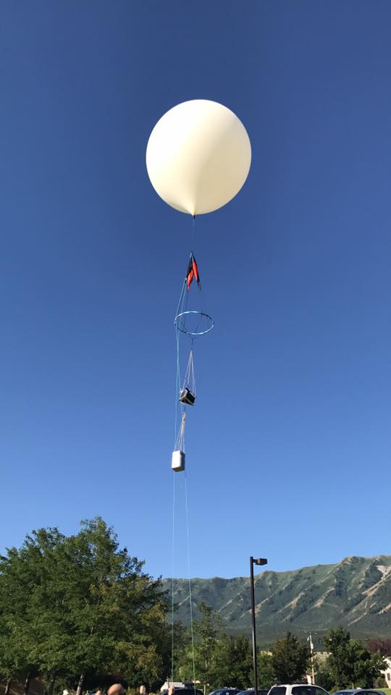

The GAS team is a long-standing group of students at Utah State University with a prolific history of sending student-engineered experiments into space. As of this document’s date, the GAS team’s current mission is a proof of concept for a potential CubeSat stabilization device. Seen in the picture is a GAS team balloon just before takeoff. Note the brightly-colored parachute, tracking payload, and collaborative payload with the University of Tsukuba. HABs are *great* at bringing people together.

As balloons ascend, they expand due to the pressure difference between the interior helium and the exterior air. Eventually, the stretching becomes too much for the balloon to bear, causing it to pop and allowing the payloads to fall back to the Earth. The parachute eventually slows the rate of descent as the payloads return to thicker atmosphere, and the tracking payload allows the team to follow its location throughout the entire flight.

The materials required to fly balloons are actually quite minimal. Starting out, some larger purchases do have to be made (such as the tracking beacons and the parachute), but once such things have been acquired, the only major replenishables that need be purchased are balloons and helium. With practice, balloon flights have become relatively easy for the GAS team to perform, so the hope of these instructions is that teams to come might not only learn how to fly balloons, but cultivate a *mastery* of doing so. The GAS Team flew 6 successful balloons during the summer of 2017 alone.

# 

# 

# 3 Checklist of Materials

**Items needed for a balloon launch:**

* Helium
* Gas tank hose
* Balloon
* Brightly-colored parachute
* 50lb Fishing scale
* 11in. 75lb Tensile Strength Zip-ties
* Scissors
* Swivels
* 15’ x 15’ Tarps
* Nitrile or Latex gloves
* Tapes (important)
  + Electrical tape
  + Kapton tape
  + Cold-weather (aluminum) tape
  + Duct tape
  + Masking tape
* Bubble level
* Mason line
* Payloads
* Radios
* Laptop computer to communicate with the payloads
* Antenna to communicate with payload
* Tow line (thin rope) 30 feet.
* Key-Ring or Carabiner - approximate size of a key ring

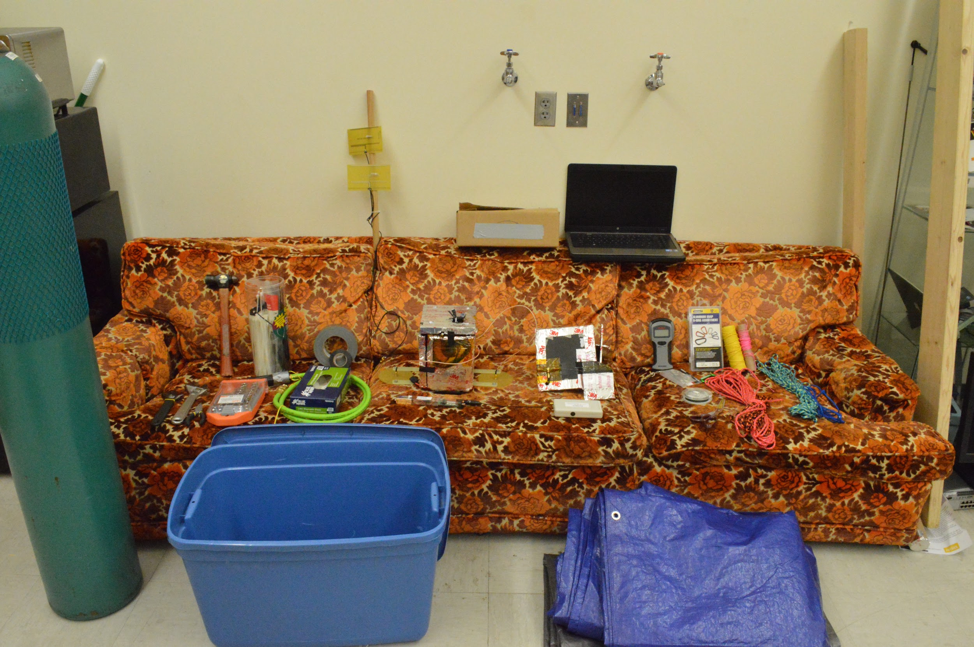

# 

# 

# 4 Instructions

Without further ado, we present the instructions on *How To Fly a High Altitude Balloon.*

## 4.1 The Week before the flight

### 4.1.1 Run predictions using HABhub

HABhub is the site the GAS Team uses to predict flight patterns. This is an essential tool to HAB teams as it gives information on where the team needs to set up, where they need to recover the payload, and, quite importantly, it allows university teams to tell their departments just how much to reimbursed for travel expenses. Below is an image of the main page, [www.habhub.org](http://www.habhub.org). To run predictions, click on “predictor:”

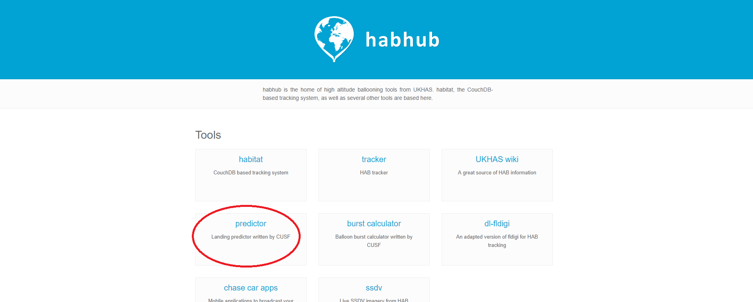

This will take you to [predict.habhub.org](http://predict.habhub.org/). The user will be placed in England; it is the user’s responsibility to select a launch point. For the GAS team, our favorite test point is Mendon, Utah: latitude 41.7095 and longitude -111.9785.

The target, circled in blue on the image below, represents the latitude and longitude of the launch location. It is important to note that your first choice may not give a favorable flight path or landing location. The user will likely have to experiment with several launch locations to avoid obstacles such as mountains and bodies of water. For the GAS team, the goal is to find a flight path where the payload lands in Cache Valley or south of the Wellsville mountains.

The red box is where the user will input data for the flight path prediction. It is important for the user to be as accurate as possible when filling out this information as it will affect the flight path.

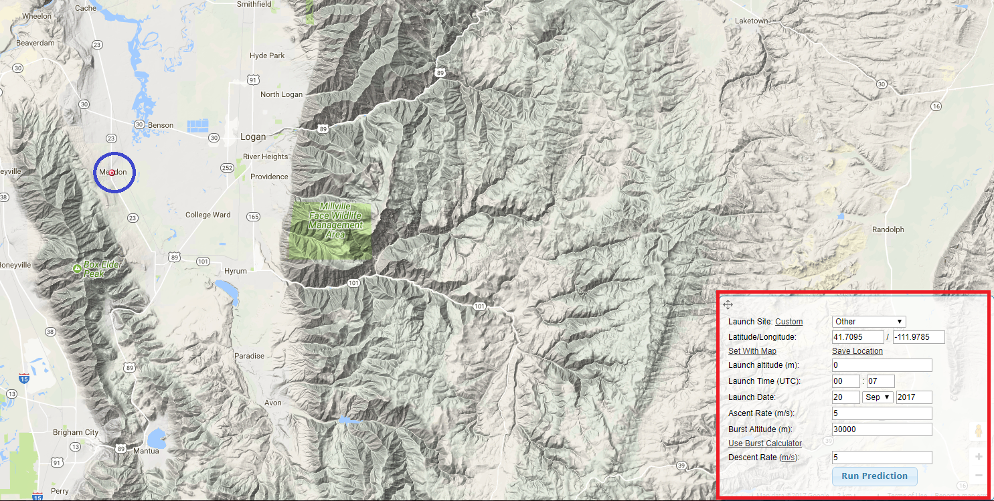

The “Launch altitude(m)” field is the launch location’s altitude in meters. We’ll use Mendon as our example. Mendon’s altitude is 1381.9632 m. The “Launch Time (UTC)” box field asks for military time in UTC (Coordinated Universal Time), which is set 6 hours ahead of Mendon’s Mountain Standard Time (MST). To avoid high winds, the best times to launch balloons are between 6 A.M. and 8 A.M which, converting from MST, translates to 12:00 and 14:00, respectively. The best results for the GAS Team has been at around 14:00.

The “Launch Date” field is the date the team intends to fly. A prediction can not be made more than 180 hours (7.5 days) in the future. The user should check the prediction daily leading up to the day of the launch. Note that predicted flight paths will become more accurate as the launch date approaches. The “Ascent Rate (m/s)” and “Burst Altitude (m)” will be determined by the burst calculator as seen in the image below:

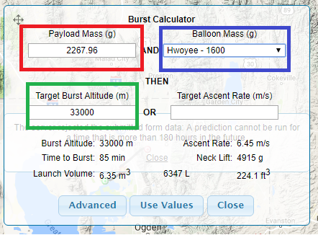

If you’re American, the FAA (Federal Aviation Agency) restricts the weight of the payload to 6 lbs. Otherwise, check with your local aviation authority. In this example we will use a payload of 5 lbs. Note, the payload weight is in grams and must be accurate as it affects the target ascent rate. The high altitude balloon that the GAS Team has used is the Hwoyee - 1600 as selected in the drop down menu highlighted in blue. The burst altitude is left by default to be 33,000m. Once you have filled in the information, click “Use Values.”

The “Ascent Rate (m/s)” will be calculated depending on the weight of your payload and target burst altitude. The “Descent Rate (m/s)” field will be set to 9 m/s for GAS team purposes. This value has been calculated from previous launch data and will be different for other experiments. Click “Run Prediction.”

Below is an image of a predicted flight path. This is where the coordinator will need to make a decision if the flight path is acceptable. In the image below, the flight path is quite unacceptable because it lands in the mountain steppes of Idaho. The coordinator ought to make recovery as simple as possible, so it is necessary to change the launch location until a suitable flight path is found. Elevations for each city or town can be found on Google. The user will need to convert from feet to meters. For American teams, once you’ve decided where the launch location will be, you will need to record the latitude and longitude and take a screenshot of the flight prediction to be sent to the FAA.

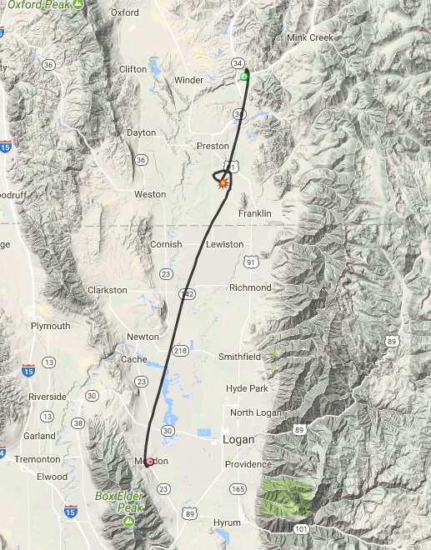

### 

### 4.1.2 Contact the FAA (U.S. teams only)

The FAA requires notification of the high altitude balloon at least 24 hours in advance. It is best to call at the beginning of the week so there is time to work out any issues. The weight restriction is six pounds. Any more than six pounds will need to be filed several months ahead of the scheduled flight.

The FAA point of contact will require the coordinator to fill out a Mission Sheet. The FAA can supply the templates upon request, see Appendix I. The coordinator will need to fill out the route of the balloon. It can be pretty succinct. For example:

*Launch from Bothwell, Utah heading E ~20 Nautical Miles to landing SE of Mendon, Utah*.

This website: <https://www.freemaptools.com/measure-distance.htm>, will allow you to draw a line from your launch location to your estimated landing location. You will need to click on the dropdown menu and select “Nautical Miles.” The coordinator will also need the time you are launching at in UTC-24h format, the description of the parachute, the weight of the balloon, and the length from the top of the balloon to the last connected payload.

### 4.1.3 File a NOTAM (U.S. teams only)

A NOTAM (Notice To Airmen) is required as well. This is used to alert all the airmen in the area of a high altitude balloon. It is for their safety and to ensure the team is relieved of liability in the rare case of an accident. To file a NOTAM call 1-877-4-US-NTMS. They will need the latitude and longitude of the launch location.

### 4.1.4 Driver Information

If your club or organization is under the care of a university, chances are there are legality complications with transportation. At Utah State University, any person driving to or from a university-sanctioned activity must have passed a driving course through the university in order to be reimbursed. This is something you may have to look into. If you are a private organization, however, this probably doesn’t apply to you.

Once you know you have drivers that can legally drive others during launch activities, it is important to make a list of drivers and passengers ahead of time. This list will state who is driving and who the drivers will have in their vehicles. This way, in the case of an emergency or accident, all persons can be accounted for. The GAS Team is a part of the Physics department at the university, so we must deliver this list to the Physics office.

### 4.1.5 Call A Gas Provider

A week before the flight it is advised to call your local gas provider, as it might take some time before the gas is ready. Most balloon flights require at least 300CF of helium in order to reach a reasonable ascent rate, so be sure to order a tank of appropriate size. You also don’t need high-grade laboratory helium; low-grade helium will do fine.

The GAS team’s provider is the university-run Laboratory Gas Sales at the university extension 72011. This is perhaps the most stressful part of the entire balloon flight process. You will call their phone number. The phone will ring at least three times before automatically going to a voicemail message: “Thank you for calling USU Lab Gas. Please leave a voicemail of the gas to be delivered, location and room number, a banner index and your name and number. If you have any questions please leave your name and number and I will call you back at my earliest convenience.” An example of the response is: “This is Raul Ramirez with the Get Away Special Team. I need a 300CF Helium tank to be delivered to SER 011 on Friday. I will be in the lab all day after 1:30PM, you should have payment information already on hand. Thank you.” Laboratory Gas Sales will not return your call or ever call to confirm that they received your order. Be patient, Laboratory Gas Sales have never failed to deliver. Please have someone present in the lab to receive the gas and to sign for the slip when they deliver.

### 4.1.6 Reconfigure APRS and Fox Beacons

The APRS and Fox beacons can be reconfigured. The following documents the process of reconfiguring the beacons when needed. **Note**, the beacons do not need to be reconfigured before each flight. All the programs and documentation mentioned can be found on the team GitHub <https://github.com/Cubium/BeaconPrograms>

#### 4.1.6.1 Reconfiguring the APRS Beacon

TinyTrak3Config_v1.4.6.exe is the program provided by the manufacturer to configure the APRS beacon. Plug the serial programming cable into a USB port and the other end firmly into the side of the APRS beacon. Then start up the TinyTrak program. When the program starts, this is what the program looks:

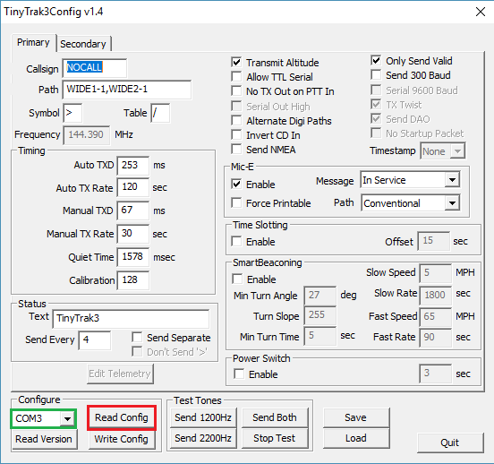

Make sure COM is selected (highlighted in green) then select Read Config (highlighted in red). This will read the configuration that is stored on the APRS beacon. After reading the config, the data fields will be populated with the currently programmed information:

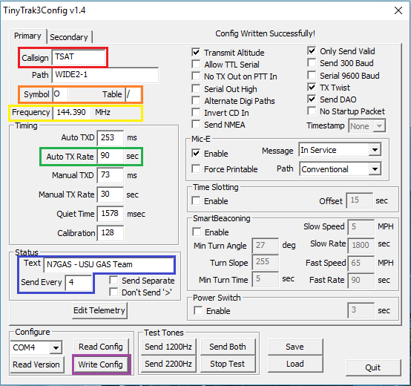

Starting at the top:

* Call Sign (red) - This does not have to be the callsign of any GAS member or the club call sign. We usually place the mission name here. This will be used to identify the packets and view them on aprs.fi by navigating to <https://aprs.fi/callsign>.
* Symbol (orange) - The icon that will be displayed on the aprs.fi map (see Appendix V for a full table of symbols).
* Frequency (yellow) - The frequency that telemetry data packets will be transmitted at. For use of the national APRS network use 144.390
* Auto TX Rate (green) - Sets how often a position report should be sent.
* Text / Send Every (blue) - An optional comment that can be added to periodic position reports. If Send Every is 4, the Text will be sent 4th transmission. We use these fields to send our team call sign. Make sure that (Send Every) x (Auto TX Rate) is at least 10 minutes which is how often a call sign needs to be transmitted.
* Write Config (purple) - Once the changes have been made, write the config to the APRS beacon.

For full documentation, see TinyTrak3Config Manual <https://github.com/Cubium/BeaconPrograms/blob/master/APRS_Beacon/TinyTrak3ConfigManual_v1.4.pdf>

#### 4.1.6.2 Reconfiguring the Fox Beacon

MicroFoxConfig_v1.6.4.exe is the program provided by the manufacturer to configure the Fox beacon. Plug the serial programming cable into a USB port and the other end firmly into the side of the Fox beacon. Then start up the Micro Fox program. When the program starts, this is what the program looks:

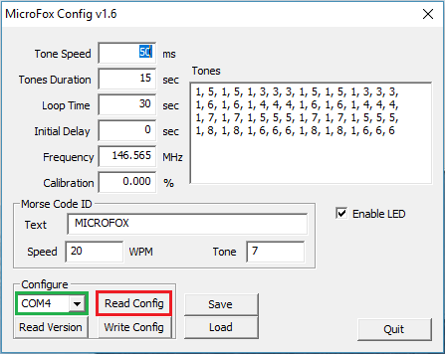

Make sure COM is selected (highlighted in green) then select Read Config (highlighted in red). This will read the configuration that is stored on the Fox beacon. After reading the config, the data fields will be populated with the currently programmed information:

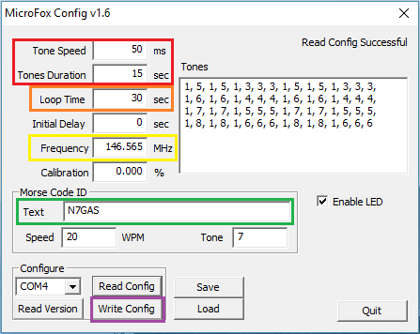

Starting at the top:

* Tone Speed / Duration (red) - This sets how fast the tone sequence will play in milliseconds per tone and how long the repeating tone sequence will play in seconds. After this the it will transmit the Morse Code Text.
* Loop Time (orange) - This sets how often the transmission loop will repeat.
* Frequency (yellow) This sets the radio frequency of the transmitter, between 144 MHz and 148 Mhz.
* Text (green) This sets the Morse Code ID message sent after the repeated tone sequence. We use the GAS Team call sign.
* Write Config (purple) - Once the changes have been made, write the config to the APRS beacon.

For full documentation, see MicroFoxConfig Manual: <https://github.com/Cubium/BeaconPrograms/blob/master/Fox_Beacon/MicroFoxConfig_v1.6a.pdf>

## 4.2 Forty-Eight Hours Before the Flight

### 4.2.1 Test Your Payloads

Before the launch it is important to inspect and test your payload. Test all your electrical components, any moving mechanical components, and make sure all your temperature dependant systems (i.e. batteries) have proper insulation. This will be your final chance to find any failures and fix them before the launch.

### 4.2.2 Tie Up Your Payloads

Part of preparing the payloads for a high altitude balloon flight will include tying up the payloads to be ready to connect them to any other payloads and to the balloon. Below is an example of the GAS team’s setup.

For this, four sections of string will be needed. Each string will be threaded through holes in each corner of the bottom of the payload such that the ends of each string will be coming out of the top of the payload. The strings need to be arranged to have a string on each side of the payload.

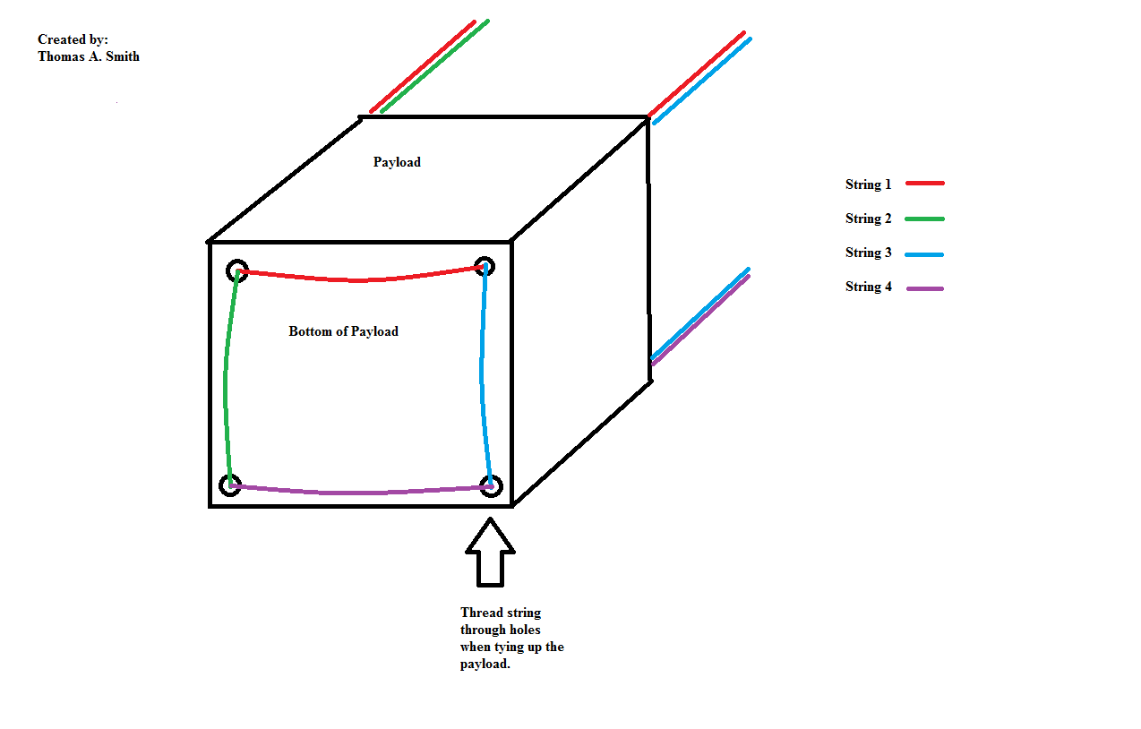

**Figure 4.2.2-1**

After threading each string through the payload, there should be eight ends coming out of the top of the payload. The height of these string ends should be even with each other and should be measured to be between three to four feet. It should be noted that the ends of each string should have a knot to prevent the strings from fraying.

After the height of the string ends are measured and cut, the string ends should be tied together with a loop at the top in order to connect to the other payloads on the day of the flight. A swivel should also be attached to all four strings on the bottom of the payload. This swivel will be used to attach other payloads on the day of the flight.

### 4.2.3 Tie up and Test Parachute

Upon acquisition of a new brightly-colored parachute, it is strongly recommended to attach the parachute to a hula hoop to avoid tangling. The standard size parachute in use is 5 ft. across and will require a hula hoop that has a 25 to 26 in. diameter. Other materials required for preparing the hula hoop and parachute include: rope, a 5 or 6 lb weight, duct tape, a bubble level, and masking tape.

First, two small holes should be poked in the hula hoop to drain out any liquid in the tubing. This is to prevent the liquid from expanding in the low atmospheric pressure. Draining the liquid also reduces the total weight of the hula hoop and parachute pair. If the hula hoop tubing does not contain any liquid, this step can be ignored.

Next, rope should be tied to the top of the parachute. This rope is then connected to the ceiling either by a hook, a pipe, or some other structure that will allow the parachute to hang freely without touching the ground.

After hanging the parachute, measure about 30 in. down the parachute’s cords from the material of the parachute. At this point, the hula hoop can be inserted, with the cords resting at equal distances from each other around the circumference of the hula hoop. The hula hoop can be temporarily kept in place with masking tape. Test to make sure that the hula hoop rests horizontally when the parachute is left to hang with the bubble level. Adjust as necessary.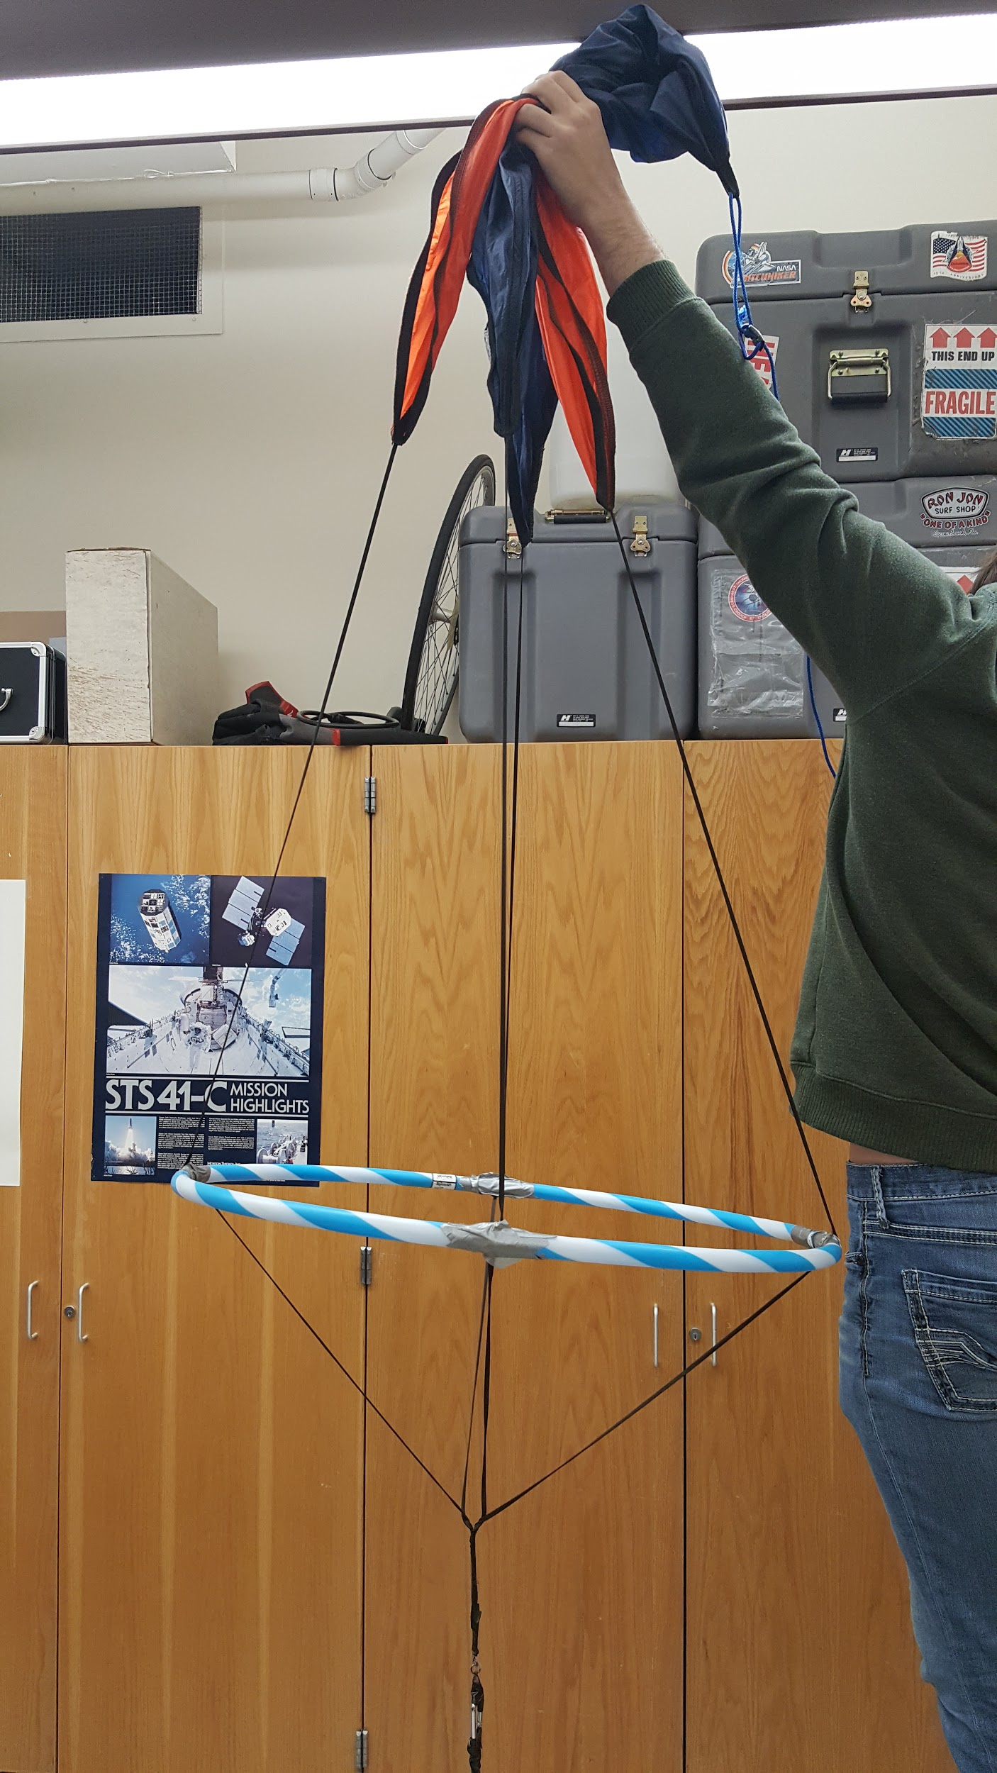

Finally, duct tape the hula hoop to the parachute cords. Liberal use of duct tape is encouraged, keeping in mind the weight constraints. Hang the 5 or 6 lb weight from the bottom of the cords to make sure that the tape is secure and that the hula hoop remains centered and horizontal. The cords may need to be adjusted so that they are the same length.

To test the parachute and hula hoop pair, the rope can be removed from the top and a simple weight may be tied to the end of the cords. The weight should be enough that the parachute opens, but not enough that it destroys the ground below. A couple rolls of tape is a good starting weight in order to gauge if the parachute will open when falling. Find a place multiple stories above the ground that the parachute and attached weight can be chucked off of. For the GAS team, a good place is the Huntsman Hall on campus. A balcony on the third floor overlooks the inner courtyard. Another potential place is the top of the SER if roof access is available.

One person will be required to throw the parachute, and a second should be on the ground to watch the parachute fall. The GAS team has found that the best time to do this is in the evening, when no students are out and about. The key here is safety, and the least disruption. As the parachute is falling, both should look to see if the parachute opens and “catches” on the wind. After successful testing, the parachute is ready for flight.

### 4.2.4 Run lift Calculator

A lift calculator has been written in order to provide a reliable way to calculate required lift from the balloon. Having the correct amount of lift from the balloon is important in order to achieve the target ascent rate used in the HABhub predictions. All the source code is available at: <https://github.com/Cubium/AscentRateCalculator>. The GitHub repository has two programs: ascent_calculator and lift_calculator.

#### 4.2.4.1 Lift Calculator

lift_calculator is used to calculate how much lift, in pounds, will be required to achieve the target ascent rate used in HABhub predictions. It will calculate the lift need to achieve the target ascent rate within 1 X 10^-3 m/s of the target. It is important to achieve the ascent rate so that the flight of the balloon will match the predicted path. If the balloon has too much or too little lift, it can affect the flight path drastically. lift_calculator is used in the following way:

1. Run lift_calculator
2. You will be prompted to enter the parachute’s weight in pounds
3. You will be prompted to enter the balloon’s weight in pounds
4. You will be prompted to enter the combined payload weight in pounds
5. You will be asked to overestimate the lift that will be required
6. You will be asked to underestimate the lift that will be required
7. Through a binary search like algorithm, the required lift will be calculated
8. The program will display the lift required to achieve the target ascent rate

#### 4.2.4.2 Ascent Rate Calculator

ascent_calculator calculates the ascent rate, in meters per second, given nozzle lift and parachute, balloon, and payload weights. This tool can be used if the balloon were to be launched with the current lift it is providing. At launch time, if the helium tank is empty but the balloon has not been filled to achieve the required nozzle lift, ascent_calculator will aid in reevaluating flight path predictions. Knowing the new ascent rate, predictions can be rerun on HABhub and decisions can be made as to whether or not the launch should be aborted. ascent_calculator is used in the following way:

1. Run the ascent_calculator
2. You will be prompted to enter the parachute’s weight in pounds
3. You will be prompted to enter the balloon’s weight in pounds
4. You will be prompted to enter the combined payload weight in pounds
5. You will be prompted to enter the current lift provided by the balloon in pounds
6. The program will display the ascent rate that the balloon will achieve
7. Given this new information, predictions can be rerun on HABhub and a decision can be made about whether or not to continue with the launch

### 4.2.5 Item checklist

There is a number of items that will need to be taken to each balloon launch. Many of these items are used in filling and launching the balloon. However, there are some items that are good to take in order to deal with any unforeseen problems that may arise. Be sure to have all of the items listed in Section 3. Other items may be included based on the needs of each payload.

## 4.3 Day of Flight

### 4.3.1 Double check flight pattern on HABhub

The morning of the launch you will need to check flight patterns one last time. Refer to 4.1.1 for how to use HABhub.

### 4.3.2 Payload setup

When setting up your payloads, make sure all electronics have been powered on and are functioning properly. Once confirmed, make sure to secure all objects inside the payload so no parts tumble or fall out of the payload. Make sure that all doors or hatches have been securely closed. Now the payloads are ready to be attached to each other with a swivel separating each payload. To string each payload together, refer to 4.2.2 and figure 4.2.2-1. It is important to note that you want to assure each payload sits square with the ground when the slack is out of the lines as seen in figure 4.3.2-1. Be sure to avoid a what is seen in figure 4.3.2-2

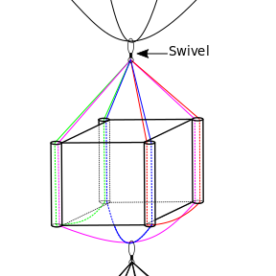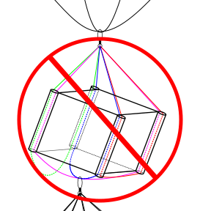

**Figure 4.3.2-1 Figure 4.3.2-2**

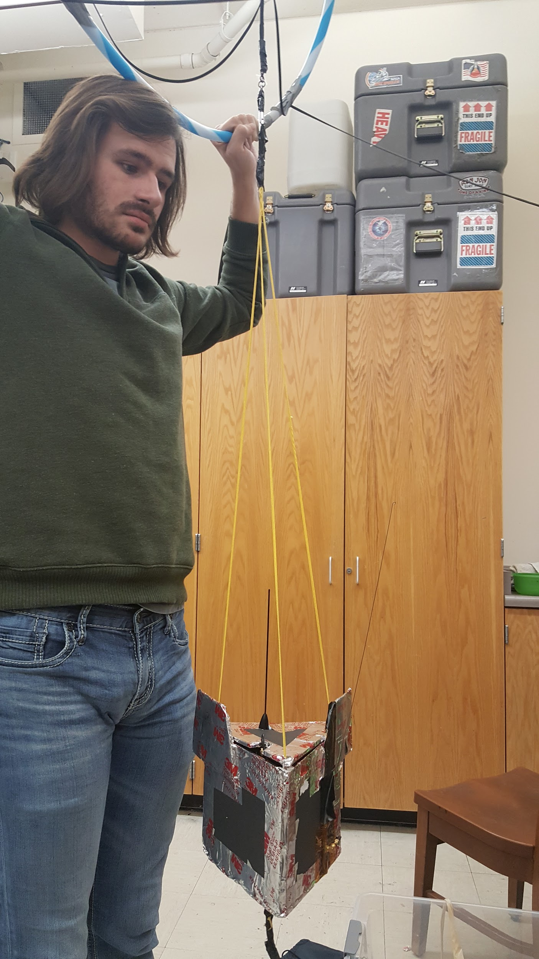

### 4.3.3 Setup APRS beacon

The APRS beacon should have a new 9 V lithium battery to ensure no loss of signal during the flight. IMPORTANT: make sure an antenna is connected before activating ANY radio, as failure to do so can fry the transmitter. WARNING: when using an exposed antenna, such as the dipole antenna currently in use on the GAS Team tracking payload, be careful of physical contact with the antenna as it is possible to receive an RF burn. After attaching the antenna, flip the switch to the “on” position and verify LED is on. You can watch aprs.fi/errno for retrieved packets but it is likely you will not see any information until the balloon is launched. You should be able to hear transmitted packets on 144.390 MHz on a handheld radio.

### 4.3.4 Setup fox beacon

The fox beacon is a backup system for locating the payload if the last received APRS packet does not have GPS coordinates close enough to the payload’s touchdown location. The fox beacon should have a new 9 V lithium battery to ensure no loss of signal during the flight. IMPORTANT: make sure an antenna is connected before activating ANY radio, as failure to do so can fry the transmitter. After attaching the antenna, flip the switch to the “on” position and verify LED is on. To verify the fox beacon is active, tune radio to 146.565 MHz and listen for the fox beacon’s tune.

### 4.3.5 Balloon setup

Ensure that all supplies in the supplies list (**see section 3**) are accounted for and in vehicles. Once at your launch site, scope out a wide grassy area where the balloon can clear any lines or poles that may be nearby. The balloon should ascend very quickly if it is filled to the correct specifications. The picture below would be an adequate place to launch a balloon.

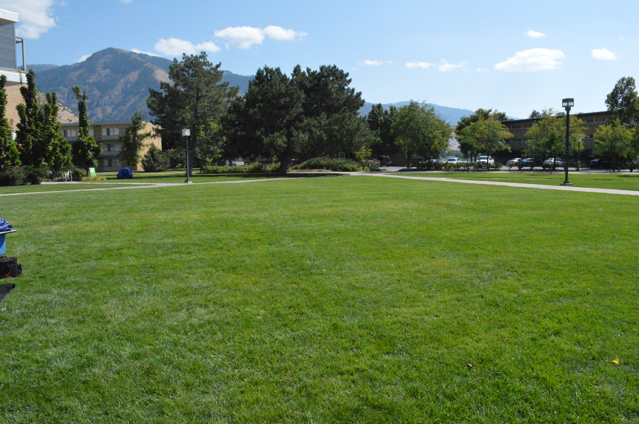

Next, lay out one or two large tarps to work on. If it is windy, the edges of the tarp will have to be held down. Nearby rocks or items from the supply box usually work. The balloon is prone to popping, so it is important to ensure that nothing located in the vicinity of the balloon is sharp, including clothing. Have anyone handling the balloon put on latex gloves. Bring the helium tank onto the tarp and set up the nozzle/fish scale add-on.

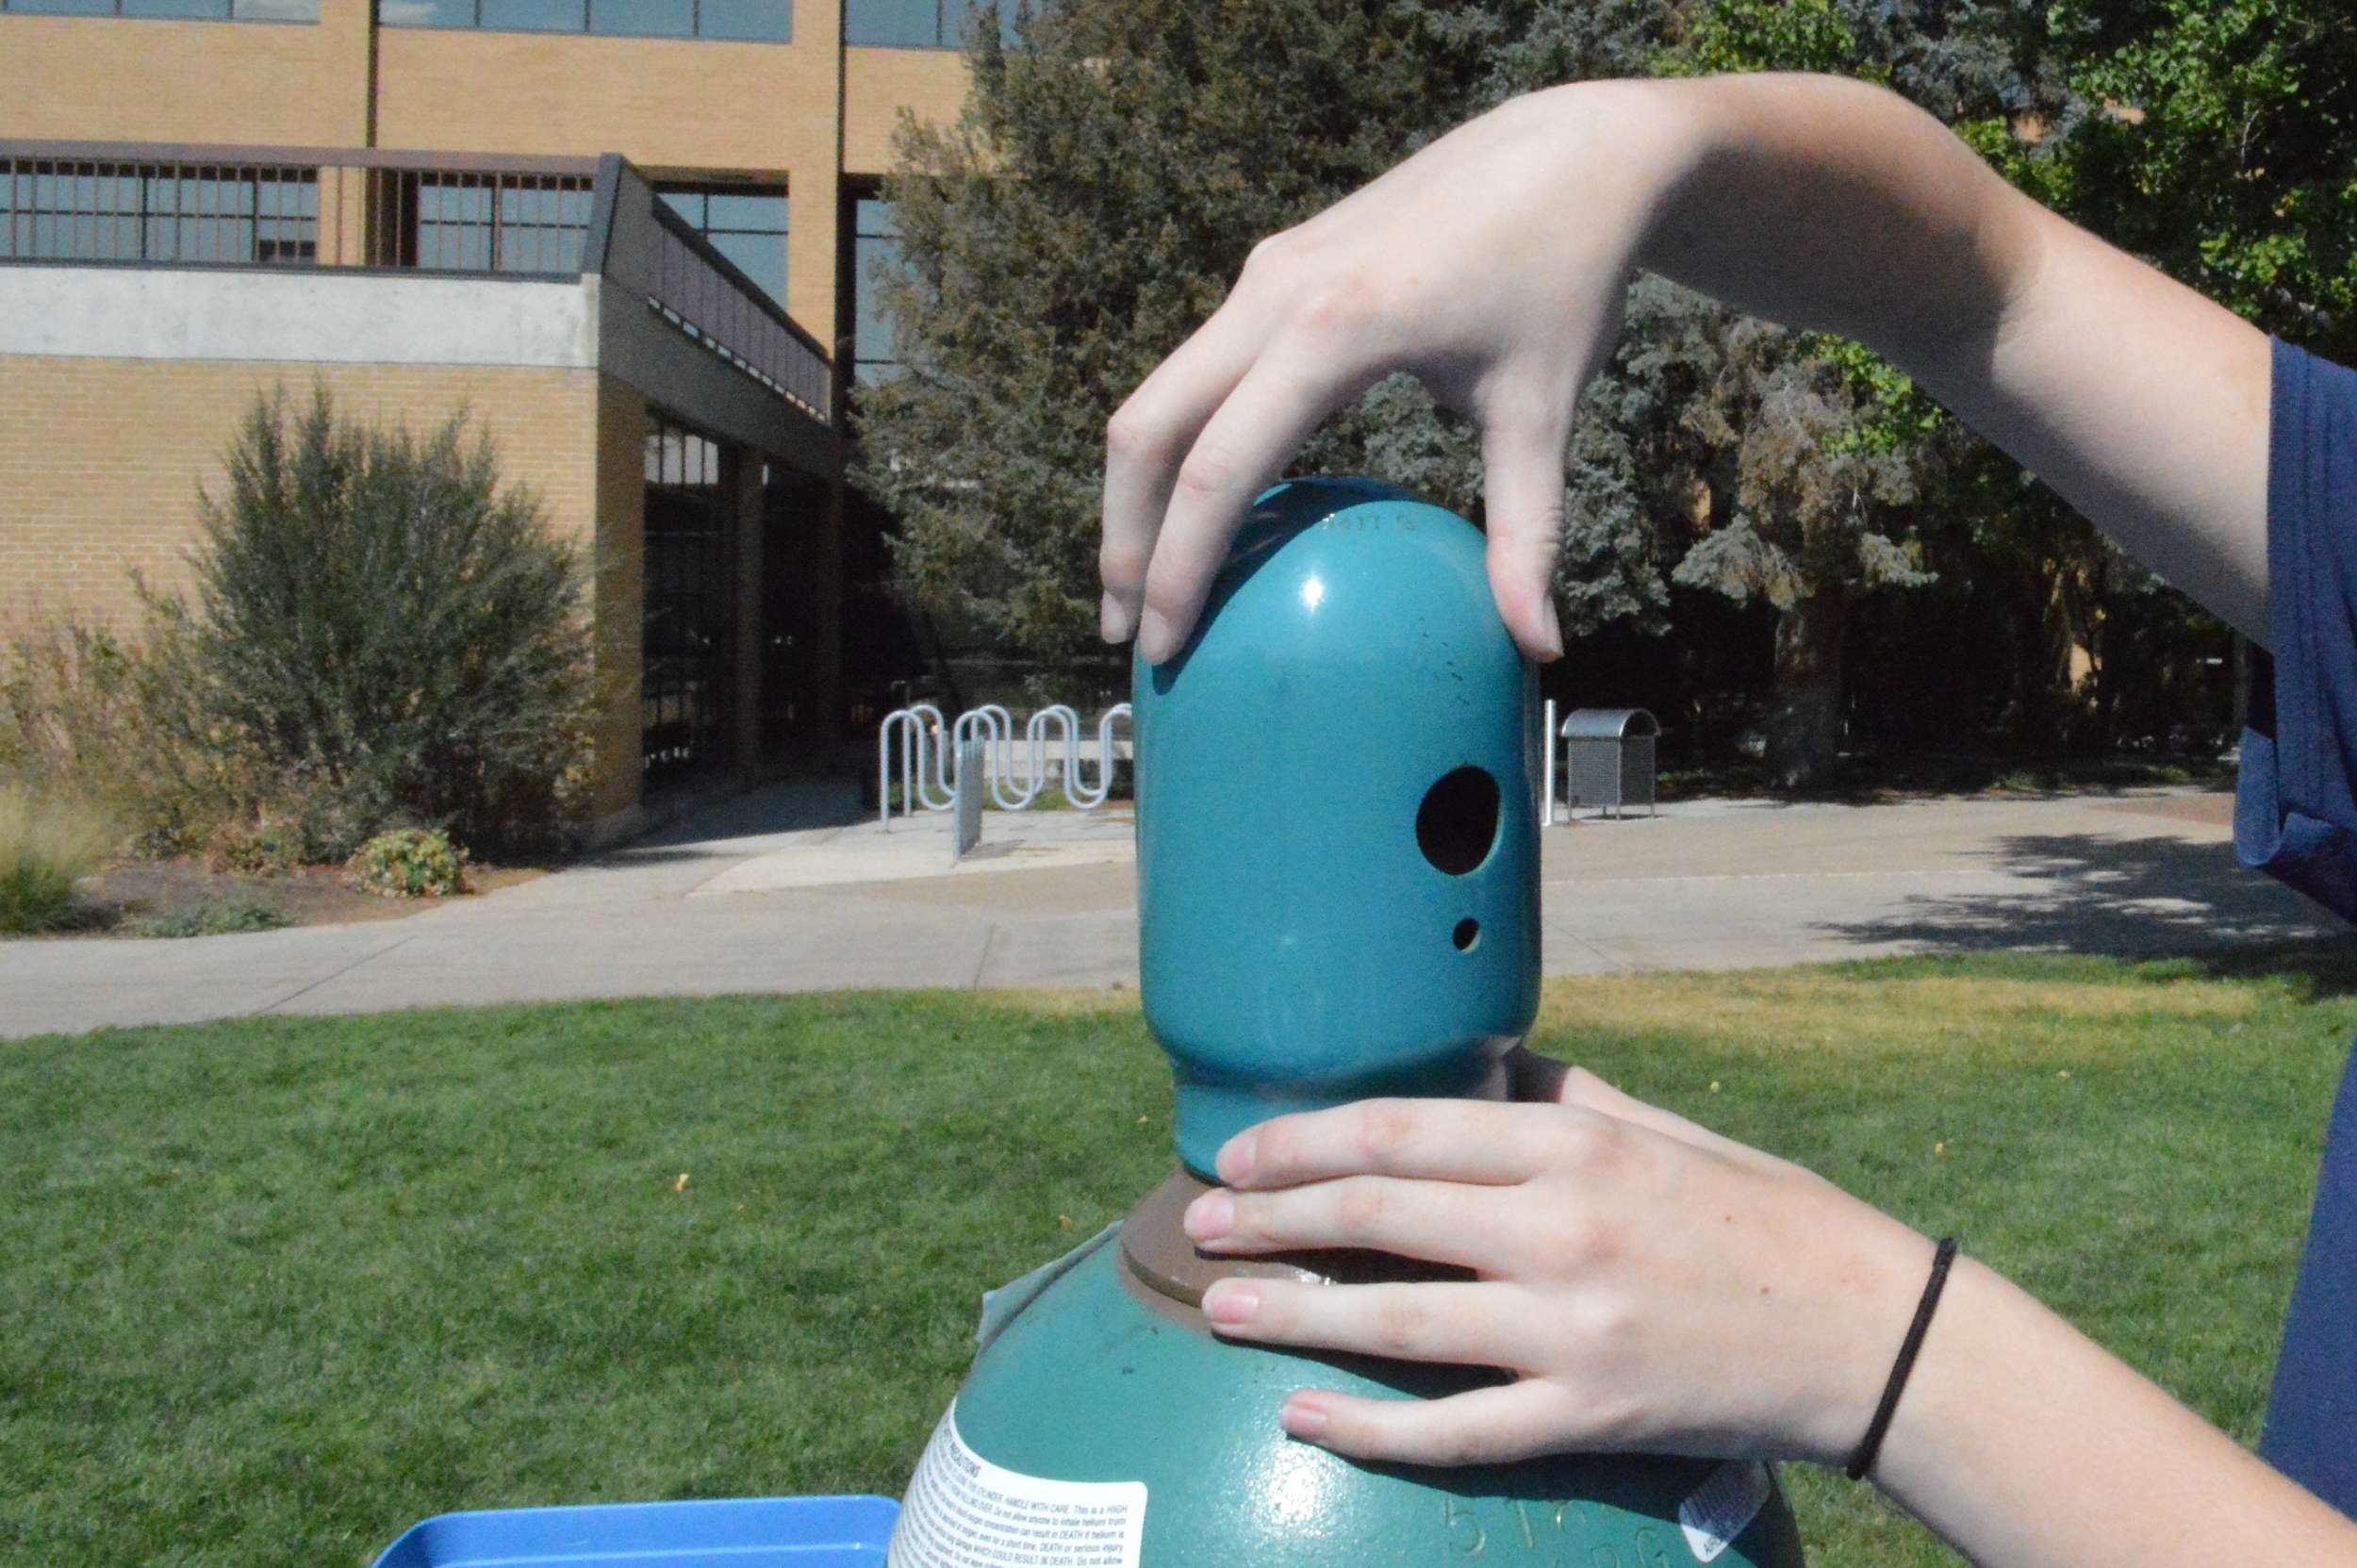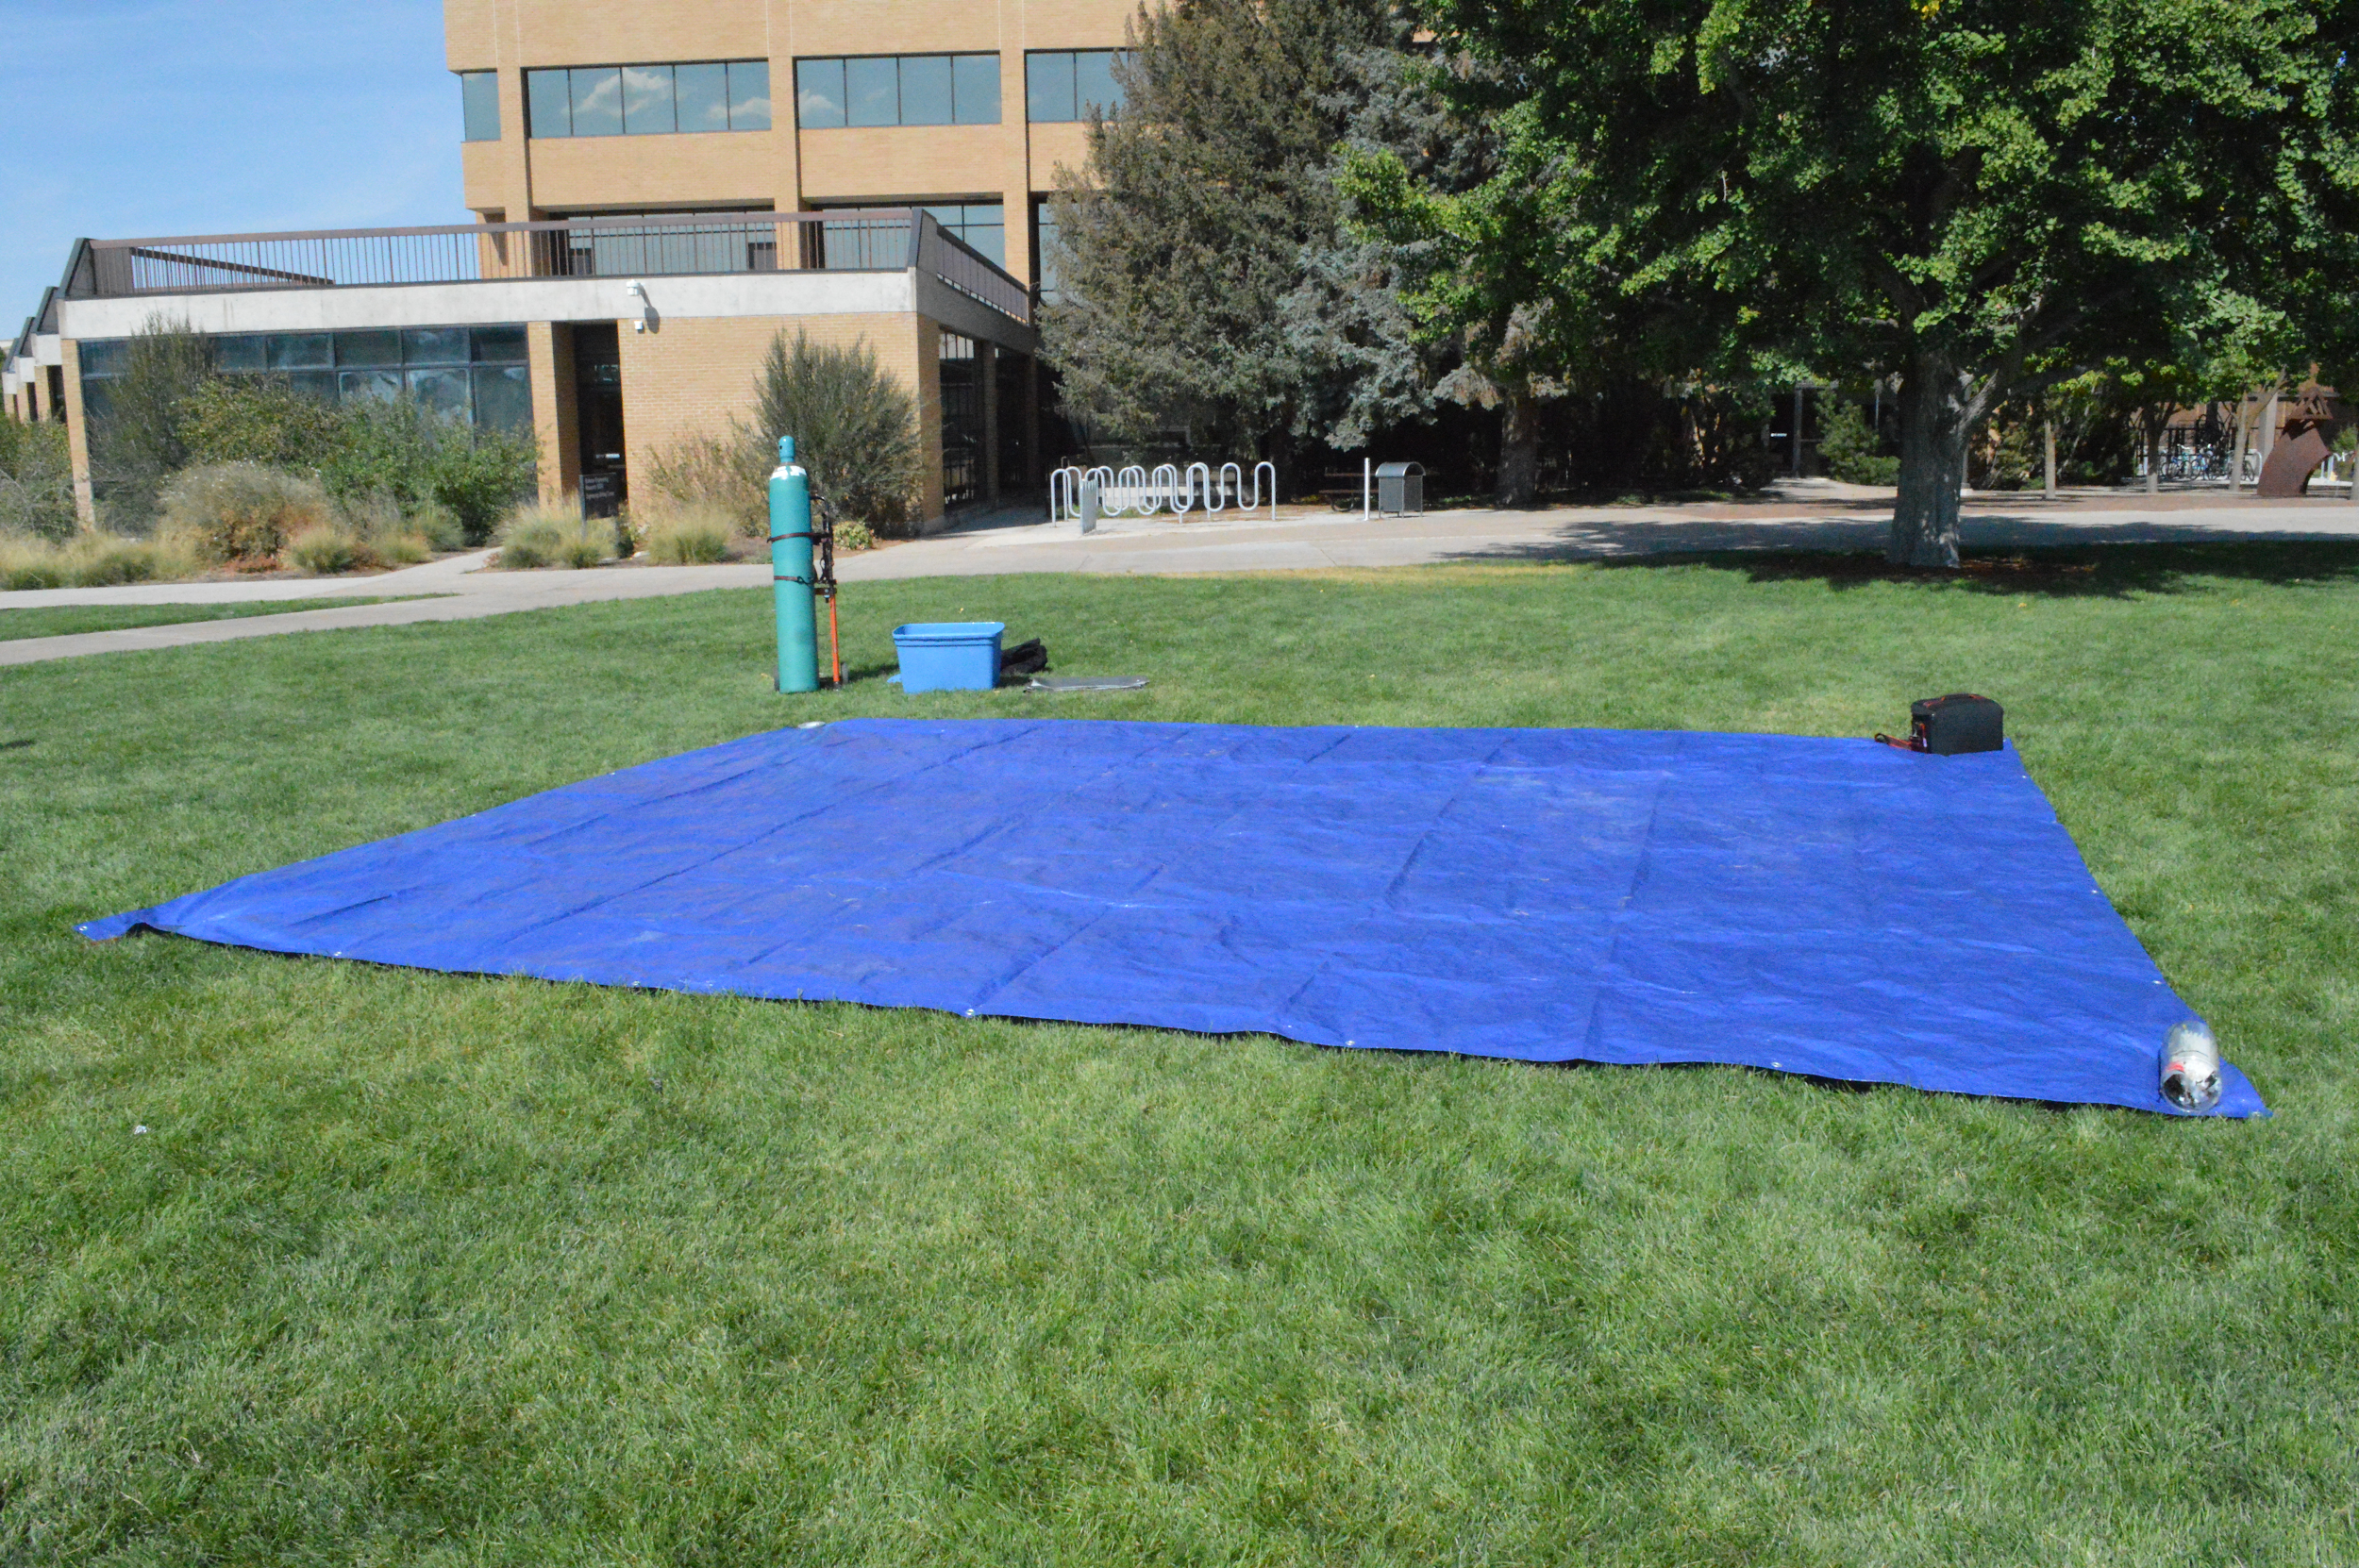

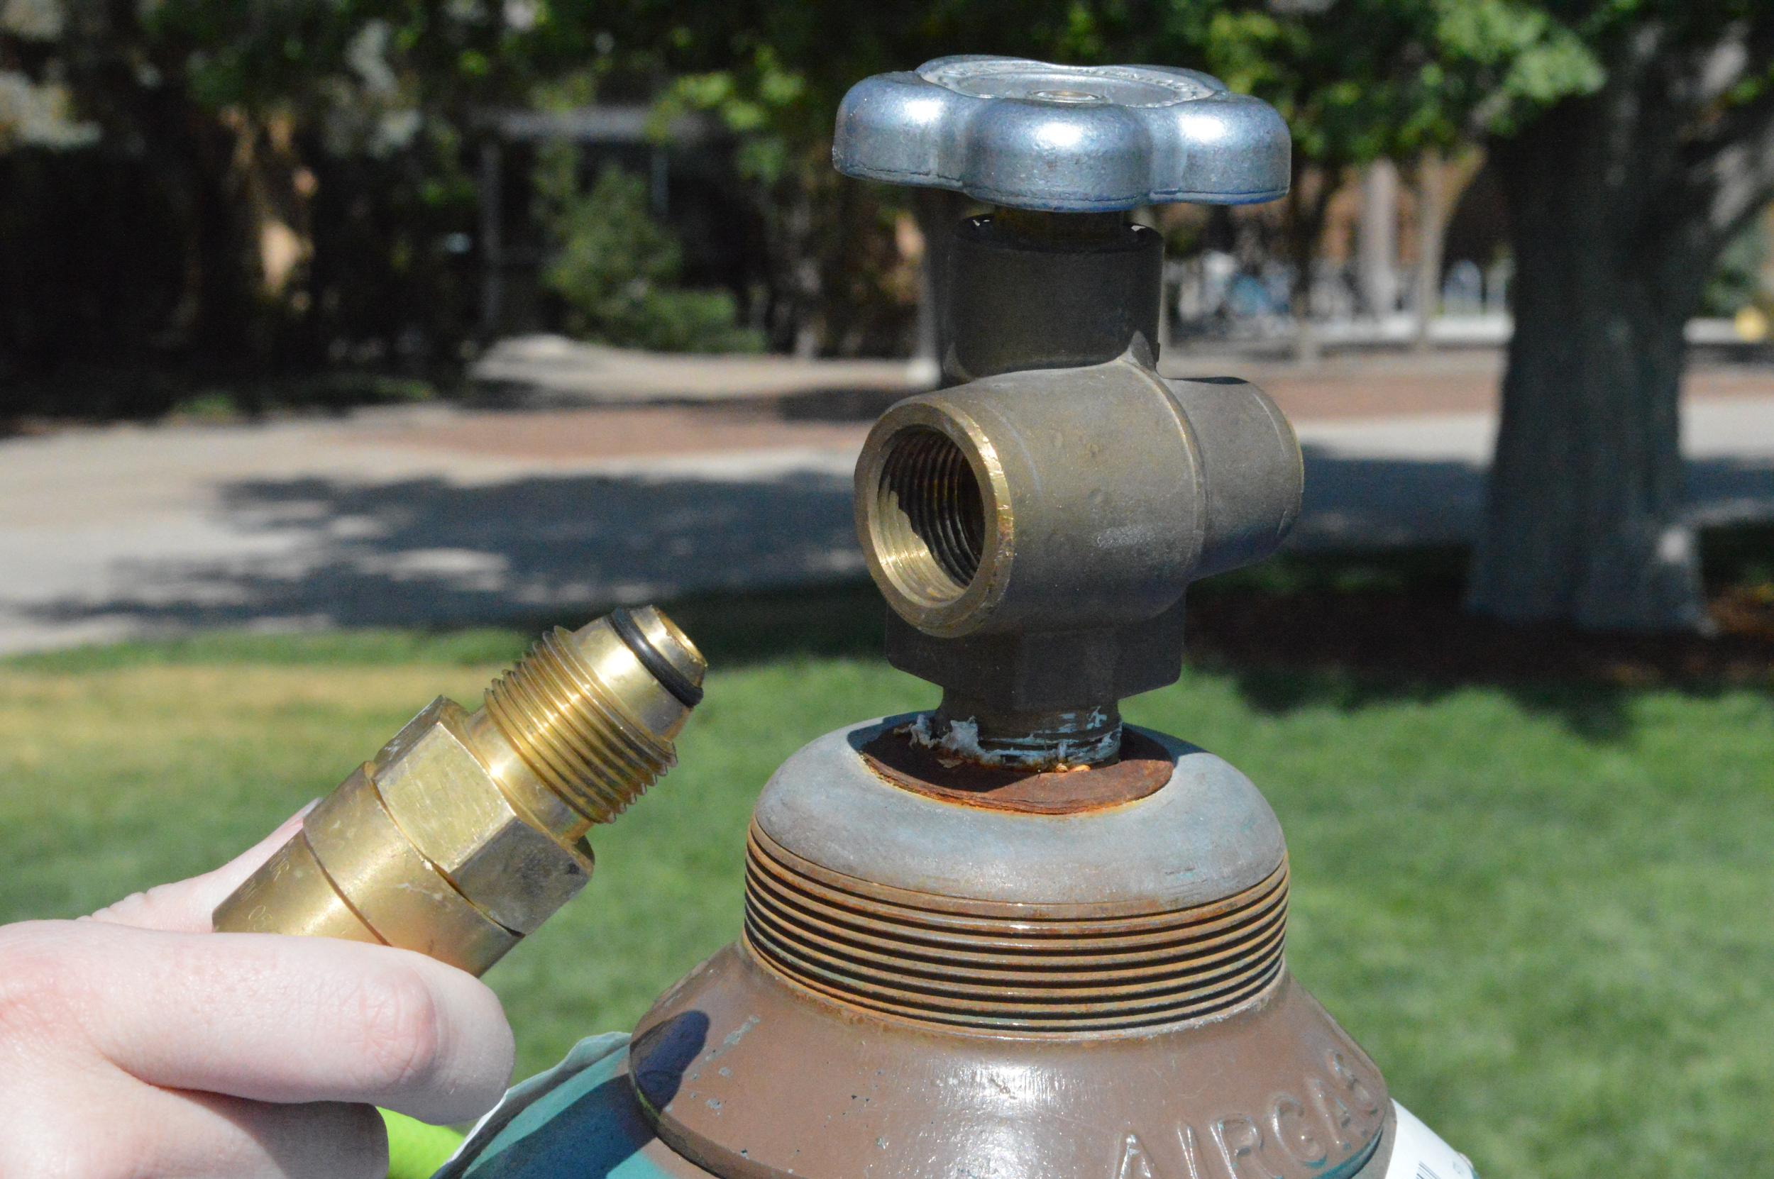

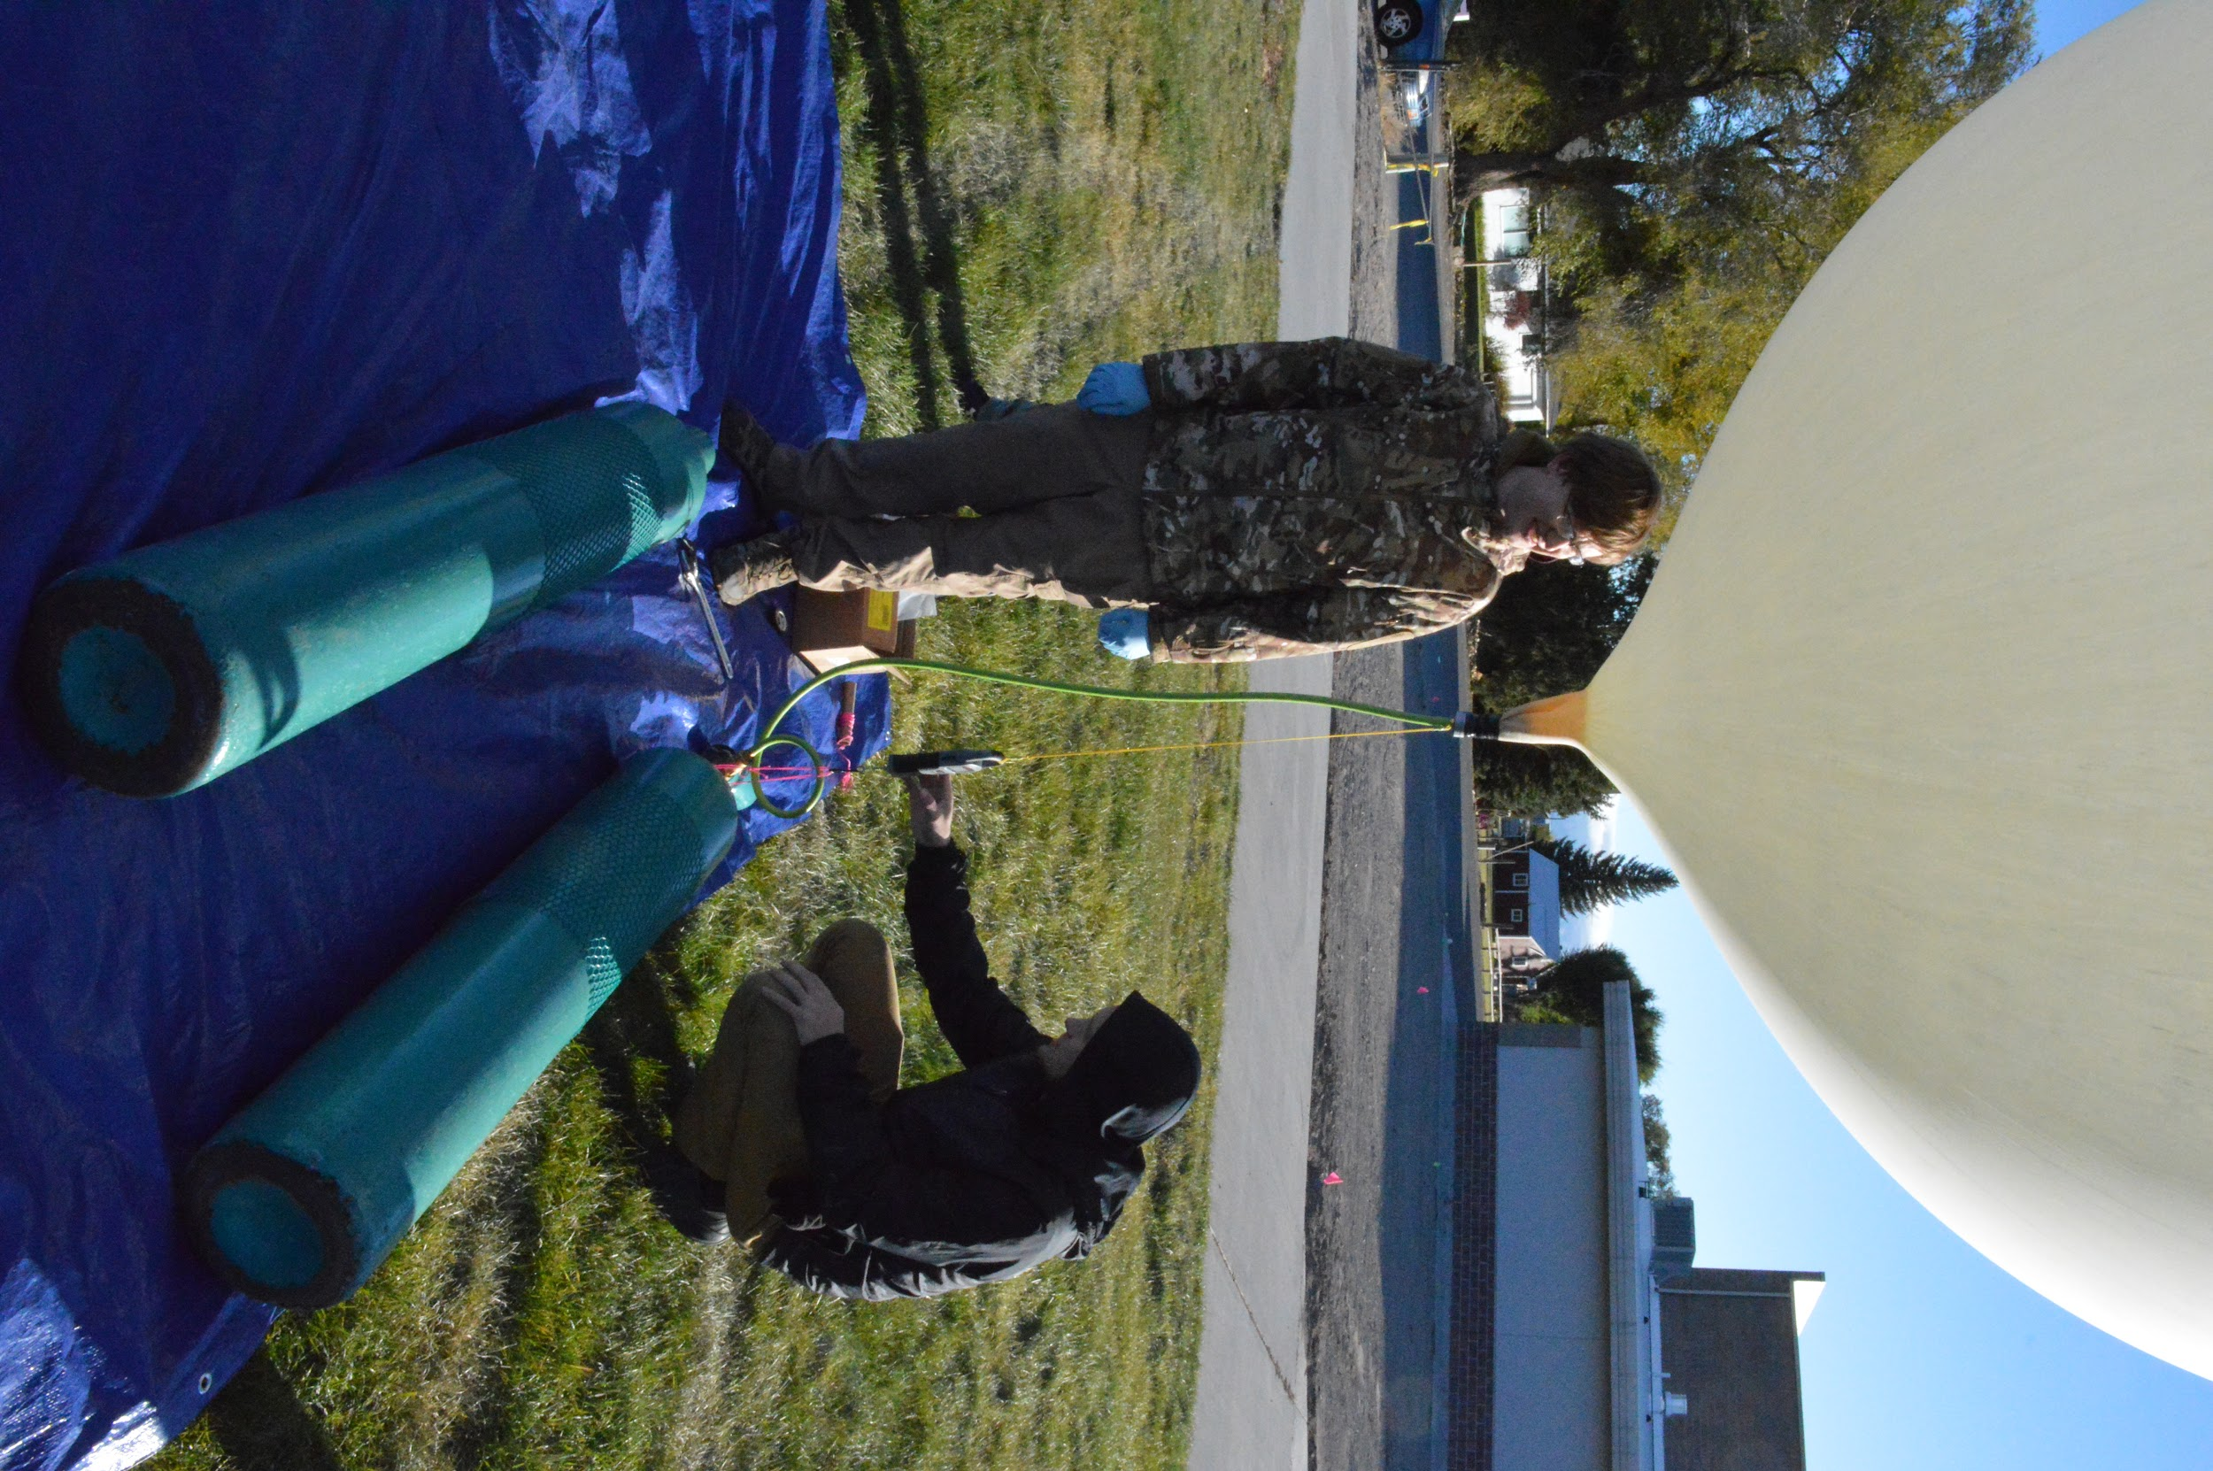

The nozzle/fish scale add-on is shown in the above image. It is made by using two bits of mason line to anchor the scale, and connect the scale to the hose. The anchor loop can be strung around the head of the tank, and the length of both lines should be shorter than the hose, so the scale reads the force of lift from the balloon as it’s filling.

Take the balloon out of its packaging, and lay it out flat on the tarp. Attach the lip of the balloon to the nozzle. Ours is a little too small for the balloon, so we fold the excess material flat against the nozzle and use electrical tape to ensure it is secure. Have multiple people ready to lift up the balloon while it is being filled and keep it stable.

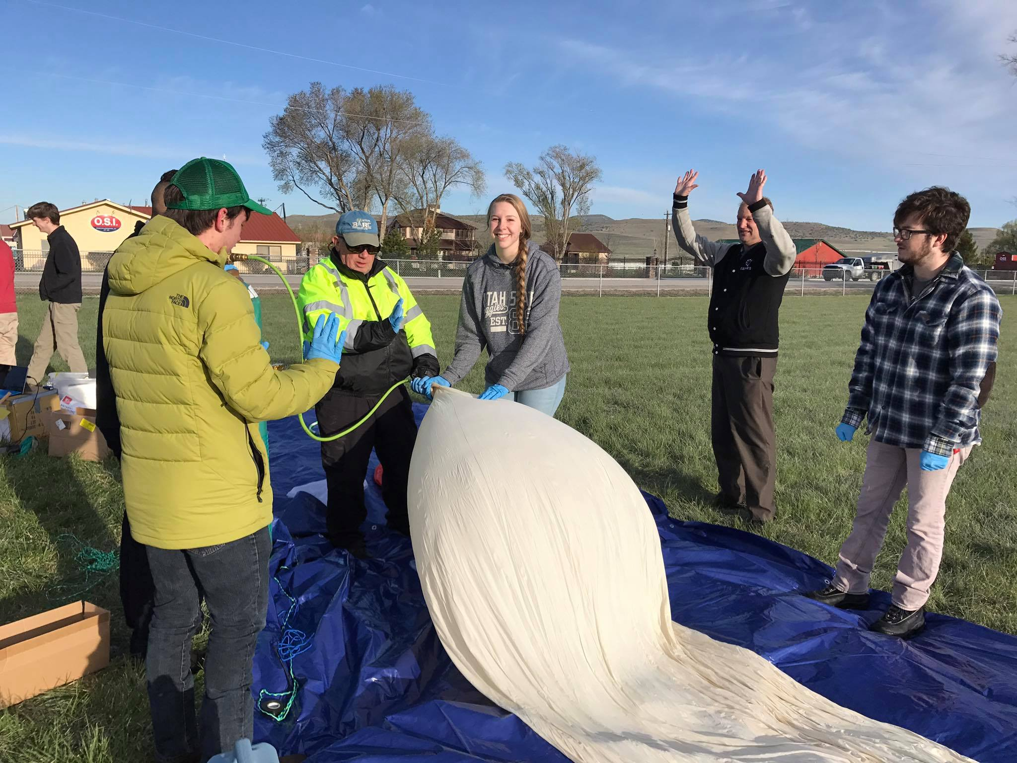

Slowly start letting helium into the balloon while having team members keep the balloon from twisting or blocking the flow. Once it starts to rise and fill out, it is the job of the balloon handlers to keep it from blowing around too much. The designated helium person should keep an eye on the scale, and once the scale reads the desired lift, shut off the flow of helium.

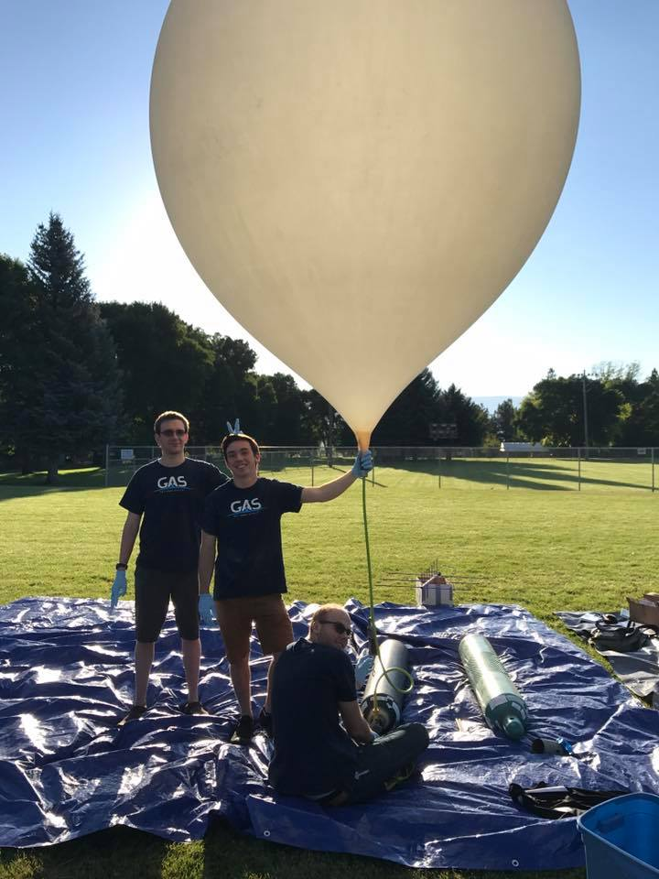

### 4.3.6 Hook Payloads to Balloon

Undo the electrical tape while having at least two people hold the bottom of the balloon at all times. Have the line tied to the parachute and payloads ready while folding part of the bottom of the balloon upwards. The line should then be set in the fold, and the fold zip tied shut with quite a few zip ties. This should create a nice closed loop in the balloon with the line going through it.

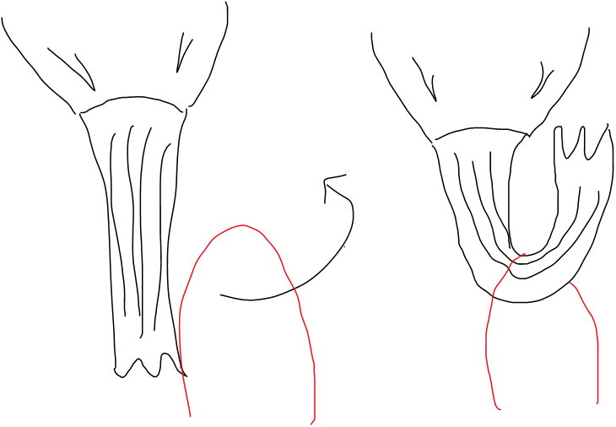



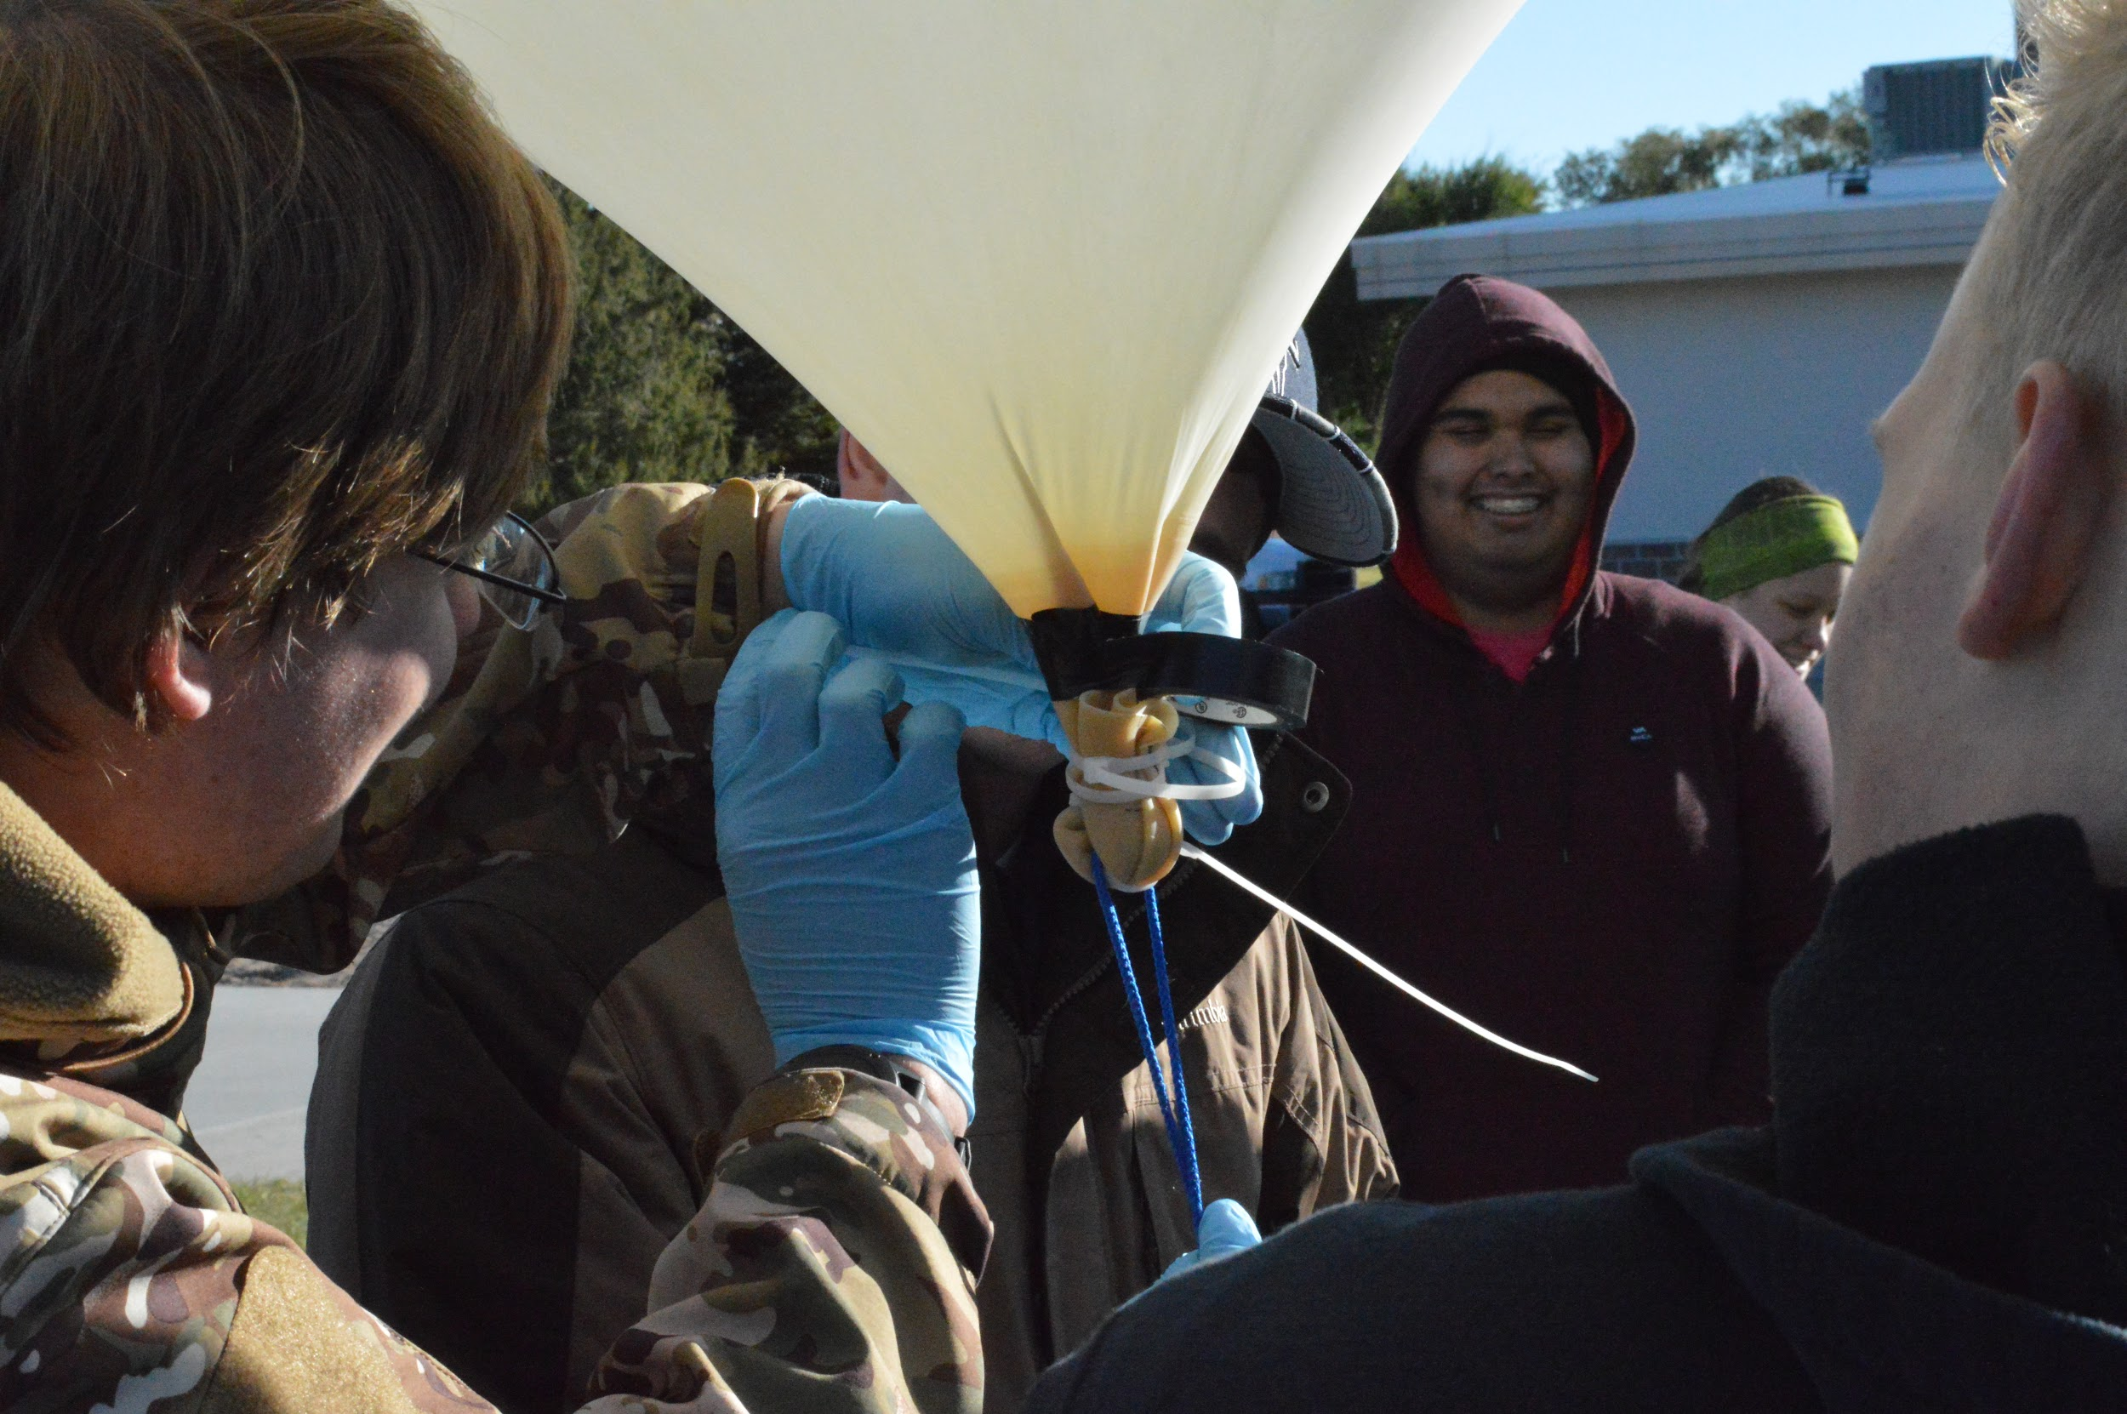

Use electrical tape to tape the zip ties down in their natural direction. Keep wrapping the tape until no zip tie is visible. This is so no stray plastic pops the balloon. At this point, the balloon is ready to go, so have people hold it steady until the payloads are set up and attached.

### 4.3.7 Release Balloon

Once the payloads, the parachute, and the balloon have all been correctly attached, you should follow these steps in releasing the balloon: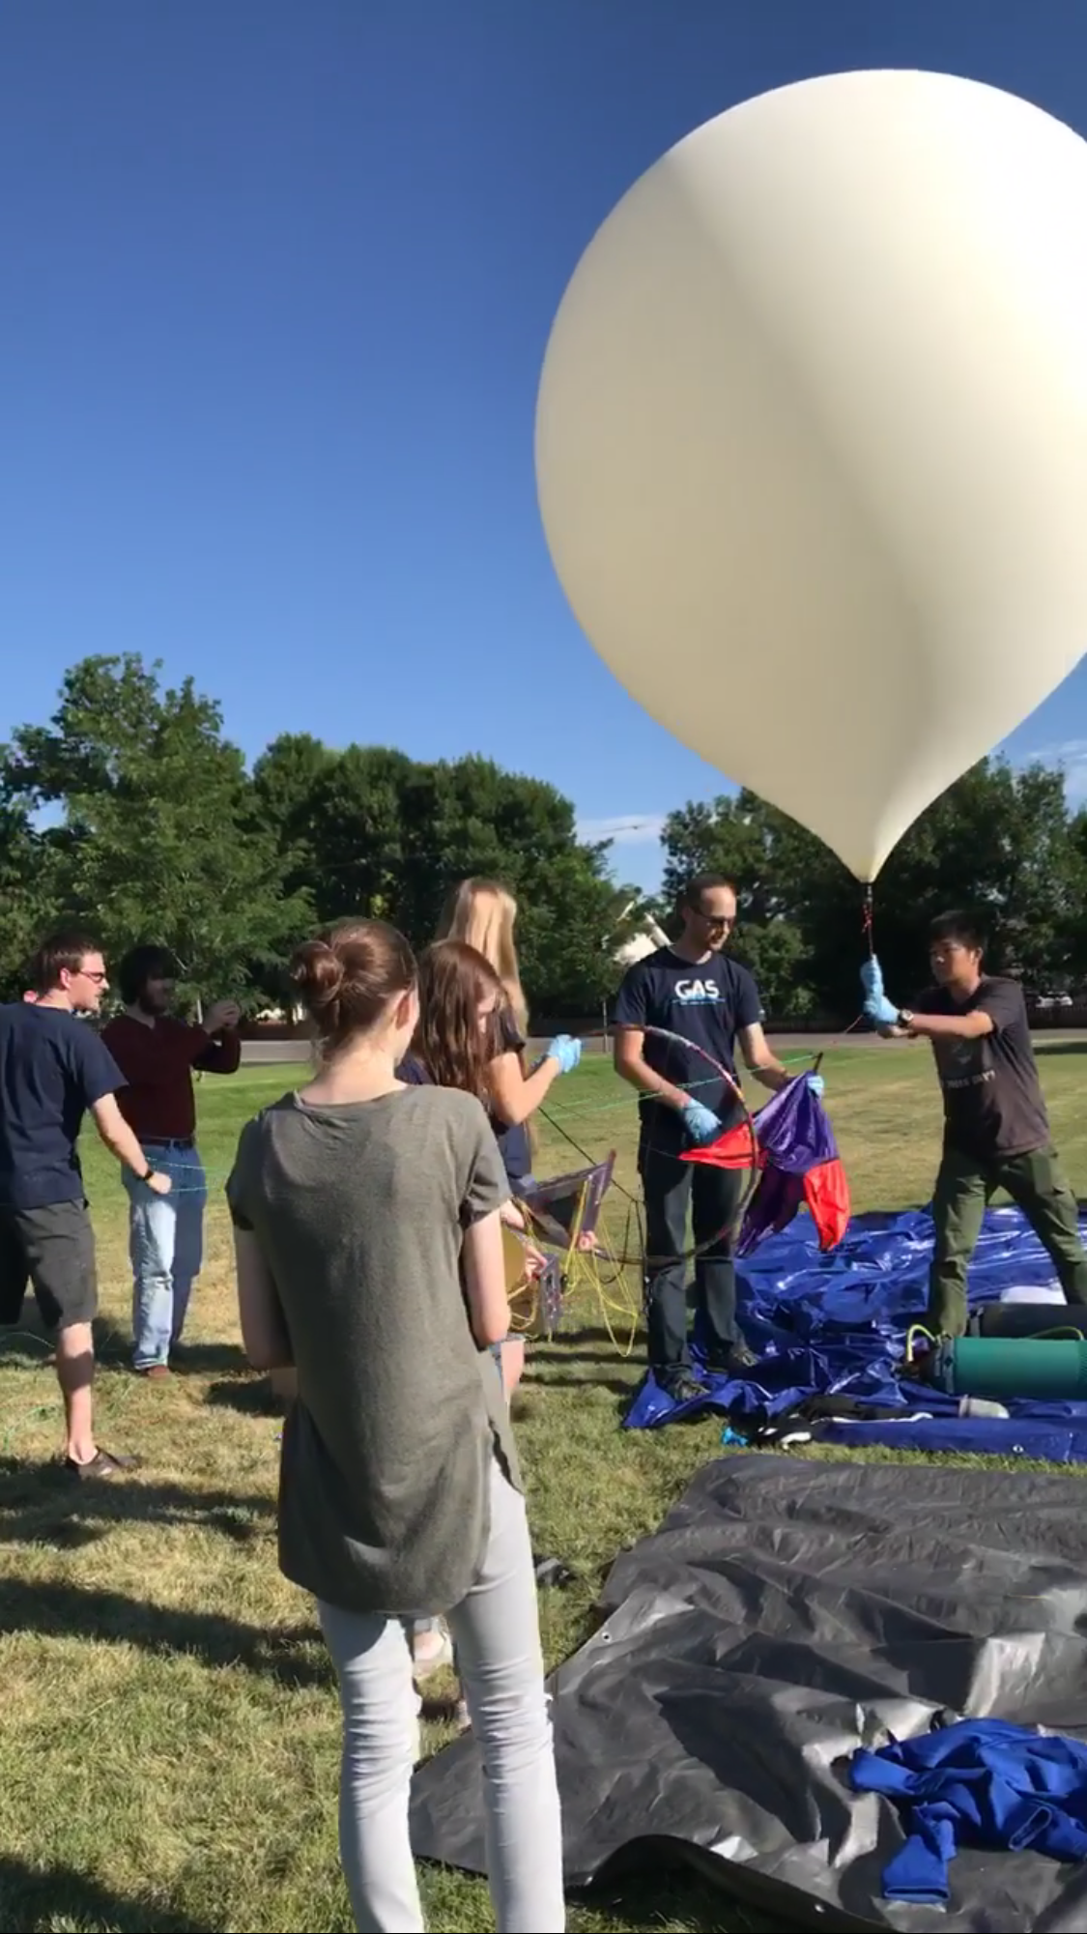

* Be sure that someone is still holding on to the balloon.
* You should first lay out your balloon attachments in a straight line, making sure that there are no tangles in the cords.
* Check to make sure that everything is turned on, including your payloads and tracking beacons.
* Verify that everything has been securely fastened and attached in the correct order. Typically, we have the parachute just beneath the balloon, then our tracking beacons, and then our payload.
* Be sure you have attached a long cord running through the O-ring that attaches the parachute to the balloon. This allows us to pull the balloon back down in case of a last minute adjustment. It also keeps most of the force off of our payload attachments while we are releasing the balloon. (See **Figures 4.3.5-1 & 2**)
* Have a member of the team hold each one of the balloon attachments separately, and carefully release them one by one, starting with the balloon. We do this to insure that the balloon does not take off too quickly, this prevents the payloads from swinging and hitting either the ground or a person.
* Someone should hold onto the cord with two hands until the balloon and its attachments are floating above the ground. The cord will slide through the o-ring and will return to the person holding the cord. If the cord does not slide through; let it go with the payload.

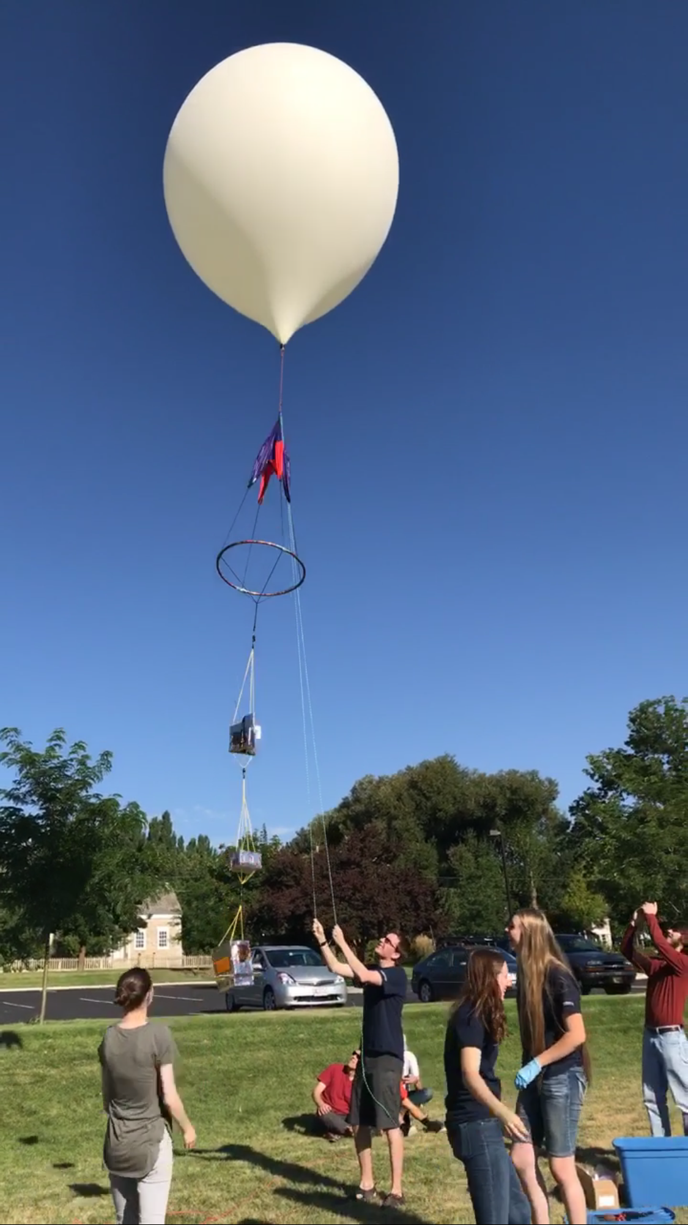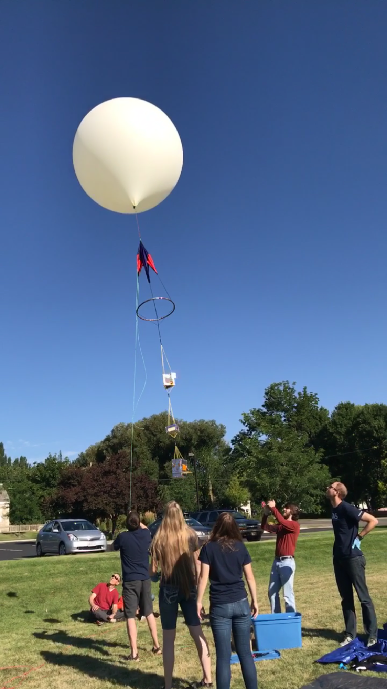

(**Figures 4.3.5-1 & 2**)

### 4.3.8 HAM Radio begins to receive data (aprs.fi)

Depending on the chosen launch site, the payload may or may not appear on aprs.fi while it is still on the ground. After the balloon is launched, the APRS network will pick up the payload’s transmissions, typically after a minute or so.

### 4.3.9 Burst and Retrieval

During the flight of the balloon you should be monitoring the data you are receiving frequently as a team. The balloon often will not fly the exact flight path that was predicted, and may not always burst at the predicted time or altitude. Because of this we actively check the tracking beacon data for its location and altitude throughout its entire flight. You may want to split the team into separate vehicles; be sure to keep in contact with the other groups of the team while chasing the balloon, and set up meeting locations throughout the retrieval process. The balloon will typically burst between 120,000-130,000 feet. Using the tracking beacon data you can monitor the altitude. When the altitude has reached a maximum and starts to descend you can be sure that the balloon has burst. If you are lucky enough, and are good at keeping up with the balloon, you may actually get the chance to see the balloon burst with your naked eye. This has been seen several times by many of our GAS Team members.

When the GPS data has reached a fixed point (the payload is no longer moving), one of two things has happened: either the payload has landed in that location, or you have lost contact with the beacon and it has landed somewhere in that vicinity. The payload can travel surprisingly far after the balloon bursts, carried only by the parachute, so keep an eye on your tracking data and follow the payload. If your payload has landed somewhere in the mountains, the APRS beacon may stop receiving data, though you might still have contact with the other tracking devices. Stick together as a group and get as close to the landing site as you can in your vehicles. You may have to hike, swim, or climb if your payload has landed in a rough area. Be sure to come prepared for the terrain, and do not do anything that may endanger yourself or others. The payload can be difficult to locate. Previous launches have resulted in poor landings such as trees, ponds, corn fields, or archery tournaments. Be aware of your surroundings and look for the brightly colored parachute. Document your retrieval by taking a picture of the payload before you pick it up and share with the rest of the team. Once someone has found the payload, notify all the other team members and reconvene at the lab.

Some things to remember while you are tracking and retrieving your high altitude balloon:

* Stick together in groups, making sure everyone is accounted for and no one gets left behind
* Drive safely, following the rules of the road and keeping off of private property unless given permission
* Only travel in vehicles with drivers that have completed the training and have been approved by the school

#### 4.3.9.1 Ask permission from landowner

The payload will sometimes land on private property. Once you have verified the landing location, it is important that you contact the landowner for permission to retrieve your payload. As excited as you might be, you should not trespass even if you know exactly where your payload is. You may have to knock on doors to find a landowner or ask people in the vicinity if they know whose land it is. There is also a website you may use to identify landowners for a given area: <http://66.232.67.238/Websites/Parcel%20and%20Zoning%20Viewer/>

#### 4.3.9.2 Bring Snowshoes, Swim Trunks, and a Really Long Pole

As stated previously, the payload can be difficult to locate and will sometimes land in very unfortunate places. It is almost impossible to prepare for every possibility that you might see in a landing but here are some tips:

* Bring clothing for both HOT and COLD weather
* Wear comfortable shoes that you wouldn't mind hiking in, getting muddy or wet
* Bring plenty of WATER, and snacks if you have to hike
* Swim suits may or may not be appropriate
* Bring a really long pole in case you have a landing in a tree, or a difficult to reach place (A stick-clip for rock climbing would be a good tool)
* If you can see by the data that the payload has landed somewhere that requires gear you do not have, it is okay to make a stop to grab something. We have even had team members rent snowshoes in order to retrieve a payload.

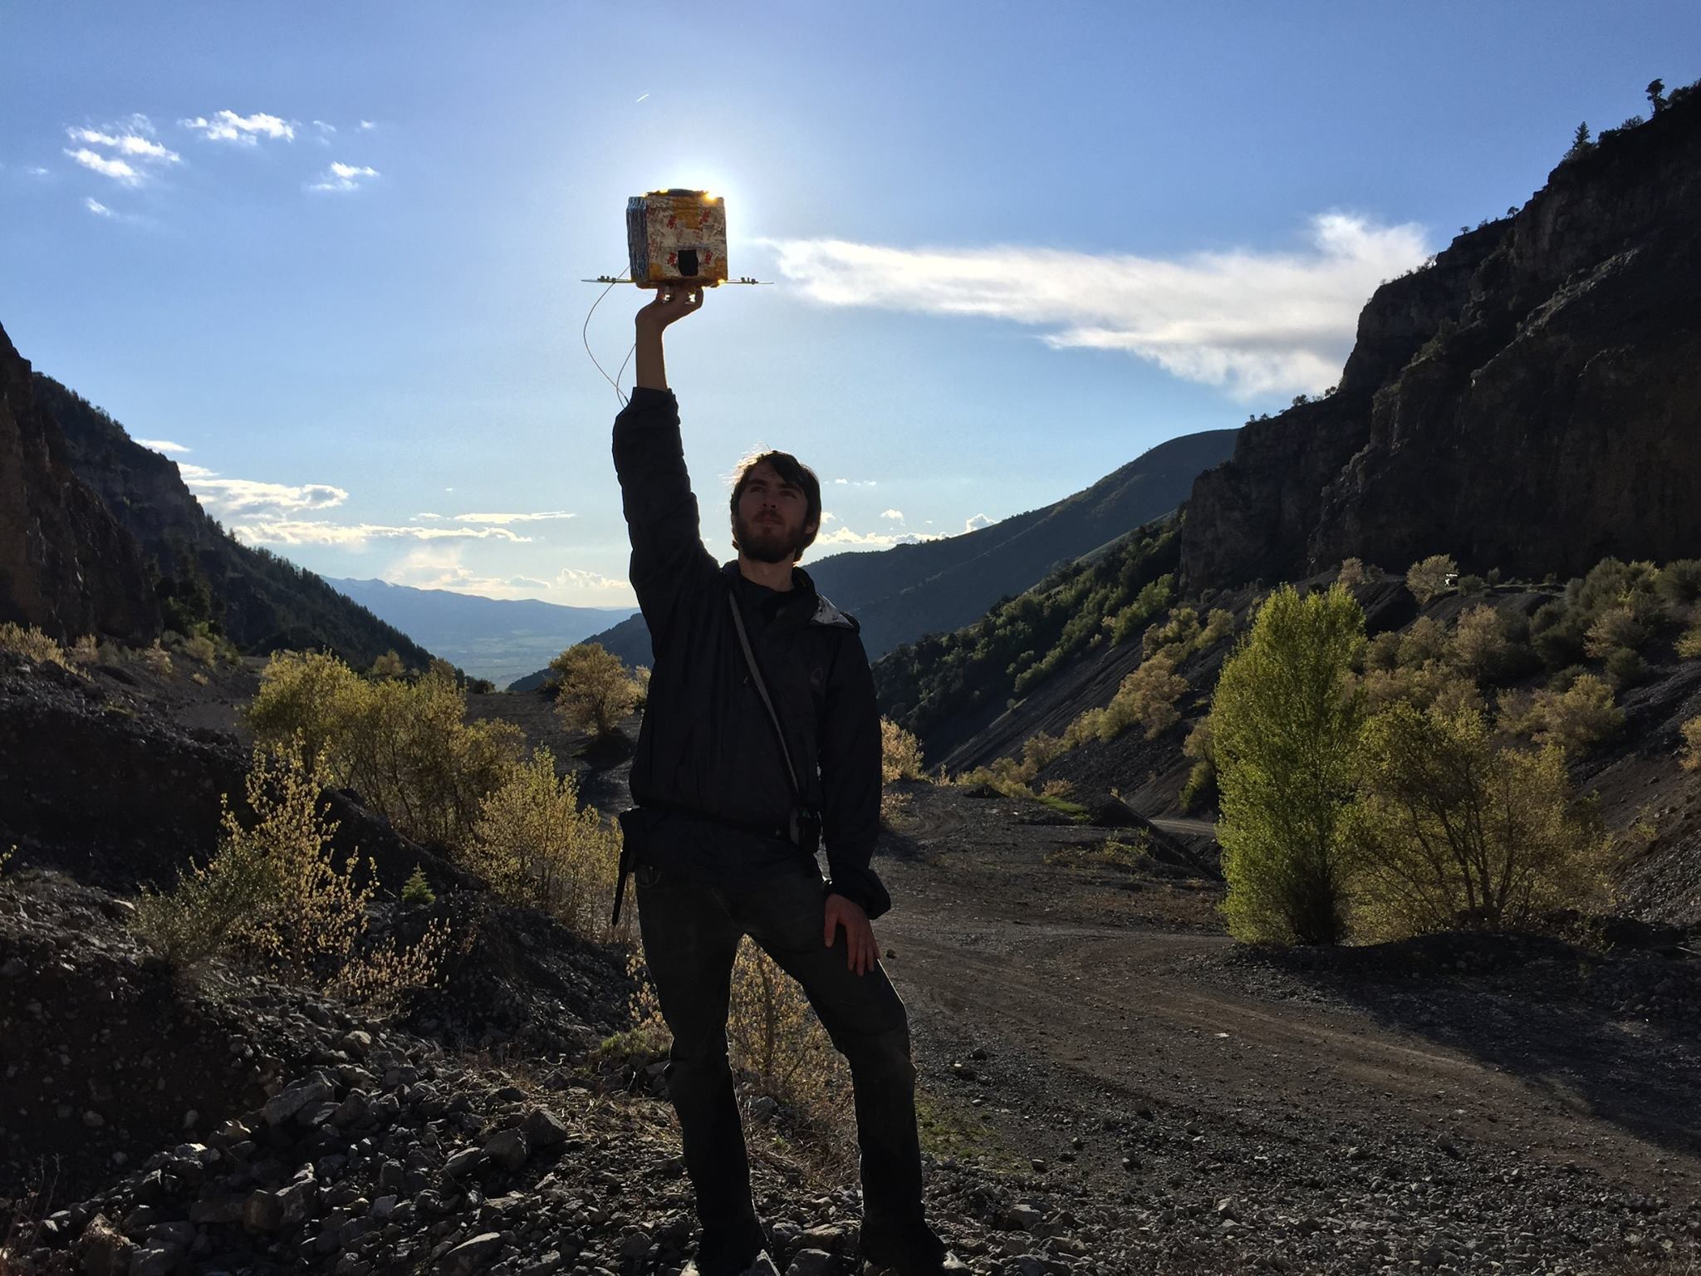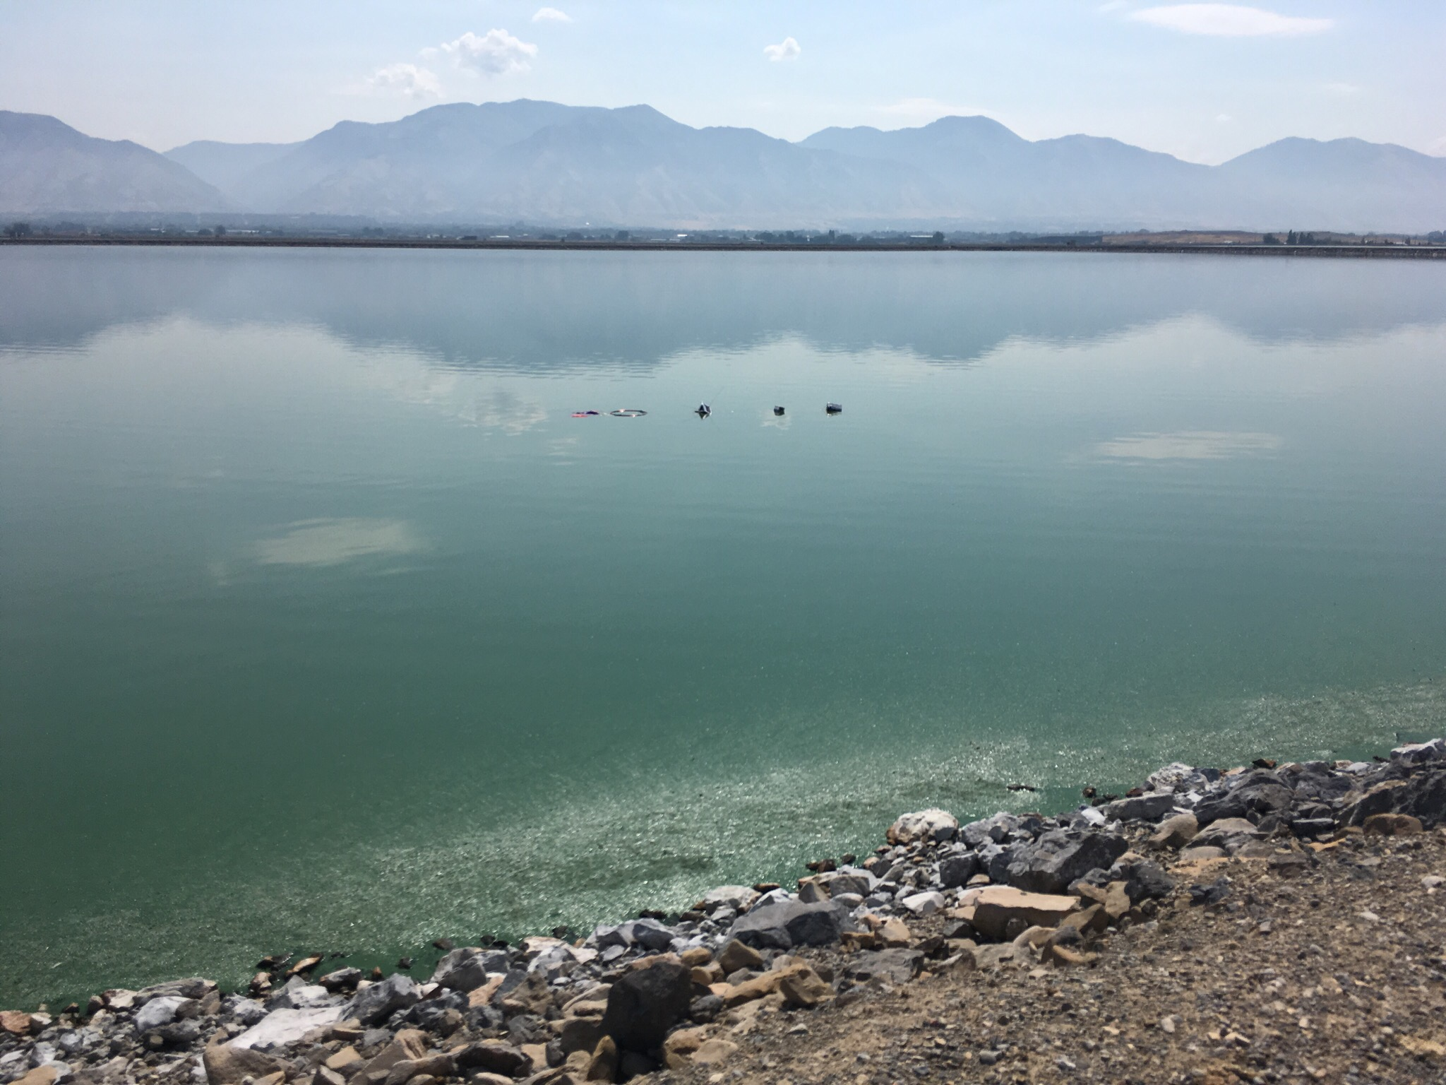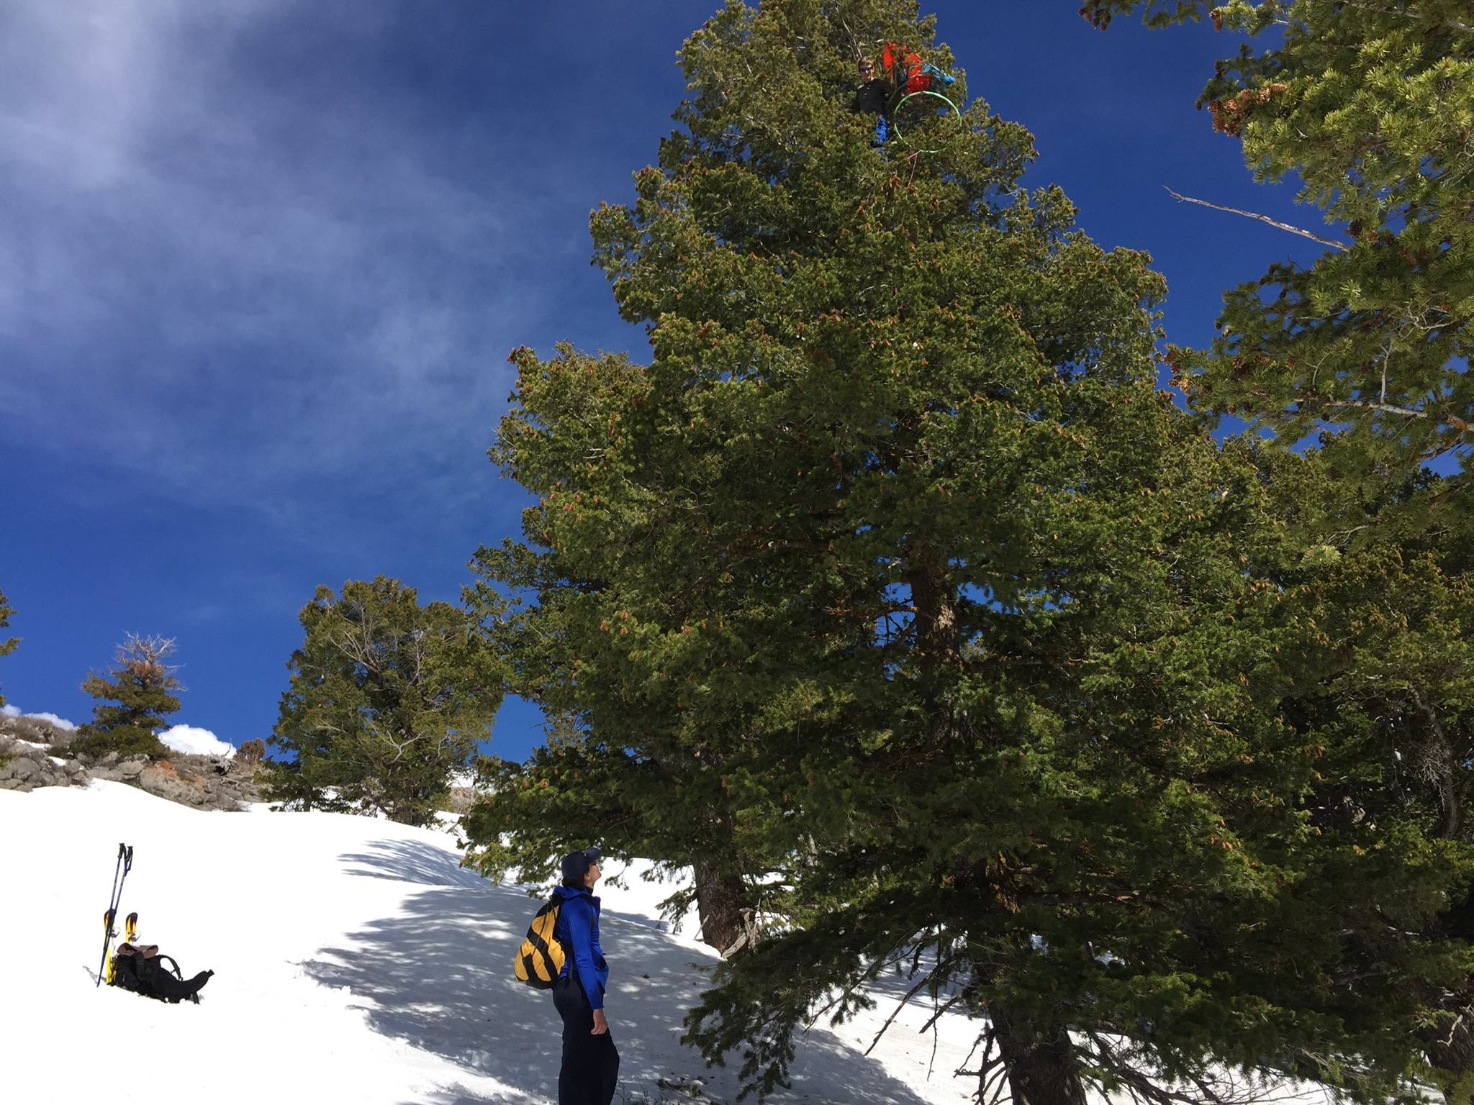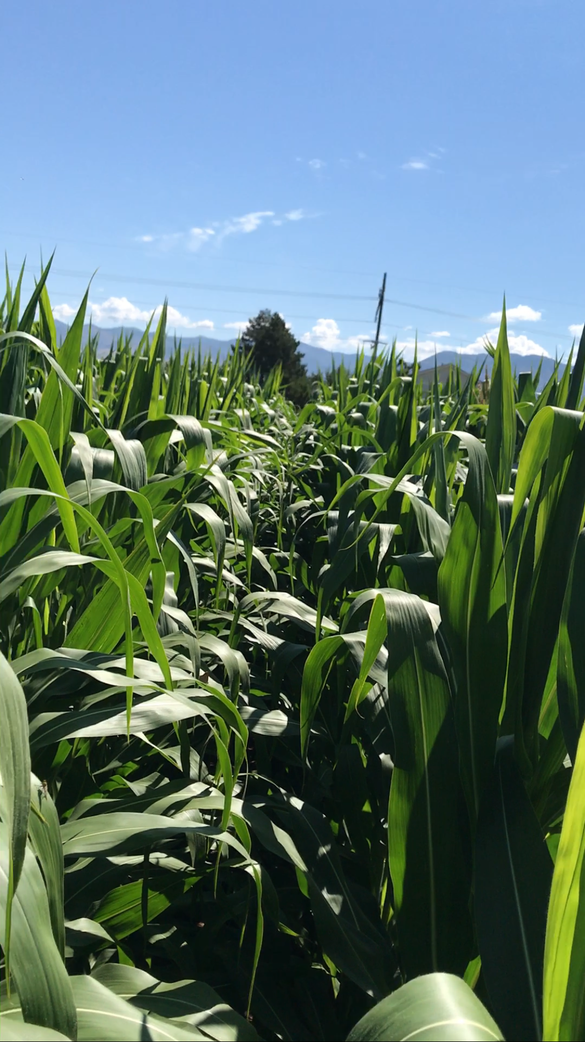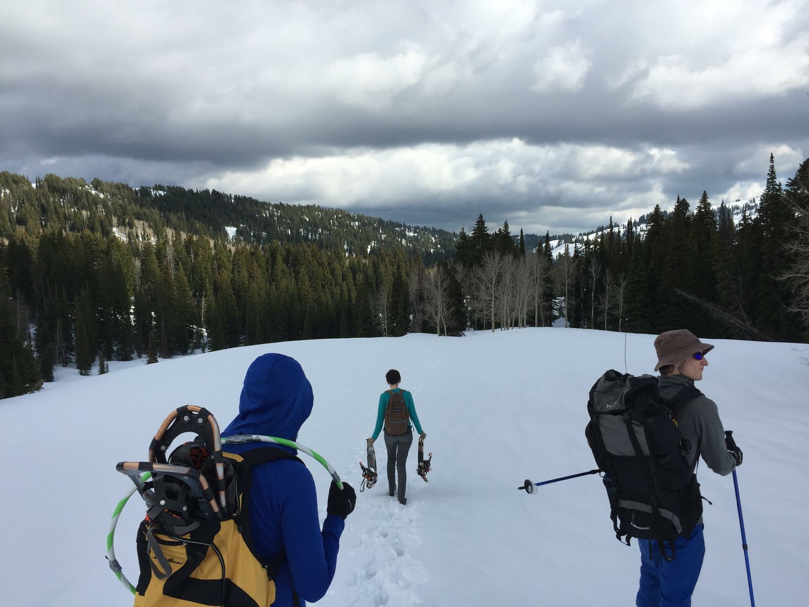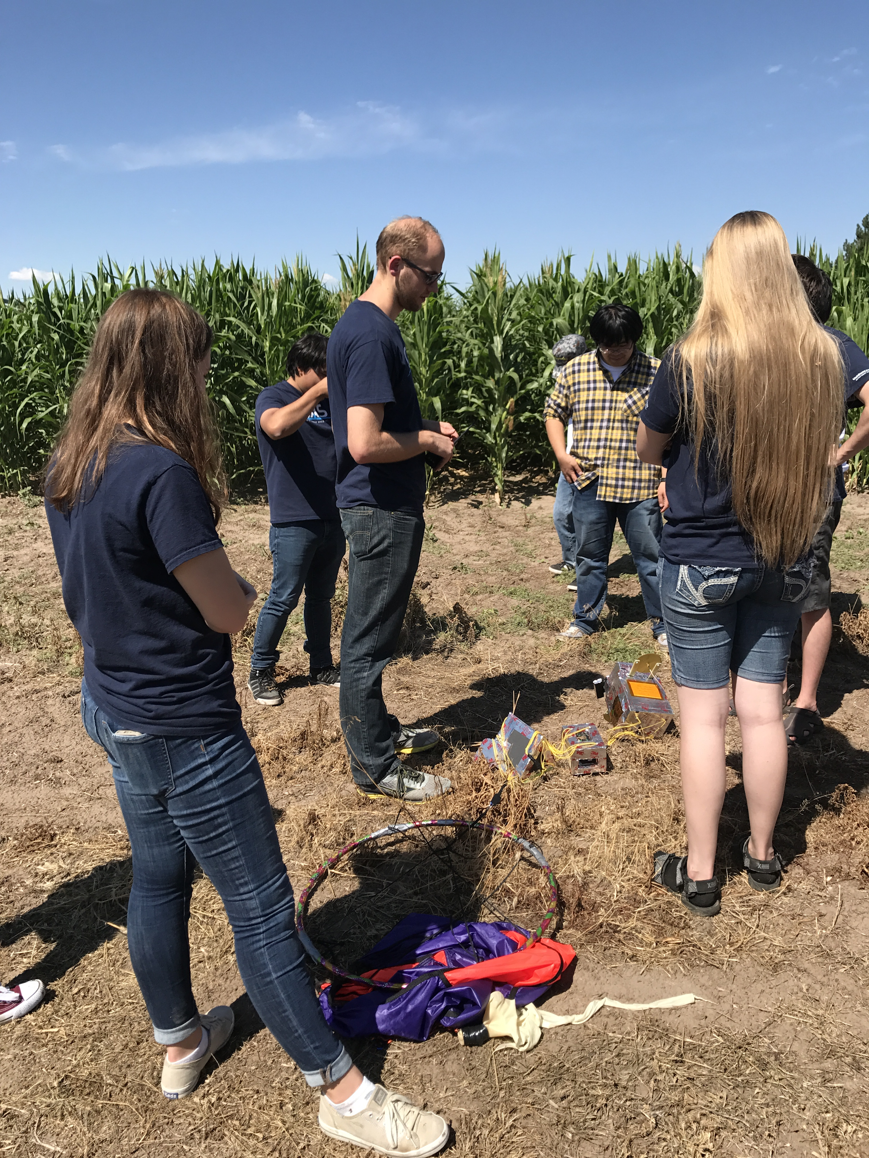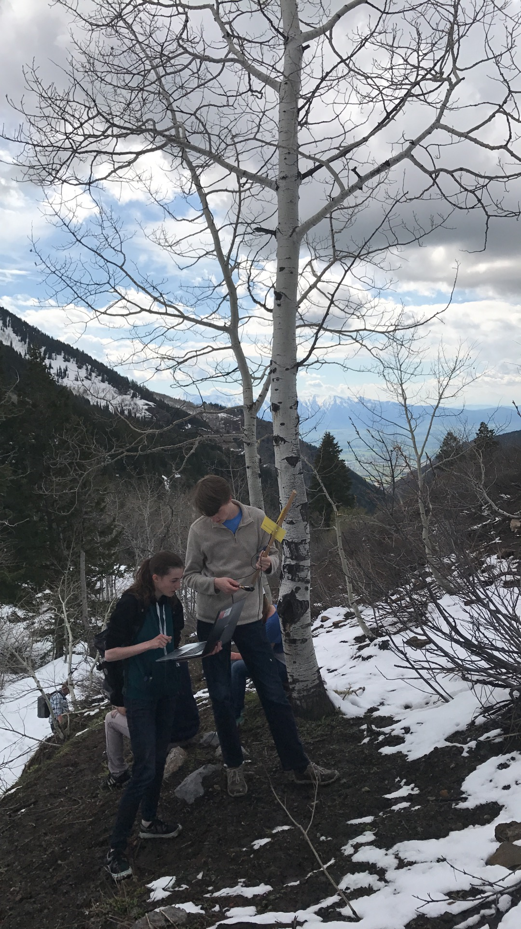

## 4.4 After flight

### 4.4.1 Documentation

For the benefit of the current team, and teams to come, document everything. Write up a report that not only identifies where and when launch and retrieval happened, but identifies challenges, what was learned from them, and the results of the flight itself. Make a document that would give a member of your team who was not present for the flight a perfect picture of what happened. From this document, you should be able to identify changes to be made for the next flight.

The documentation for all ERRNO flights this season can be found in **Appendix 3**. The first flight report, which is given in **Appendix 3.1**, was written well after the flight, and is therefore a bad example of documentation. The report in **Appendix 3.2**, however, is a perfect example of thorough documentation.

# 5 Tracking Payload

The GAS Team uses two methods to track payloads: an Automatic Packet Reporting System (APRS) beacon and a fox beacon. The APRS beacon sends a packet every 90 seconds that contains its telemetry which is picked up by the APRS network and recorded online. The team can follow the path of the balloon on aprs.fi/errno. When the payloads have returned to ground, the fox beacon in conjunction with a directional antenna can be used to locate the payloads if the last APRS packet does not have accurate enough GPS coordinates.

To set up a tracking payload, a team must first purchase the radio beacons and then must have a Ham licensed team member to provide a callsign for the beacons’ use. The APRS beacon we use is the Byonics Micro-Trak 1000; it can be purchased at <http://byonics.com/mt-1000>. The Fox beacon we us is the Byonics Micro-Fox 15; it can be purchased at <http://byonics.com/mf>. The Byonics website has software that can be used to alter the beacons’ programming. In order to program the beacons’ with your call sign and change the transmit frequency you will need a usb programming cable. This cable can be purchased in combination with the Fox beacon. The same cable can be used for both beacons.

The APRS beacon can be reprogrammed using <http://byonics.com/downloads/tt3_config_v1.4.6.zip> and a USB serial cable. The Fox beacon can be reprogrammed using <http://byonics.com/downloads/microfoxconfig_v1.65.zip> and a USB serial cable.

The team then needs to construct a housing for the beacons which allows minimal interference between the tracking payload and whatever payload the team wishes to launch.

# errno.jpg

# 6 ERRNO

While this document is not intended solely for GAS team use, it will also be used by current and future generations of the team. As such, this section contains information concerning the current testing platform used by the team.

## 6.1 What is ERRNO?

ERRNO (a lighthearted backronym for Elevated Real-time Research Near-space Observer) is a prototype CubeSat platform that the GAS team began using in the hot summer of 2016. Since then, it has been the primary platform for our HAB flights.

ERRNO is a system powered by an Arduino Mega that collects scientific measurements from various on-board sensors and handles the deployment and observation of prototype aerobooms. As sensors collect data, the system will write the data to an SD card before also beaming it to our ground station via radio. When it detects that the time is ripe to deploy the aeroboom based on filtered barometric pressure readings, it will do so and proceed to take several photos.

## 6.2 Setup

Before any testing or flights can be done, ERRNO itself must be set up. When setting up ERRNO, three things are absolutely necessary to remember. The first is that the most current working code should be uploaded to the Arduino Mega. Second, a clean and formatted mini SD card should be placed inside the card reader. Finally, the radio dongle must be attached and should transmit when power is connected to the circuit. Some secondary setup may also be necessary, depending on the test or flight. These secondary setups include: attaching all sensors, connect loose wires to the secondary wire cutter, connect loose wires to the boom box, and mounting the Raspberry Pi and Pi-camera.

The code for ERRNO is contained at<https://github.com/SmallSatGasTeam/errno_3>. The most current working code should be uploaded to the Arduino Mega at all times. This can most easily be done from a computer in the lab, specifically the computer currently located on the electrical table. Sign in to a user that has the code cloned onto the local machine and has all dependencies installed and updated (most notably platformio and FreeRTOS). Open up a terminal and navigate to the working directory of the cloned repository. Two commands are important to remember: “platformio run” and “platformio run -t upload”.

By executing “platformio run”, the code in the current branch is compiled. Platformio will return whether the compilation was successful or not. If successful, you can then execute “platformio run -t upload” which will compile and upload the code to the Arduino Mega if it is connected to the computer. Anytime power is introduced to the circuit, the Arduino should automatically run the code. It will attempt to save the sensor data to the SD card and transmit the data over the connected radio.

To save data to the SD card, a mini SD needs to be inserted into the SD card reader on the top circuit board, next to the Arduino Mega. The SD card should be suitably formatted for read and write, but otherwise clean of any other files or folders. When the Arduino Mega powers up, it will autonomously create the necessary .CSV files for each of the sensors. When extracting the data by plugging in the mini SD card into a computer or laptop, these .CSV files will open up as spreadsheets. Any error or misuse of the mini SD card will result in a loss of data, so setup is extremely important and testing should be done before each flight.

The radio dongle should be connected to the circuit board as well. If transmitting across any lengthy distance, the two radio “antenna” should also be connected. They can be screwed into place on the radio dongle itself and the antenna are often mounted on the bottom of the payload beneath the boom box. To test that the radio is transmitting, the paired dongle and a receiving antenna should be connected to a computer that can run PuTTY. The radio will be connected serially on 9600. The only thing the user needs to know is what serial port the dongle is connected to. Generally, it is some variation of “ttyUSB0” for a UNIX based machine, but some work may be required to find out for sure. If the correct serial port and frequency is inputted and the radio dongle has connection to its counterpart, data should be outputted to a terminal opened by PuTTY.

If everything on the primary setup is completed, some secondary setup may also be required for the test or flight. There are two sensors that are easily detached from the payload: the UV sensor and external temperature sensor. They dangle on extended wires with the light sensor, since all three need to be without the insulation box in order to give accurate readings. The GPS also needs to be attached if the test or flight will be recording and transmitting that data.

The secondary wire cutter is on a separate board from the main three. Wires leading off of the secondary wire cutter can be attached to wires coming off of the main circuit and boom box. Each of the wires should be marked with masking tape labels. Similar labels will be connected together. The boom box will also be connected to the main boards with two wires as well. One wire represents the primary wire cutter and the other wire is the boom switch. By following the labels, everything can be connected and tested appropriately.

Finally, if the test or flight requires pictures to be taken, that functionality has been outsourced to a Raspberry Pi and Pi-camera. The Pi-camera has a place on the bottom of the payload that it can be screwed in to. The Raspberry Pi can be mounted on an empty shelf above and will need to have its own power source. The code currently on the Raspberry Pi will run on startup and takes pictures every 30 sec. The code is a basic Python script and config.json file that can be modified as necessary by connecting a monitor and keyboard to the Raspberry Pi. The script can also be found at <https://github.com/kylehovey/ERRNO_Picture_Daemon>.

If all setup goes smoothly, then ERRNO is up-to-date and ready for any tests or flights.

# 7 HAB-Stack

Much like the previous section, this section exists to provide information concerning a current GAS team project.

## 7.1 What is HAB-Stack?

The GAS team is currently collaborating with Tony Messina and Ed Galindo of the University of Idaho to fly and test a flight-ready, modular sensor board known as HAB-Stack. HAB-stack’s purpose is to serve as a ready-made HAB payload meant to lower the bar of entry for ballooning.

The boards include sensors for temperature, humidity, radiation, pressure/altitude, and gyroscopic data. A data-recording main board includes a full SD-card reader for permanent storage. The board itself can be programmed using the same language used for Arduino (which is a slight mutation of C++).

## 7.2 Setup

HAB-Stack starts with plugging the desired boards into the bottom data recording board. The order of the boards does not matter as long as the data recording board is on the bottom. The upper boards only fit together in one way, so making a mistake is nearly impossible. When inserting and removing the boards, be sure to lift/push with perpendicular force to the bottom board, as to avoid bending the pins. Next, insert a blank, full size SD card into the SD reader on the data recording board.

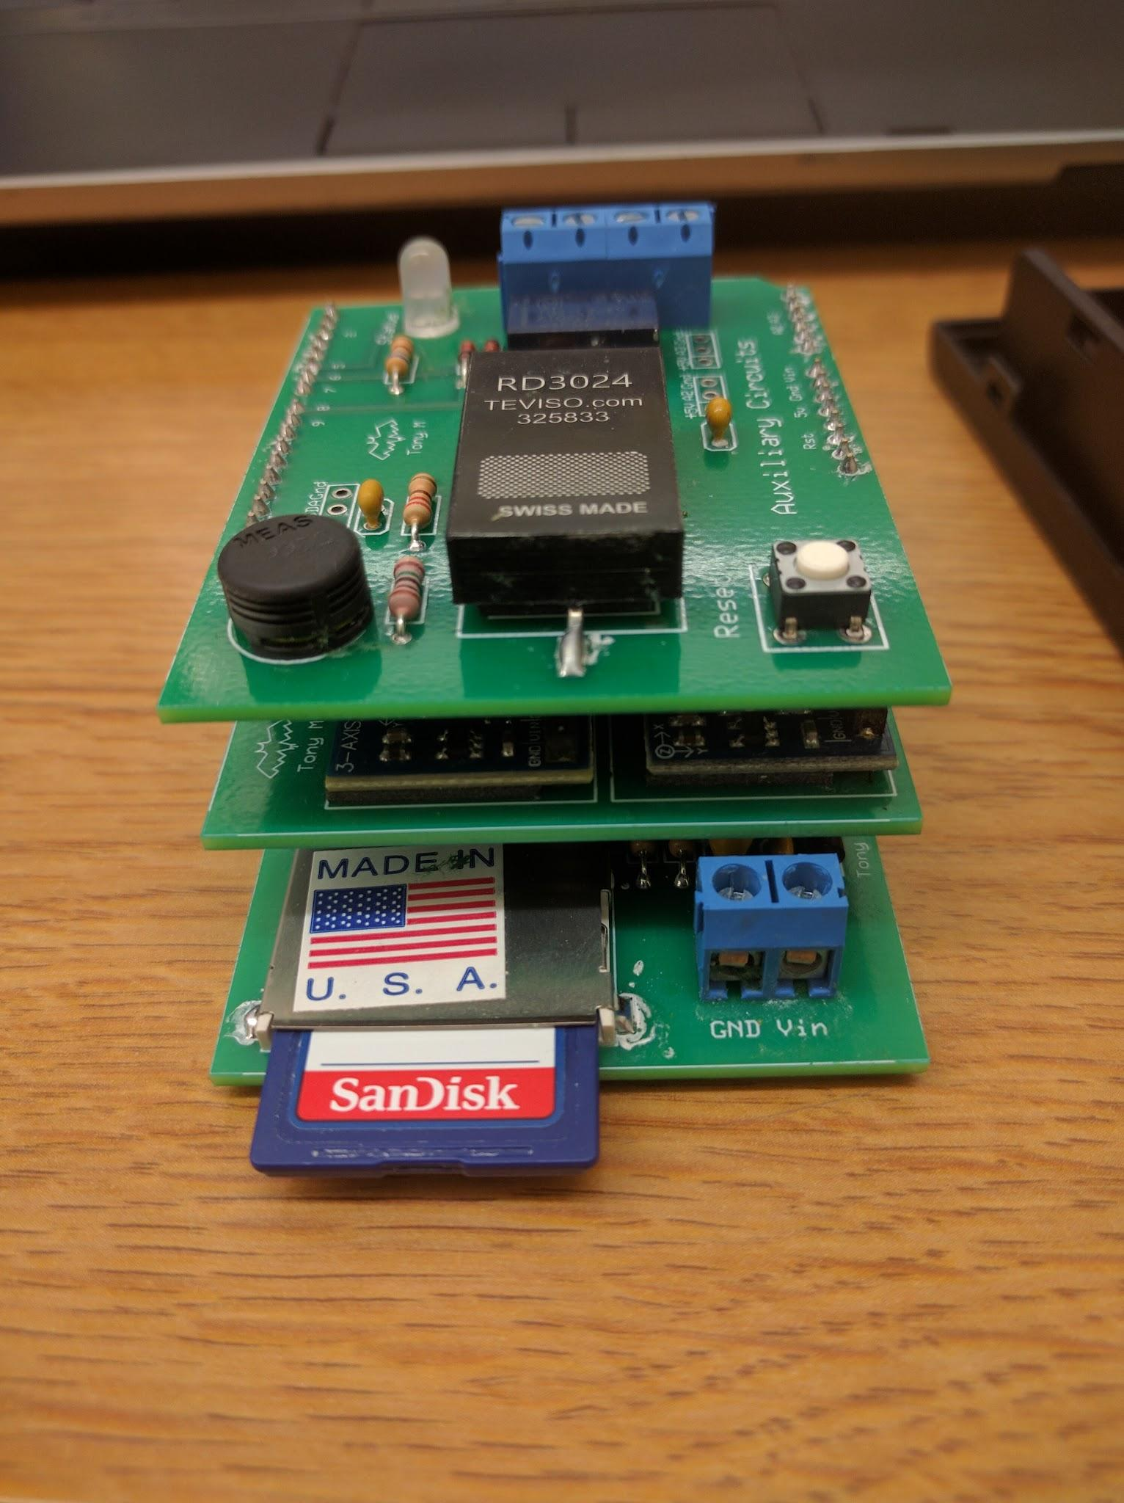

Neighboring the SD card reader is a blue block with two screw-down wire holds labeled GND and Vin. This is where your power and ground lines will be connected. The HAB-Stack takes 6 AA lithium ion batteries in series for a total of 9 V of power. The batteries are typically loaded into a battery array (pictured below) that connects them for you and provides ground and power wires. When examining data, slightly less than 9 V is nominal, and the HAB-Stack tends to operate well above 7.5 V. Below that, usually because of cold, it will restart often or refuse to boot.

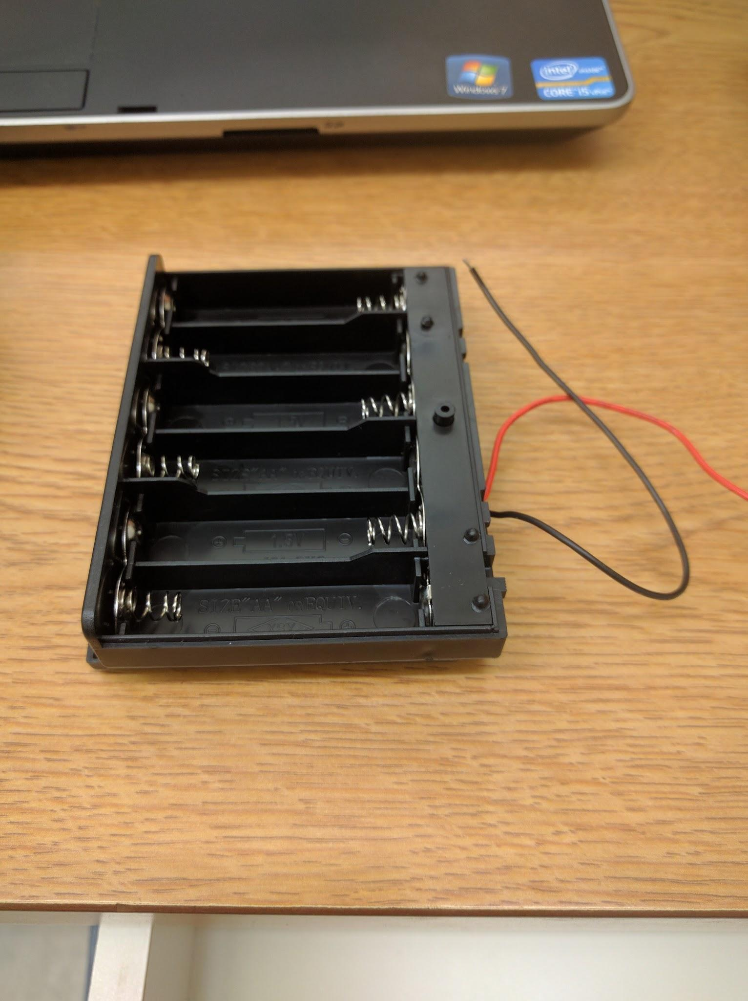

Once the batteries are properly connected to each other, unscrew the wire holds on the HAB-Stack from the top using a small flathead screwdriver and place the wires through the holes below. Once inserted, screw them down to hold them in place and the HAB-Stack should be powered. This completes the physical setup of the HAB-Stack. To keep the HAB-Stack from being torn apart, place the HAB-Stack on top of the battery box and wrap electrical tape around the bottom of the battery box and wrapping around the electrical boards at least four times, until it feels as if it would not separate if vigorously shaken inside of a box.

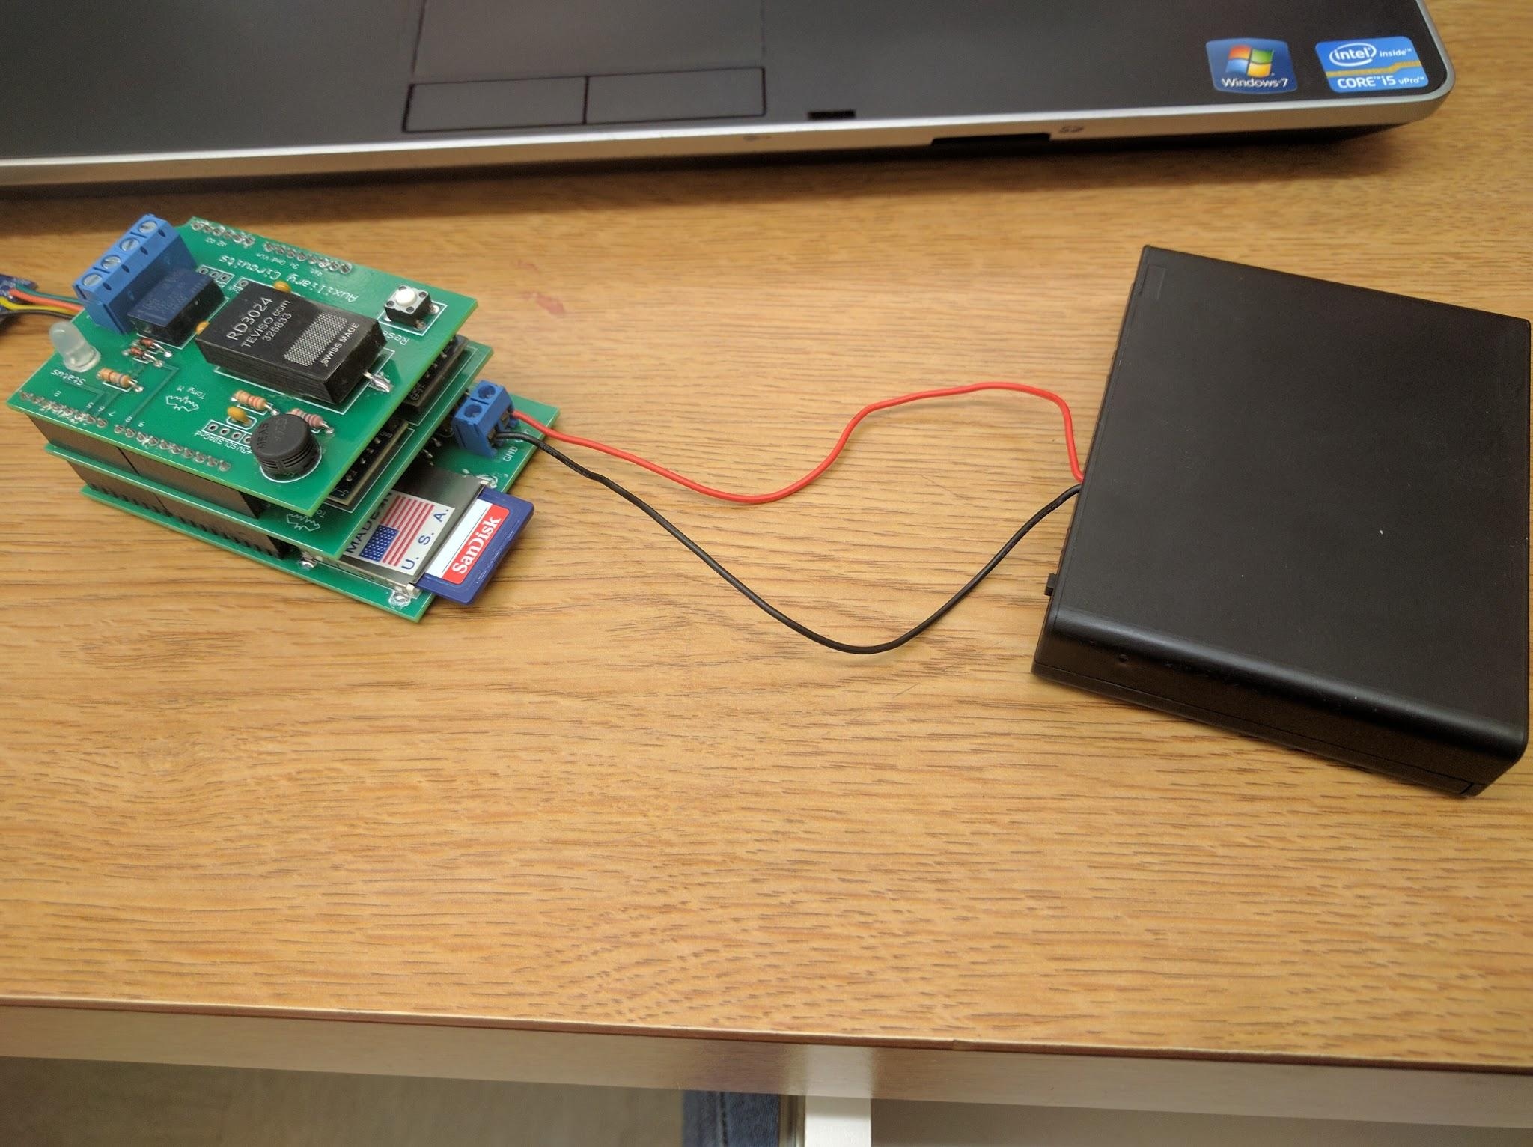

To install the sample software and libraries onto the Stack, follow these instructions:

1. If you do not already have it, acquire the Arduino IDE from <https://www.arduino.cc/en/Main/Software>. Copy all of the library folders on the Google Drive under HAB Stack/Sample Programs to the Arduino /libraries folder on the computer you wish to use with the HABStack. The libraries you need to support the HABStack include: MMA_7455 , RTClib , SD , and I2C . Only the SD card uses the SPI port. All of the other peripheral / sensor communications are either direct pin interface, or I2C.

2. Copy the 4 program folders found under Arduino Program Folders in the archive to your Documents/Arduino/ folder.

These are:

HAB_ALT : This program runs on the full stack and outputs the altitude

to the Serial monitor. There is another file - IntersemaBaro.h

in this program folder that is required for the support of the

altitude sensor. This file also needs to be in any program folder

that is working with the altitude sensor.

HAB_AUX : This program works primarily with the Auxiliary Circuits deck,

but the full stack is fine. The program creates a text data file

on the SD card and logs the date, time, temperature in C & F ,

the raw data from the humidity sensor, the radiation count from

a 20 second sample period, and the battery voltage. This data is

recorded every minute. An important feature of this program is

that it has the time setting routine, which looks for a special file

on the SD card that is used to set the date and time of the RTC.

HAB_MAX : This program uses the full stack and writes the raw data from all

of the HAB sensors to a text data file at one minute intervals, This

program does NOT have the time setting routine though, as code

space was getting tight. This program would be a good test flight

program in that it would collect all of the raw data that the

HABStack can generate at one minute intervals.

HAB_NAV : This program uses the full HABStack. It will continuously output the

raw data from the Accelerometer, Compass, and Gyro sensors to the

serial monitor.

These programs were meant to test the HABStack during development, and to provide commented example code for the development of specific flight programs by the team that works with the HABStack. These were not meant to be "final" flight programs, as those would need to be crafted for the actual flight requirements.

3. Copy the *datetime.txt* file onto the SD card provided with the HABStack. This file will be used later to program the real time clock in the HABStack with the correct date and time. Whenever you work with the text files used with the HABStack, you should use windows notepad as the editor. Other editors may insert non-text characters that could impeded the proper operation of the HABStack programs using these files.

4. Connect the FTDI programming module to the HABStack. Align the connectors so that the black wire from the FTDI board is connecting to the HABStack pin marked ground. Procure a USB cable that can be used to connect the FTDI module to the computer you are using for the HABStack.

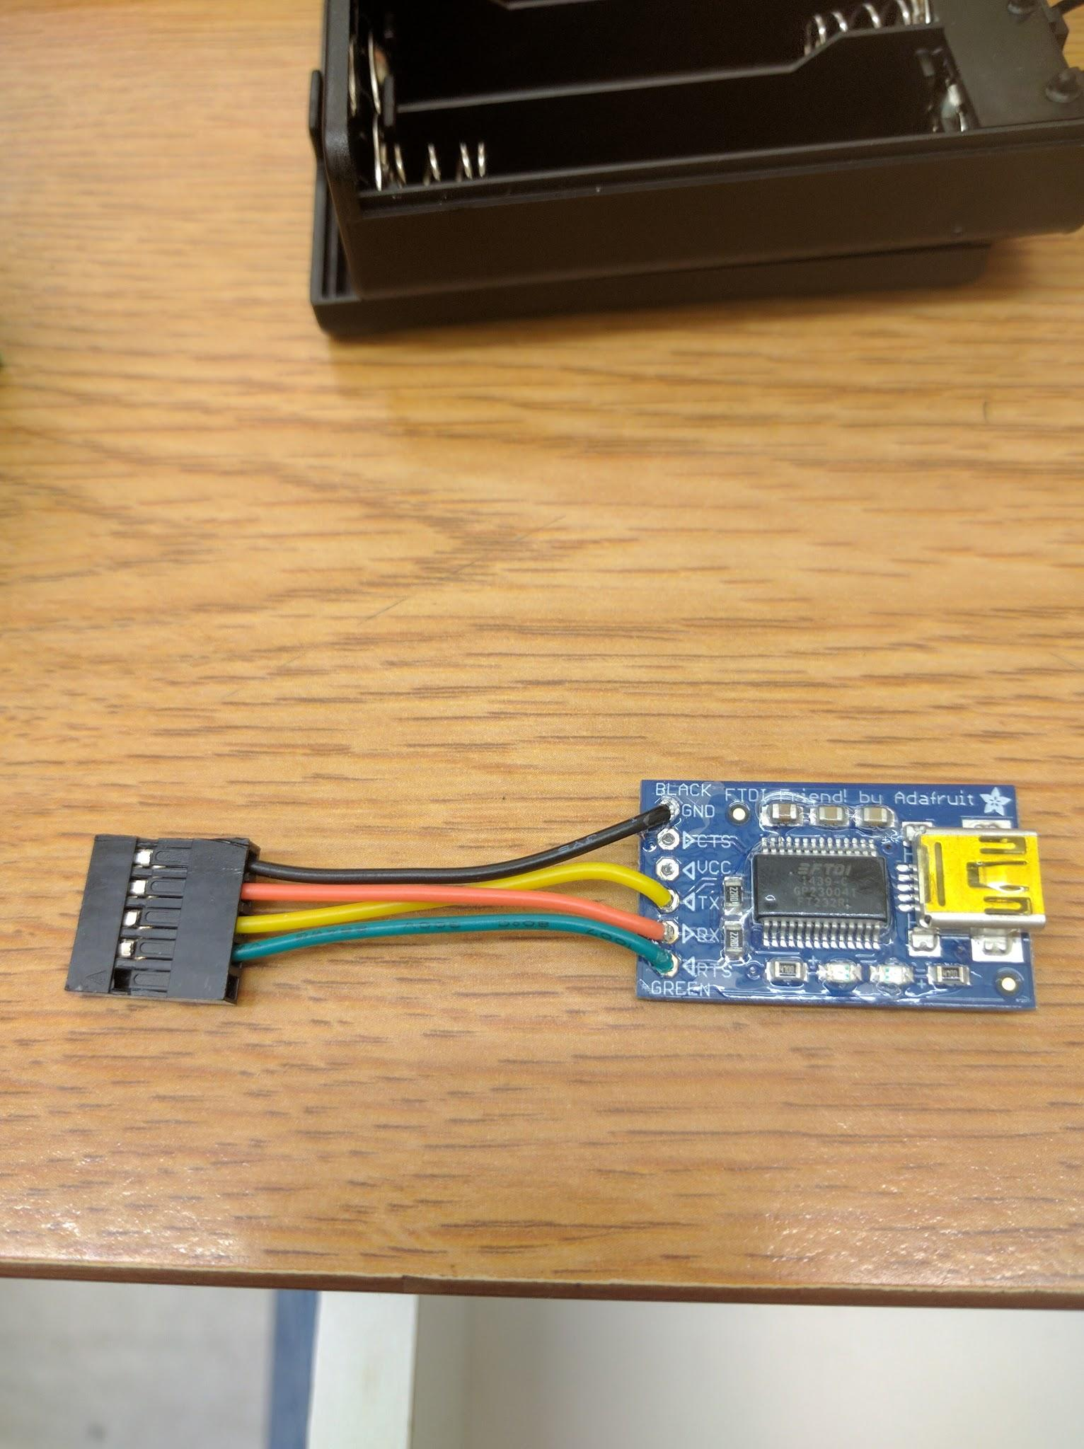

5. Connect the HABStack to its battery, and connect the HABStack and its FTDI module to the HABStack support computer. Run the Arduino IDE program. Set the Arduino IDE to work with UNO boards. The HABStack basically functions as an Arduino UNO R3.

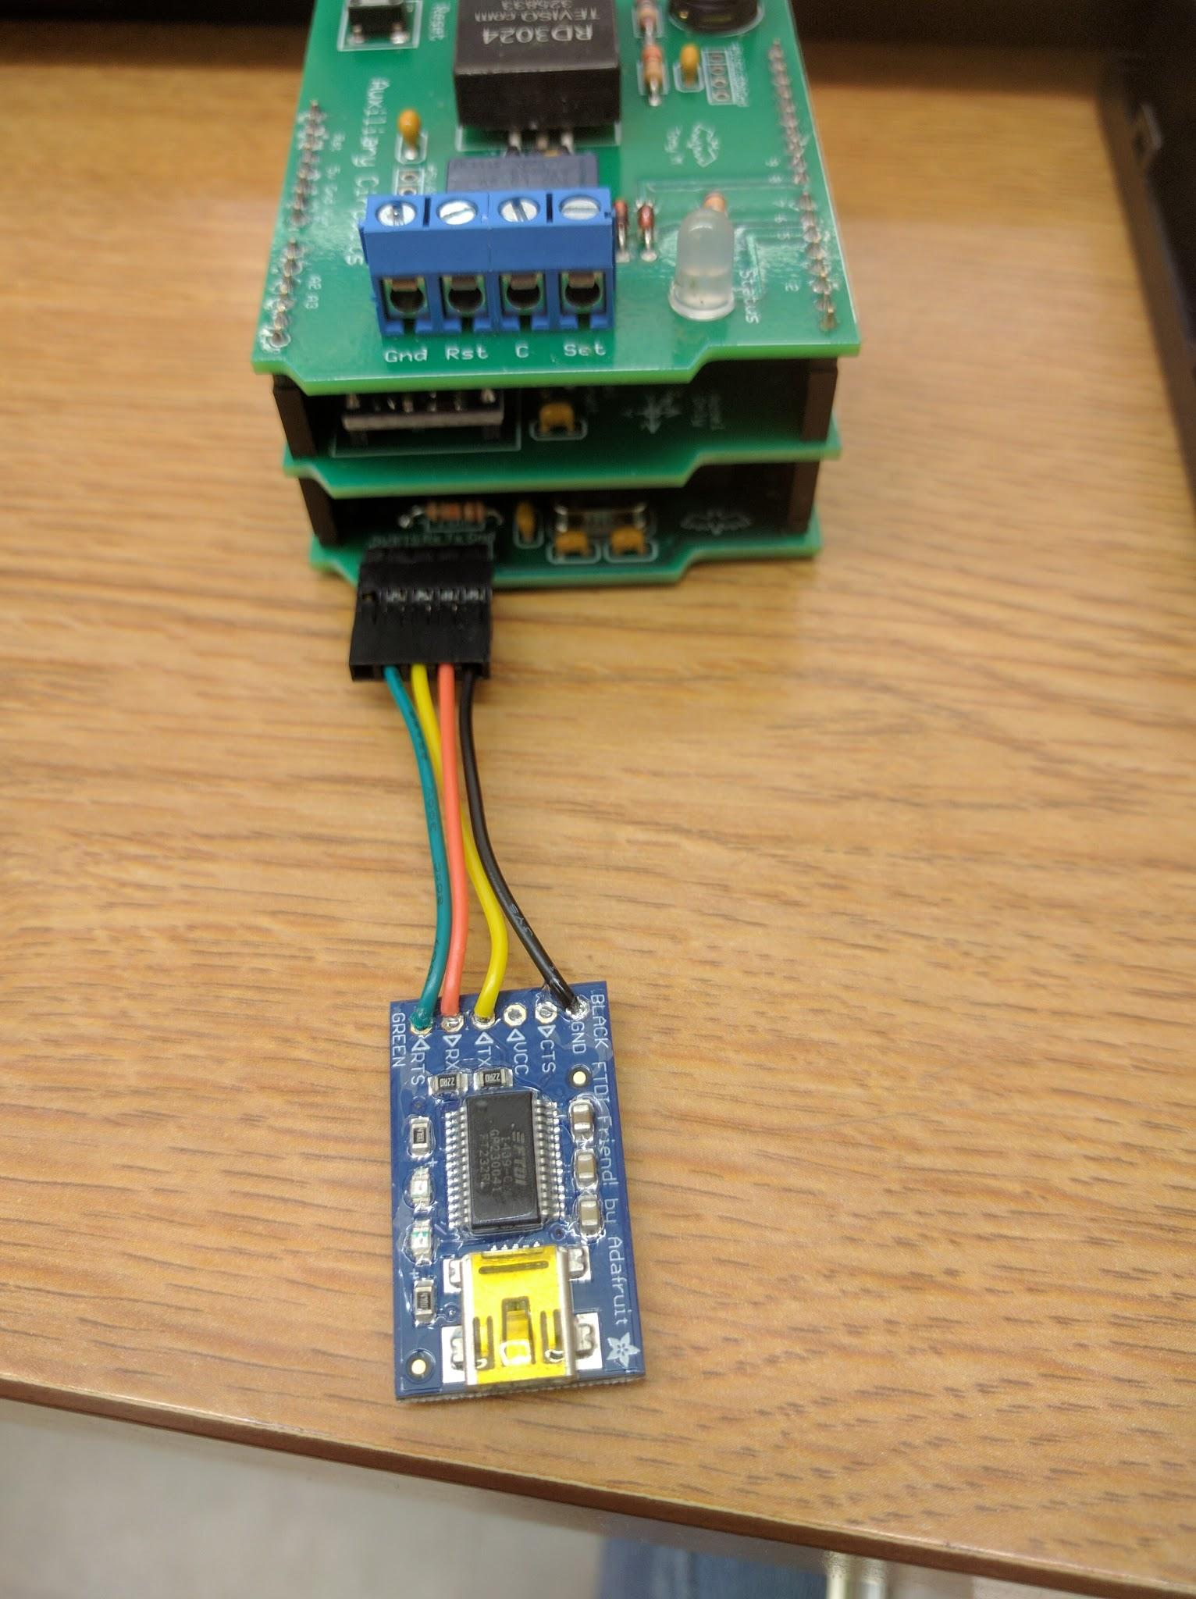

6. Open the HAB_AUX program in the IDE and load it into the HABStack. This program will set the RTC according to the time and date that the program was loaded, so the RTC will be running, but it may not be set as you wish.

**SETTING THE RTC: To set the time and date of the RTC follow these steps:**

**HAB_AUX MUST BE RUNNING ON THE STACK**

a.) Edit the *datetime.txt* file on the SD card for the HABStack so that it has the exact date and time you wish to set the HABStack to. Give yourself some extra time to perform all the steps that follow. Follow the exact format in the text file, keep the same spacing, and do not add spaces. The text file actually has some included pointers for its use.

b.) Save the edited file with the name *datetime.set*. This is the filename the HABStack will look for to set the RTC date and time. If there is a *datalog.txt* file on the SD card, either delete it or rename it.

c.) Now is the tricky part. With the SD card removed from the HABStack, fire it up ( you should have the HAB_AUX program loaded ). Watch the clock that you are synchronizing with ... hold down the Reset button on the HABStack Auxiliary deck, and install the SD card. When the sync time occurs, release the Reset button, and the HABStack program will read the datetime.set file and set the RTC. After the RTC is set, the datetime.set file will be deleted by the HABStack program. This keeps the program from repeatedly resetting the RTC when the program is run.

d.) If these steps went the way they should, you should be able to see that a *datalog.txt* file was created at the time you set in the *datetime.set* file - and that file will have been deleted.

7. At this point you will have a fully configured HABStack. Load and run the other programs as desired to see how the HABStack functions. If you wish to test fly the HABStack with one of these example programs, I would recommend the HAB_MAX program be used.

If you have found that the coin cell battery powering the real time clock has died, carefully separate the bottom deck of the HABStack from the other decks. Once the bottom board ( the data recorder ) is free, install the *2020 3V* coin cell battery. The + side should be up. Once it is seated, the decks can be re-stacked. It shouldn't be necessary to separate those decks again, as the RTC battery should last for a year or more.

Refer to Appendix IV for an example spreadsheet that shows the data formatting that will be written to the SD card. If placing the HAB-Stack inside of an insulated box of your making or any other enclosure, be sure to secure it to the bottom well. Three or four 1 inch pieces of strong, rolled electrical tape has done fine in the past.

Appendix I

This section contains detailed information on contacting the FAA. The current FAA Point of Contact for Utah State University is Marnie Escandon; she can be reached at [marnie.escandon@faa.gov](mailto:marnie.escandon@faa.gov) or via telephone at 801-320-2535. Marnie will ask you to fill out a templated Word Document see pages 32 and 33. The following sections need to be filled out:

* Dates of Use - The day(s) of your launch.
* Times of Use (Z) - The range of time that your balloon will be in the air. This needs to be in Zulu (UTC) time.
* Point of Contact - Someone that the FAA can contact with questions or concerns. This person needs to be present at the launch and will notify the FAA of launch, burst, and touchdown.
* Altitude (MSL) - An estimate of the balloons burst altitude.
* Route - A brief description of the high altitude balloons flight path.
* Additional Information - Specific information about your balloon and payloads.
* Internet Position Reports - URL for a website that tracks your payload (we use aprs.fi); however, this is not a necessity. If no URL is provided the coordinator will need to notify the FAA when the balloon reaches certain altitudes (the FAA will provide these altitudes).

**Get Away Special Team Balloon Launch**

**NOTIFY:** AREAS A & B, SECTORS 6, 15, FLMs, OMIC

**DATES OF USE:** Wednesday August 9th, 2017

**TIMES OF USE (Z):** Launch 1400Z-1430Z with operation lasting approximately 3 hours.

**Contact will notify Area B Supervisor at (801)320-2562, 30 minutes prior to launch.**

**POINT OF CONTACT:** Raul Ramirez, Utah State University, Cell phone: 801-708-9475

**ALTITUDES (MSL):** SURFACE TO APPROX. 115,000 Feet

**ROUTE:** Launch from Bothwell, Utah heading E ~20 Nautical Miles to landing SE of Mendon, Utah.

**REPORTS:** POC will report the following progress points:

* Launch
* Burst
* Touchdown

**ADDITIONAL INFORMATION:**

* Balloon: 1600 gram latex balloon
* Total Length – balloon + parachute + payload ~ 30 feet
* Payload weight: 2.27kg
* Parachute length including suspension lines: 10 feet
* Parachute Color: blue/orange balloon - White
* Transponder equipped: No
* Balloon GPS monitored via Iridium satellite telemetry

**INTERNET POSITION REPORTS:**

* www.aprs.fi/errno



Appendix II

## 7.3 Appendix II.1

**Fishing line is a bad string to use to tie up the payloads.**

When the Get Away Special Team first started flying balloons we believed that using 50lb fishing line would suffice. We took three strands of fishing line and created a rope out of them by intertwining the lines together. We believed that this would give us 150lbs of allowable force and would not break by any means.

When we launched our first balloon the weather was less than ideal with cloudy conditions. The payload was launched just fine but upon retrieval it was lost somewhere in Idaho. Inspecting the rope showed us the rope had spun too much and had torn itself in half. The strength in fishing line is not it’s ability to twist, but in pulling.

We learned to use mason line as Kevin Reeve used that same day. It was a lot cheaper and it held its strength when tested against the elements. Never use fishing line to tie up your payloads.

## 7.4 Appendix II.2

**Do not fill the balloon too fast.**

On our first attempt to fly a balloon on our own, we blew up our only balloon. The balloon was filled within five minutes and later exploded in the hands of one of the students. Stan, a friend of Kevin Reeve who flew HAB’s for a living at SDL, later informed us that we had filled the balloon too fast. Filling the balloon too fast caused the balloon to get cold. The balloon got cold enough that the weather outside was too warm, causing the neck to get brittle and weak, bursting the balloon.

Take your time filling the balloon. It is not a race.

## 7.5 Appendix II.3

**Bring a backup balloon and extra helium.**

Due to the events in Appendix II.2, we were not adequately prepared to continue with our flight since we did not have a backup balloon. And even if we had a backup balloon, we would not have been able to fly since we ran out of helium as well. This resulted in us canceling the flight. Make sure to have an extra balloon on hand and enough helium to fill both balloons.

## 7.6 Appendix II.4

**Launch early enough that you are not retrieving at night.**

To allow everyone to attend a launch we decided to go forward with a launch later in the day. The launch was set around 4 p.m. MST and touched down in the mountains at around 6 p.m. MST. By the time we had received permission from the landowners to enter their fields, it was well into the night. This resulted in us having to use our cell phone flash lights to light our way. Thankfully, the Bridgerland Amateur Radio Club was there to help us locate the payload. However, we did not get back to the lab until 11 p.m. MST.

Launching the payload is routine, but finding the payload is the hardest, most time consuming part of the process. Launch early in the morning to give yourself extra time to find the payload, especially if you need to get in contact with landowners.

## 7.7 Appendix II.5

**The local amateur radio club is a good ally to have.**

There have been times in the past where the Get Away Special Team has lost track of their payload and did not possess the technology to track the payload. Our local radio team, the Bridgerland Amateur Radio Club (BARC) has come to the rescue many times in finding our payload, and has taught us valuable skills in tracking our payloads. It is a good idea to keep good contact with BARC, or your own club, and have someone you can call in case you cannot find the payload.

## 7.8 Appendix II.6

**Placing the yagi disk antennas parallel to the walls will kill the payload.**

After our first flight, we believed the design of ERRNO to have helicoptered itself and tangled all of the fishing line. We decided to instead place the disk antennas parallel to the walls of the payload as to avoid tangling. After the payload reached about 20,000 feet, the payload shut down entirely.

After we retrieved the payload, extensive tests showed placing the antennas parallel to the walls bounced RF Frequencies throughout the entire payload and therefore killed the payload. To solve this, we went back to our original design and changed the fishing line to mason line.

## 

## 7.9 Appendix II.7

**Having amateur licenses for ham radios is important for communication.**

When ERRNO 3.14 had landed on Mount Logan, there was no way to retrieve it without having to hike in the mountains themselves. Students had to rent equipment from the USU ORC (Outdoor Recreation Center) and ventured forth onto the mountain. This was a very dangerous task to do as there was very wet snow and avalanches are common with wet snow.

Having one of the students being a licensed technician was absolutely incredible to have. The radio technician was able to communicate with BARC, Logan, and the coordinator of the GAS Team in case there was an emergency. Thankfully, there was no need for help, and they were able to retrieve ERRNO from the top of a tree.

It is absolutely critical that a couple members are licensed technicians. Not only is it beneficial for tracking and talking with balloons, it is also vital to have in situations like Mount Logan.

## 7.10 Appendix II.8

**Make sure connections are plugged in correctly.**

During ERRNO 3.1’s flight, the boom did not deploy. Putting together the payload was rushed and resulted in mistaking the wire connections of the payload. The coordinator had accidentally connected “Wire Cutters” to “Boom Switch.” This resulted in the payload not deploying once it got to the optimal altitude. Double check your connections and do not be afraid to take your time.

## 7.11 Appendix II.9

**Keep the Batteries in your payload warmer than 0℃.**

Power is essential in our experiments with high altitude balloons. During ERRNO 3.141’s flight there was a slight scare as ERRNO made it to optimal deployment range and could not deploy the boom. Our roof technician was spamming the deploy button and the on ground radio technician was also spamming the deploy button. The payload would attempt to deploy the boom and would then proceed to shutdown and restart.

The coordinator then decided to have the radio technicians back off and wait until the payload was able to warm up a bit. Once the payload had gained another 10,000 feet of elevation, the payload had also increased in temperature. The coordinator then called for the payload to be deployed and it finally gave the deployment confirmation.

Once the payload was retrieved and the data was analyzed, it was determined that the payload had gotten too cold and drained the battery below a workable power limit. This is a problem, since dropping below a certain voltage can permanently damage the batteries. It is also a problem since the payload depends on the batteries to supply power and could damage components if anything goes wrong with the batteries.

To solve this, the GAS team decided to increase the deployment range from the original 70,000 feet to 80,000 feet. This would give the payload time to warm back up. The GAS team also used handwarmers on ERRNO 3.1415 to make sure that the temperature stayed consistent. Keep your batteries warm if you want good data.

## 7.12 Appendix II.10

**Make sure antenna connections are secure and replace the wires if they are broken.**

On ERRNO’s last flight, the wires connecting the yagi disk antennas were broken. GAS members believed that shoving the wire back into the terminal would solve the problem. However, once the payload reached about 200 feet in the air, the radio technicians lost contact with ERRNO. This initially led us to believe that the payload had died.

Once ERRNO was retrieved, it was found to still be alive and transmitting. It was later determined the connections for the yagi disk antennas could not simply be shoved back into their terminals. The wires needed to be replaced, instead.

Appendix III

Reports were written for each successive balloon flight of the season in which ERRNO was flown. The following appendices are what was written both collectively and individually by team members after each flight.

## 7.13 Appendix III.1

**ERRNO Balloon Write-Up**

**April 22, 2017**

The first balloon launch of the season was carried out in Snowville, ID. It landed in the foothills near Hardware Ranch. The launch itself was a success for the software team, as the median filter worked to give back nice, clean data. For the mechanical team, it was not a success, as the boom did not deploy. This was found to be a user error in which the boom switch had been plugged into the wire cutters, not allowing voltage to go through the wire. On the ground, the wires were plugged into the right places, and the boom deployed without problem. One benefit of this happening was being able to see the state that the boom was in after being contained in the box for a whole flight. The boom came out uncured, and within the span of a few seconds being in the sunlight, it cured. This confirmed that the box was not allowing UV light in.

Appendix III.2

**ERRNO Flight Analysis**

GET AWAY SPECIAL TEAM

# *8 Utah State University*

June 2, 2017

## **8.1 Abstract**

The goal of this flight was to achieve deployment of the Aeroboom that the GAS team has been developing for some time now. It reviews the data that we have received, the achievements of the flight, and the faults of the flight.

# **9 The Goal of HAPCAD, now known as ERRNO**

High Altitude Payload for CubeSat Aeroboom Deployment (HAPCAD), was originally created by James Gardner, had attempted to deploy an Aeroboom which was engineered and constructed by the Get Away Special (GAS) Team. Upon reviewing their flight report the GAS team identified where they went wrong and was able to make changes for future flights. The first flaw was reliance on time for deployment. James’ team did not take into account that the balloon would not have an identical assent rate across flights. Therefore, it deployed much too soon and at too low of an altitude for proper inflation. The second flaw was the lack of direct communication between the payload and the team on the ground.

The GAS Team set out to fix these flaws and in doing so lead to the creation of the Elevated Real-time Research Near-earth Orbiter (ERRNO). The GAS Team’s software team was able to fix this first flaw easily by adding a Barometer, called the MS5607, to measure the payload’s altitude. The Barometer is accurate up to 120,000 feet. ERRNO, was designed to focus on the Barometer as a primary instrument to tell the payload to deploy at a specific altitude. From the GAS Team’s mechanical team, they determined that a pressure reading of 44 millibar (75,000 ft), as described by James in his original report, would be the correct altitude and pressure to deploy the Aeroboom. ERRNO was then programmed to deploy the boom in the pressure range of 30-44 Millibars.

The second flaw was fixed by having direct 2-way radio communication with ERRNO. With the RFD900, the software and the GAS Team’s electrical team were able to allow ERRNO to have radio communication. ERRNO has successfully sent and received information at over 100,000. ERRNO’s backup deployment system is a manual override received directly from a user on the ground. "b", for boom, is pressed on the computer in communication with ERRNO to enable the backup deployment. The system then confirms deployment by prompting the user to press "y", for Yes. Confirmation is required only to deploy deployed manually.

# **10 Mechanical Team Report**

## **10.1 Observed Problems**

In the summer of 2016 we had a few different high altitude balloon flight to test the Aeroboom. During this time we noticed some problems to the boom. The boom was not holding air the way that it was intended. The inner boom is intended to hold all of the necessary air for deployment while the layer between the inner boom and the outer boom is evacuated of air. At this time the air was escaping from the inner boom into the layer between the inner boom and the outer boom, making it difficult to for boom to remain effective for even a short period of a few days. Even shortly after the boom was glued into the box and deployed in the vacuum chamber the boom popped out between 6-10 inches and then continued slowly expanding from there. We attributed the poor ability to retain air first to poor seals and sealing techniques, and then later to permeability of the lay-flat plastic tubing that we were using. To seal the boom we needed to insert the end into the heat sealer for a period of about 5-7 seconds. Afterwards the plastic would stick to the hot metal of the heat sealer requiring steady and delicate movements to remove without affecting the viability of the seal. This by itself led to wildly inconsistent seals, with failed seals leading to wasted material.

## **10.2 Testing and Changes**

Towards the end of summer and into the fall of 2016 we started conducting tests and making small changes to the boom. As poor sealing was the biggest problem, we looked for ways to improve the consistency and quality of our sealing method. We eventually came to find that kapton was a good non- stick material. We decided to try wrapping kapton tape around the end of the plastic tubing before sealing and we increased the sealing time from 5-7 seconds to 35-40 seconds to ensure that Teflon seals through the kapton tape. This method proved both successful and consistent. Under burst testing the Teflon tubing fails before the seal. We conducted more tests to determine a rough idea of the lifetime of the booms with the new seals. We made booms of just the inner boom Teflon as well as booms of just the outer boom Teflon.

These test booms we placed in the vacuum chamber for extended periods of time. When the test booms were laid flat in the vacuum chamber the lifetime was about a week. The test booms that were z-folded and clamped lasted at most three days. The new seals helped the booms to hold air more than in the past. However, air was still escaping, albeit at a slower pace. This time we decided to look at the material itself. Every material has a rate of permeability as determined by the pressure difference, the thickness of the material, and also by the nature of the material itself. In our research we found that there were some materials that had a better permeability coefficient than the Teflon we were using. Seran has the greatest permeability coefficient, however it has very low strength. Mylar, or biaxially-oriented polyethylene, has a great permeability coefficient while also having good strength. We spent a good deal of time trying to find lay-flat Mylar tubing. Unfortunately, Mylar is only produced in sheets. We next decided to look into creating the inner boom with multiple layers to create a more gradual pressure gradient across layers rather that a sharp pressure drop. We found that we had difficulty with the seals for this. However, a couple of weeks ago one of our team members had an idea to wrap the entirety of the inner boom in kapton. Kapton has a decent permeability coefficient and it is a material we are familiar with that we use regularly for our seals. We made a couple of booms with a kapton lined inner boom for testing. This type of boom lasted in the vacuum chamber for about a week and a half. Additionally, before the spring flight this year we tested the deployment of this type of boom from a box on the payload inside of the vacuum chamber. During this test deployment the boom immediately extended to the full intended length, which was a large improvement from deployment tests of earlier booms which only extended about 8 inches before slowly expanding the rest of the way.

## **10.3 Other Changes**

The initial design for the boom called for having some putty at each end of the inner boom to act as a support seal. However, during our vacuum chamber testing we found that the putty would begin to pull away from the sides, thus ruining its purpose as a support seal. We have since modified our construction process as we have deemed the putty be unnecessary and it is taking up valuable space. We are also planning to change how we fill the boom with air from using a metal rod to instead using a syringe to fill the boom with the exact amount of air we wish to use. In addition to this we are looking to make a box that will be reusable from boom to boom. Both of these changes will allow for our testing to be more exact as well as making our booms more consistent.

In conclusion, we have worked to fix the seals of the boom and reduce its permeability by wrapping the boom in kapton. We have removed the putty from the design of the boom and working towards being able to inject an exact amount of air into the boom. All of these changes have proven to be good improvements, and we are hopeful for successful high altitude balloon launch and boom deployment.

## **10.4 The Flight**

The second balloon launch of the summer, which took place on the 20th of May, was an overall success. There were issues with the boom itself, but it deployed at the correct altitude, which was better than the past launch. Next time changes will be made so a successfully deployed boom will come back down.

**What Went Wrong?**

Two weeks before the launch, some members of the mechanical team noticed that the fiberglass supply was running low. Due to some miscommunication, more fiberglass did not get ordered until the week of the launch. The team would have been okay with the amount of fiberglass left if a few troubles had not been run into in the boom making process.

On schedule, a few members met to make the boom for the launch. Everything went smoothly until it was time to take the flat metal rod out. In this portion of the process, the inner boom is inside a sleeve of fiberglass, taped in such a manner that a rod can be used to push both materials into the outer boom. In a race against the clock, heated epoxy is painted onto the fiberglass as it is slid into the outer boom. At the end, the rod is flush with the seal of the outer boom, and a team member must try to grab some of the inner material so the rod can be pulled out without disturbing the rest of the boom. This proves difficult, as trying to pull the rod out frequently results in the inner boom and fiberglass moving with it.

The same problem occurred in this boom making process, and despite the best efforts of team members, the epoxy hardened too much and the rod could not be pulled out. The whole boom had to be scrapped. With just enough fiberglass left for another boom, other team members attempted to make a boom the next day. To avoid the same issue, a smaller flat rod was used to push the inner boom and fiberglass into the outer boom.

This resulted in the fiberglass significantly stretching, allowing a significant amount of space between the inner and outer layers (see Fig. 1). This made the boom unfit to use, as the fiberglass, which is what gives the boom its structure, was not a good cylinder. One team member then suggested using an old boom, and they were able to scrounge up a two-month-old Kapton boom that was decent to launch. Some air had made it into its outer boom, but the Kapton boom was still in pristine condition compared to the boom that was just made.

One issue that was foreseen with the old Kapton boom before the flight was the bit of extra air in the outer boom. It caused the fit in the boom box to be tight, and the team accepted that the box might be slightly open when tied. When the boom came back cured in a kinked fashion, the team was not surprised. Ultraviolet light got into the box during the flight, as it was not closed all the way.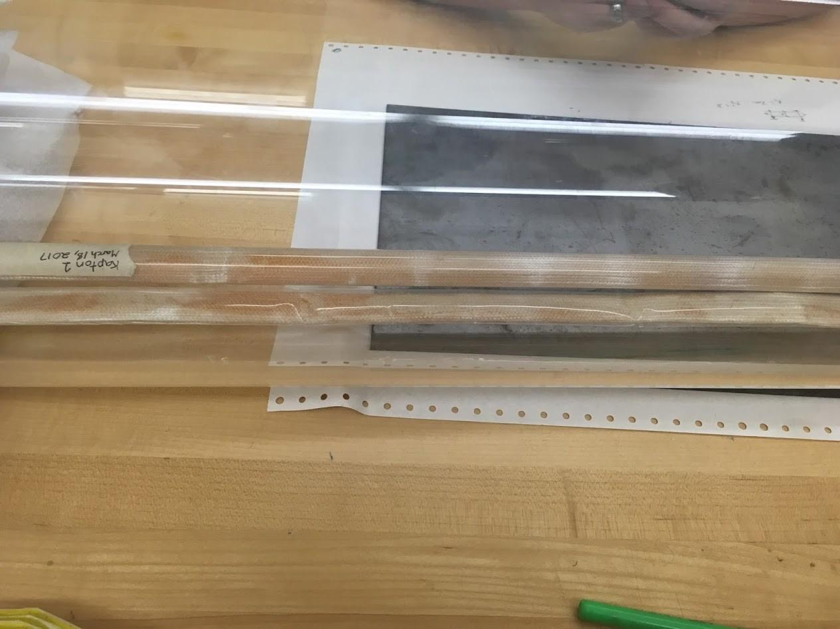

Figure 1: New boom (close) and old boom (far) in vacuum chamber. Both Kapton booms are fully inflated. The older one is more uni-form and cylindrical.

Another significant issue the team ran into was that the payload ended up at around 9700 feet on Logan Peak. Seeing from this experience, wind patterns and predictions thereof cannot be trusted. Allowing the payload to be completely at the will of the wind and when the balloon pops has already presented itself as an issue when a payload was completely lost. Thankfully, this time the tracker on the payload continued to run much longer than expected, allowing a few team members to execute a rescue mission. Although it worked out this time around, it should not be expected to work out so well in the

future.

**What Went Right?**

There were quite a few aspects of the launch that were encouraging. The fact that the Kapton boom used had been sitting on a shelf for not only months, but had been left in a vacuum chamber for a week, and was still in good condition, was incredible. The wire cutter issue that occurred last time, which resulted in the boom not deploying, was remedied. Extra precautions were taken, such as putting on a second set of wire cutters, to make sure the wire would cut. The coordination of team members going up to Logan Peak was incredible and showed an immense amount of initiative and devotion to the project. Overall, the launch was successful in testing the wire cutters, as well as giving the team another project, which is figuring out how to control balloon landings.

**What Next?**

Learning from this experience, materials will be replenished well before they run out. Booms will be made in more advance to the launch date, since the Kapton has worked so well in keeping air in the inner boom. To remedy the issue of pulling out the inner boom, a notch will be cut in the metal rod to ensure the material can be grabbed, and no more booms will have to be scrapped. To fix the boom curing prematurely, either the box itself will be lengthened, or the booms will not have extra air in them from sitting for a few months. The issue with the balloon ending up wherever the wind takes it will be remedied by creating a sort of cut down system to pop the balloon on command. Making these changes will certainly put the team that much closer to a successful deployed boom.

# **11 Electrical Team Report**

During the previous balloon launch, the payload, despite three separate attempts of boom deployment, was recovered with the boom box still tied closed. After testing the wire cutters in temperatures similar to those found in the boom’s typical deployment range and unable to recreate the error, it was determined that a boom switch and secondary wire cutter should be implemented. The satellite’s designs already included a boom switch for verification of deployment. The boom switch rests just beneath the lid and reads “open” upon successful deployment. The only changes necessary for this implementation was adding a small notch next to the camera for the boom switch’s wires to leave the inside of the box and writing additional code for the software to test whether the switch was reading open or closed. For the secondary wire cutter, a little more work was necessary, which included designing and implementing another PCB (printed circuit board) with the necessary components attached.

## **11.1 Changes Made**

The purpose of the secondary wire cutter was to work in a loop with the primary, until the boom switch read open or a predetermined amount of time had passed. First the primary wire cutter would run for the designated three seconds, and then switch off. The secondary wire cutter would run for another three seconds, before also switching off. These two wire cutters would then increment their time by half a second and continue the same process until both had ran for five seconds. At that point, if the boom switch still read closed, the code would return a message detailing that the boom had failed to deploy. A manual deployment could then be sent to attempt the process again.

During the week leading up to this most recent flight, the schematics for the payload were found and studied. From there, the base components that corresponded to the primary wire cutters were copied and integrated into the drawn circuits. With very little time until the flight, a temporary PCB was designed, etched, and then the necessary components soldered in place. Upon testing, both wire cutters worked as prescribed and the PCB was taped into the satellite a night or so before the balloon flight.

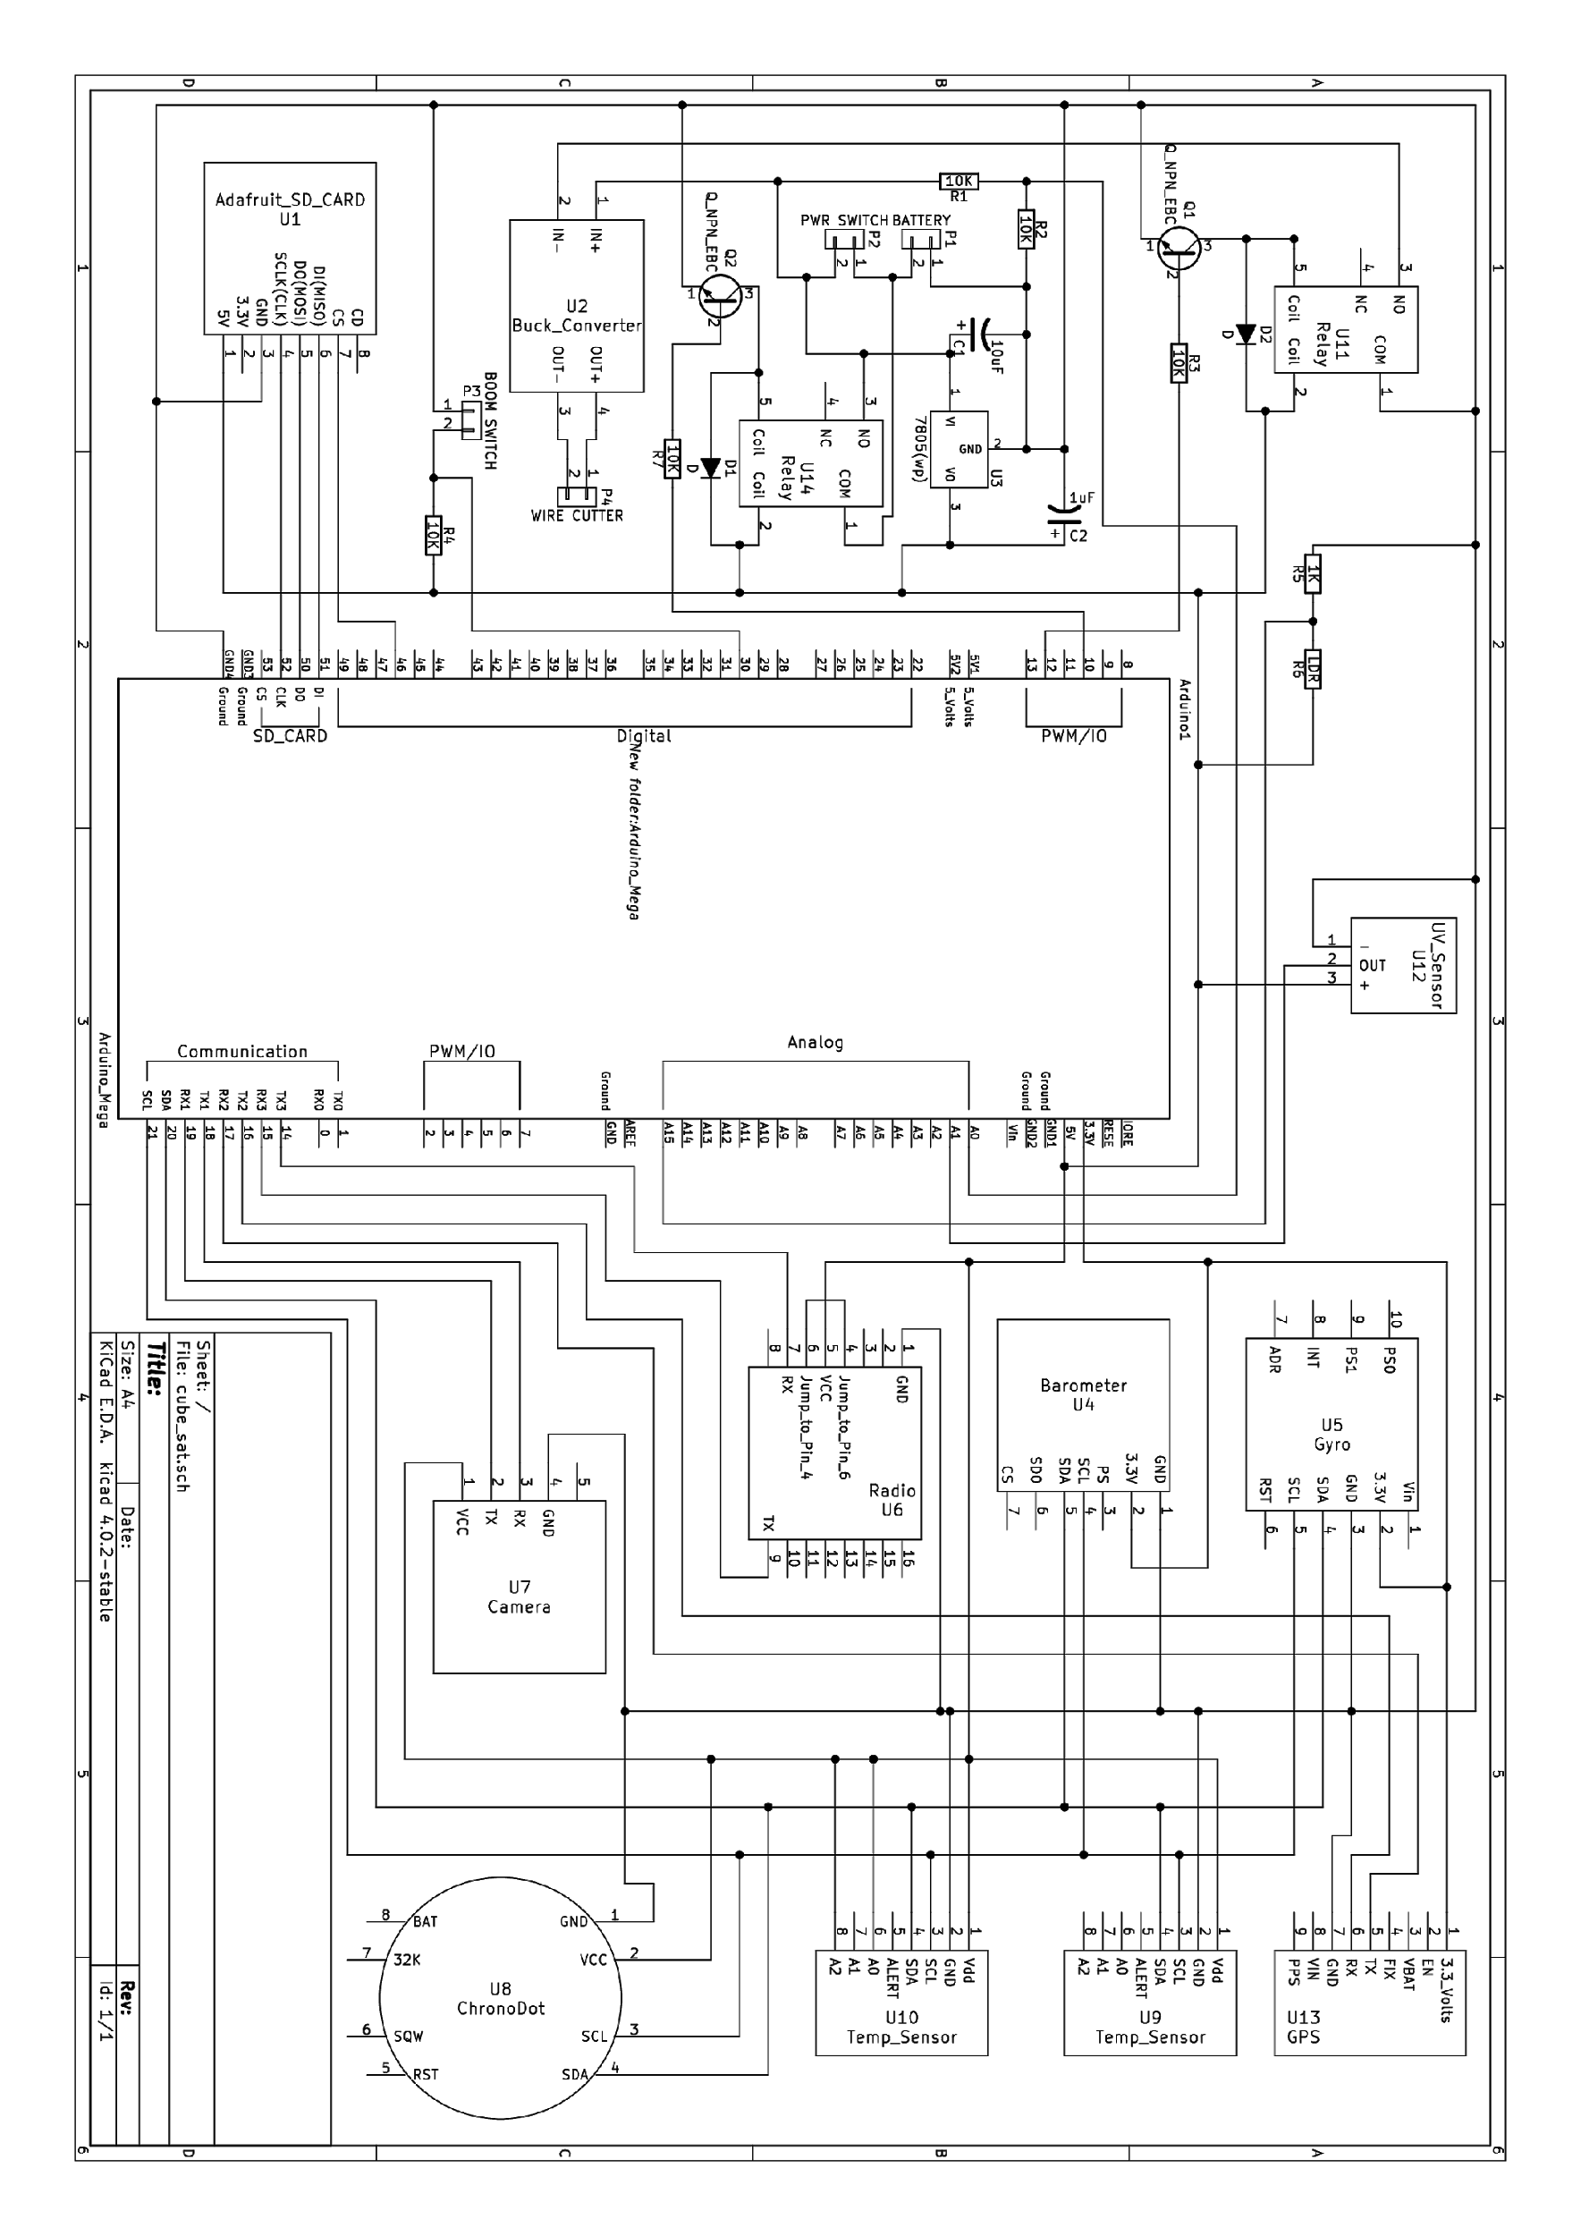

Figure 2: Full schematic of payload containing only the primary wire cutters.

## **11.2 Problems**

With implementing the boom switch, no significant problems arose. The schematic had been designed intending to use the switch, so only the code needed to be written and

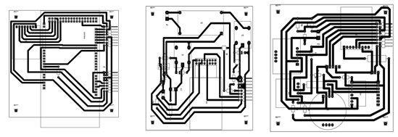

Figure 3: From left to right, PCB designs for the payload layers. First contains the

Arduino and SD card reader. The second is the primary wire cutter, radio, and a couple other components. The third contains the clock and some sensors.

tested. No major changes were made to the payloads design for this implementation, and everything with the boom switch ran smoothly while in the air.

While attempting to add the secondary wire cutter, due to the limited time and access to materials, a couple complications arose. The foremost of these complications involved determining a place to attach the newly designed PCB. Upon discussion with Mechanical Team, it was determined that the battery was to be ousted from the base of the payload and a place for it was carved into the interior wall of the Styrofoam insulation. This battery was then padded with more Styrofoam in hopes that the extra outside layer would help to keep it warm. The PCB was then taped to the bottom base plate of the payload next to the camera.

During flight, when the boom attempted to deploy at the specified pressure of 44 millibars, the payload instead lapsed into a strange loop where it would restart itself, read that it was within the correct pressure range, and then retry heating up the primary wire cutters before immediately shutting off again. Scrambling to figure out what could be causing this problem, the only thing we noticed out of the ordinary was that the battery voltage was reading very low. Attempting to manually deploy the boom did nothing to stop this loop, and, for the most part, we just had to wait until the balloon lifted the payload high enough that it would exit the pressure range for boom deployment and we could attempt the send another manual confirmation. However, after about ten thousand or so more feet, the voltage on the battery started rising again along with both the external and internal temperature. There came a point where the payload broke out of its loop and sent a confirmation that the boom switch was open, indicating the boom successfully deployed. We don’t have an accurate reading on exactly where this point was, since the boom deployment information that was to be written on the mini SD card was corrupted.

## **11.3 Possible Solutions**

Our current hypothesis is that there was not enough voltage given by the battery available to keep everything running and also heat up the wire cutters, hence the restarting loop. Though we are currently uncertain, statistically, if there is a correlation between the temperature and the battery voltage, we did observe that the voltage started rising again once the payload started heating up. It was during this point that the payload stopped restarting and successfully deployed the boom. Until we can further analyze the collected data, we have determined to better insulate the battery and change the pressure range for deployment such that it is between 15-30 millibars instead of the 10-44 millibars it was before. In the future, we also hope to redesign the PCB’s such that the secondary wire cutters can be better implemented with all the other components, reducing the amount of empty space on the boards and compacting them down to the necessary size for our final design.

# **12 Conclusion**

ERRNO went really well. Apart from small issues that the flight had, as low voltage, late deployment, and boom not inflating. We did have a larger issue that software will begin looking into, the data that was on the SD card was corrupted. Software will begin looking into why this happened, as the theory right now is that the SD Card was not formatted properly before flight. The battery voltage stopped recording data so it is impossible to tell if temperature has an affect on power with our data. However, our research online suggests that temperature does play a massive effect on how battery voltage comes into effect, but the next flight will be able to tell us that. Software has also multiple image captures for the payload. When the box opens, it will be delayed for about 5 seconds. After the 5 seconds it will take 5 pictures consecutively so the GAS Team will have the chances of capturing a photo.

Software is also working on image retrieval from a radio using Slow Scan TV. The only issue that the GAS Team can see is that SSTV uses 100% power utilization. Which can be a massive problem if the battery voltage is too low.

# **13 Appendix A : Data**

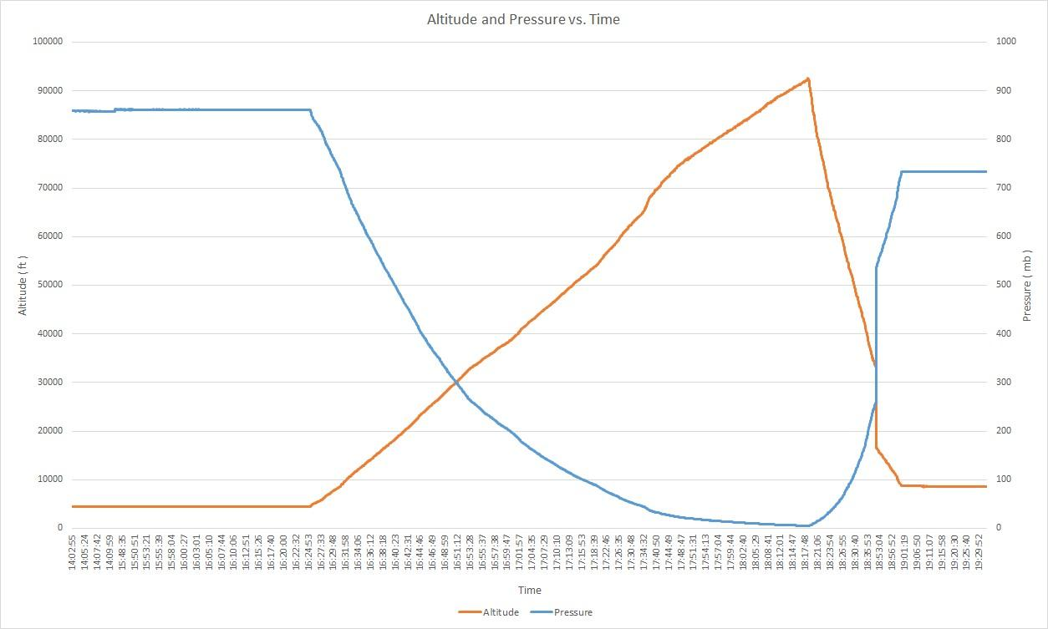

Figure 4: Altitude compared with Pressure vs Time

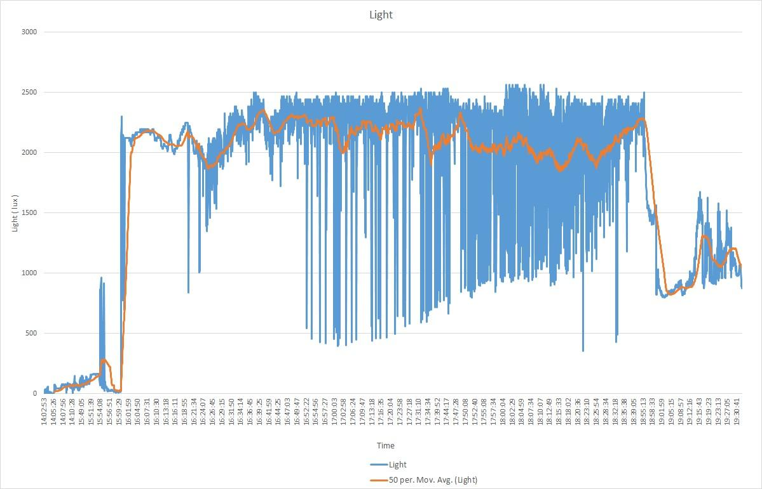

Figure 5: Light Intensity vs Time

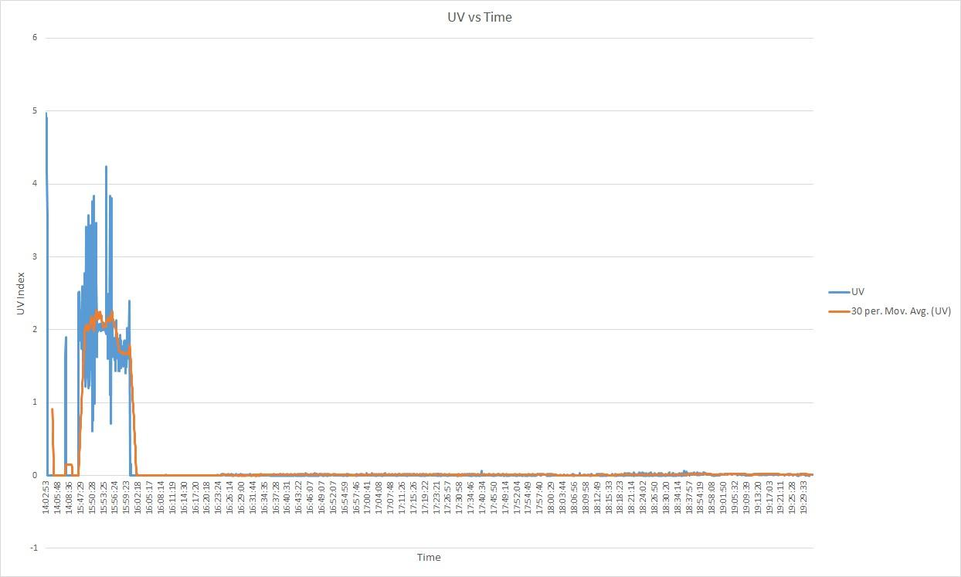

Figure 6: Ultraviolet Light Intensity vs Time

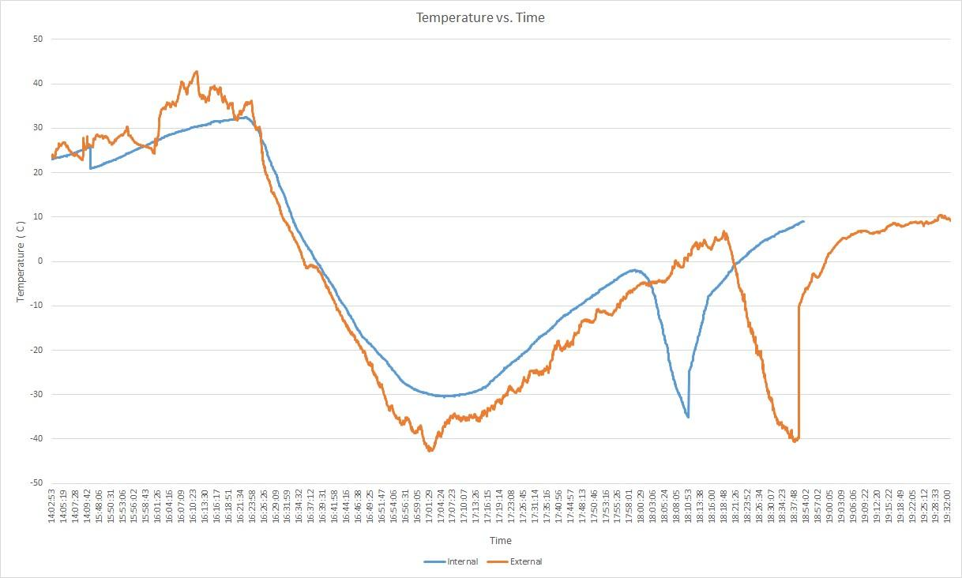

Figure 7: Temperature (inside and outside) vs Time

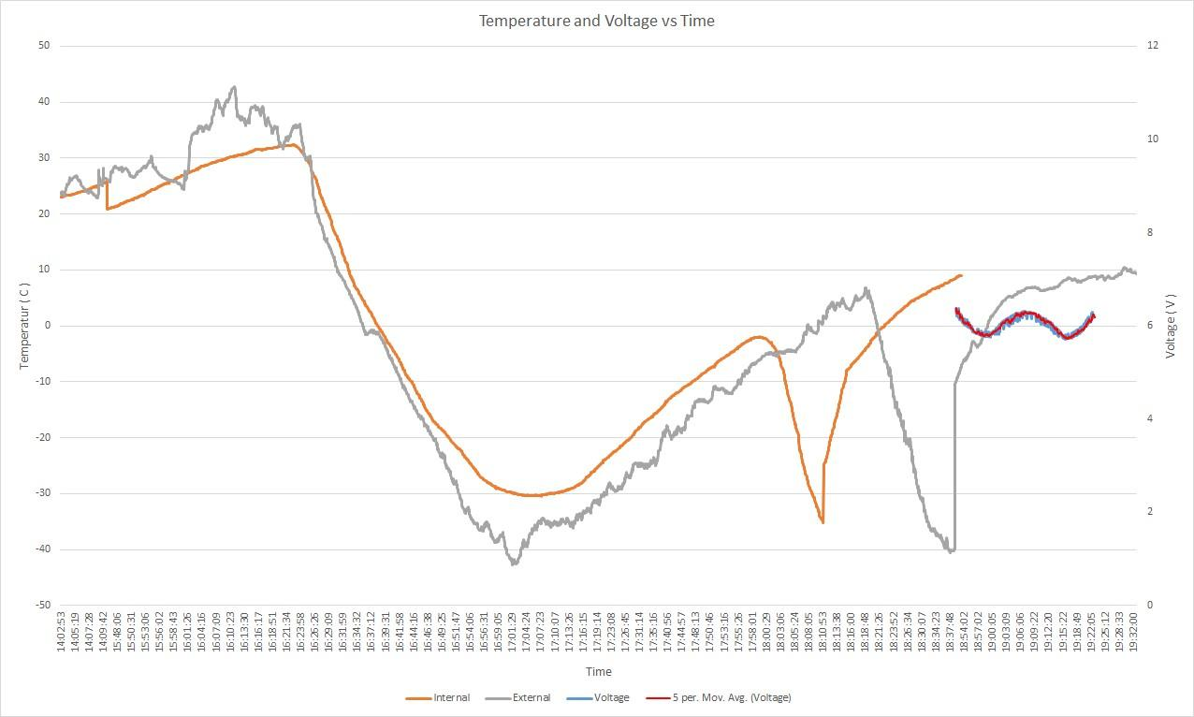

Figure 8: Temperature compared with Voltage vs Time

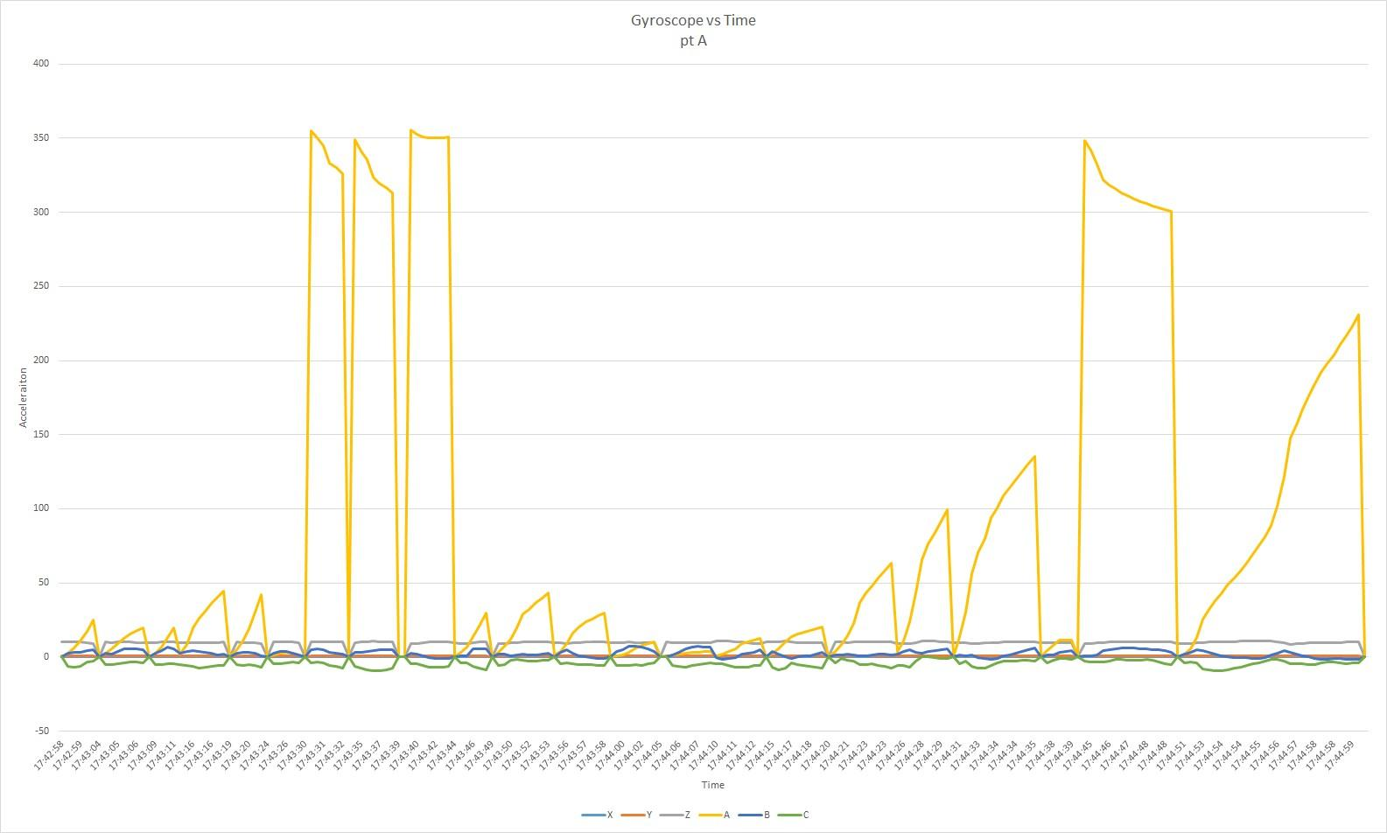

Figure 9: Good Gyroscope Data vs Time (pt A)

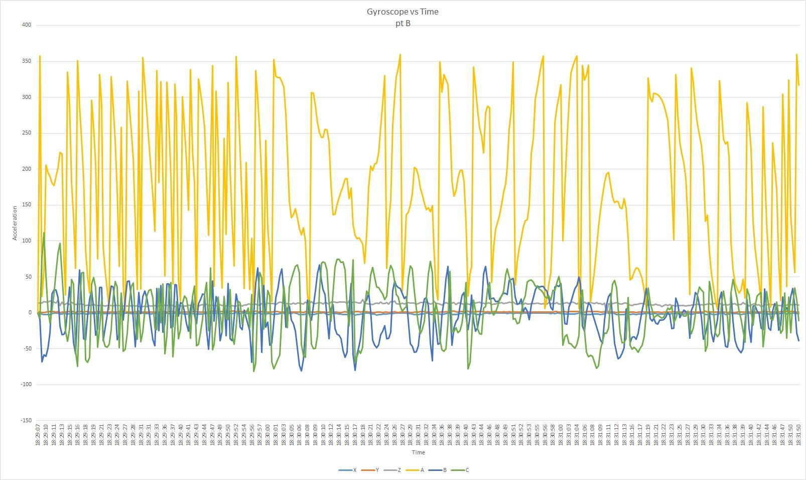

Figure 10: Good Gyroscope Data vs Time (pt B)

# 14 Appendix B : Flight Information



* Raul Ramirez
* Hailee Maxwell
* Jacob Yates
* Carlos Denoso
* Sam Dalrymple
* Kaden Ledbetter
* Ian Jepson
* Scott Glaittli
* Hailey Hampton
* Nathan Hampton

Communications

* Ammon Hepworth
* Kelly Burch

Retrieval

* Ammon Hepworth
* Kyle Hovey
* Jack Conrad Kiefer II
* Whittney Despain

Appendix III.3

Errno Balloon Report

6/17/2017

This report is a small follow up of the balloon flight that the Get Away Special Team completed on Saturday June 17th. Overall, the balloon flight was a success, as the goal was to deploy the Aeroboom and retrieve the payload for analysis after recovery. We had 2 goals in mind during the flight. The first was to take care of our battery temperature problem, and the second was to deploy the Aeroboom at a higher altitude of 80,000 feet instead of the original 70,000 feet.

The first was solved by sticking the battery back in it’s original housing underneath the payload right next to the camera. This kept the payload warm and the battery warmer since it was closer to all of the electronics instead of the walls of the payload. However, this is a temporary fix, and the report from the electrical side of things goes into much further detail of what happened with the battery. I will not spend a lot of time with it here, I will spend time on what we can do with further solutions.

The second goal was finally achieved but had some shocking results. As described in the Mechanical Team’s paper, it seems that the boom was either caught on deployment and fully did not deploy or it cured in the box. We later tested these two theories and came out with some interesting results which I will speak of shortly, as attached will be a full report on the boom testing.

The Battery problem. I have proposed that a total overhaul must be done on the design of our payload to accommodate more batteries. This payload must be able to house 2-3 Arduinos for the following purposes. The first Arduino will be responsible for the entire payloads data collection. The Arduino will still be connected to the radio to tell us the life and how the mission is going overall. The second Arduino will be to handle the camera alone, I feel this is a safer solution rather than buying a nice space camera just to lose it somewhere in the mountains. The third Arduino would provide a heating space.

In the boom testing report, we tested to see if cold temperatures were the issue of the boom not deploying. Again, the report goes into further detail, but the test proved to us the reason the boom did not deploy, was because the resin did not handle the cold temperature at all. So the Mechanical Team proposed to find a less viscous curing material than what we are currently using.

I am proposing that we build a simple heater system. The third Arduino will monitor the data from many temperature sensors inside of the payload. It will take the average of all the readings in the payload, and then it will be set within a “room temperature” range so if the payload is too cold, the heaters will turn on and heat up the payload. If the payload is too hot, the heater will turn off to let the payload cool down. Again, this will only really work here on earth, and a space application will need to be further looked into. I will test this method by sticking two temperature sensors inside the boom box with a heater, and regulate the heat inside.

Appendix III.4

**Mechanical Team Report**

**Summer 2017 Third Balloon Flight**

**Preparation**

The Mechanical Team made three booms in preparation for testing, as well as for this balloon flight. The preparation and making of these booms was uneventful; there were no problems that arose while constructing the booms. The Mechanical Team also prepared a reusable box to test the boom deployment in the vacuum chamber. Initially, a small amount of putty was placed on the end of the booms that were put into the reusable box. However, after removing the second boom from the box after deployment testing, it was found that the pressure from bolting down the reusable box with the putty could result in a breach of the seal for the outer layer of the boom. Thin layers of foam replaced the putty for buffering the booms going into the reusable boom-box.

Other than the problem with the putty, the deployment testing proceeded smoothly and a boom was chosen for the high altitude balloon flight. This boom was then glued into a more permanent box. During the process of tying up the boom into the box it was discovered that there was too much air into outer layer of the boom preventing the boom from being closed into the box. The air in the outer layer of the boom had not been there during the deployment testing a two days prior. In theory, the outer boom is there to protect the fiberglass and resin, but has no effect on the structure of the boom during deployment.

It was decided to break the outer seal and remove air from the layer to allow for a better deployment opportunity and to allow packing for the flight. To remove the air, a small hole was carefully made in the outer layer without compromising the inner boom. After the air was released, Kapton tape was used to patch up the hole. The Mechanical Team will look further into the permeability of our materials to try to avoid such problems in the future.

**The Flight**

The third balloon launch of the summer, which took place on the 17th of June, had few mechanical issues. Except for the issues packing the boom, and the irregular deployment of the boom, the other mechanical systems functioned properly. The boom deployed at the correct altitude and at the correct time, but was unable to extend to its full length and harden into a rod. It instead hardened in a zig-zag fashion similar to the way it is stored in its box, but curved towards the side of the box opposite of the wire cutters, as seen in figure 1.

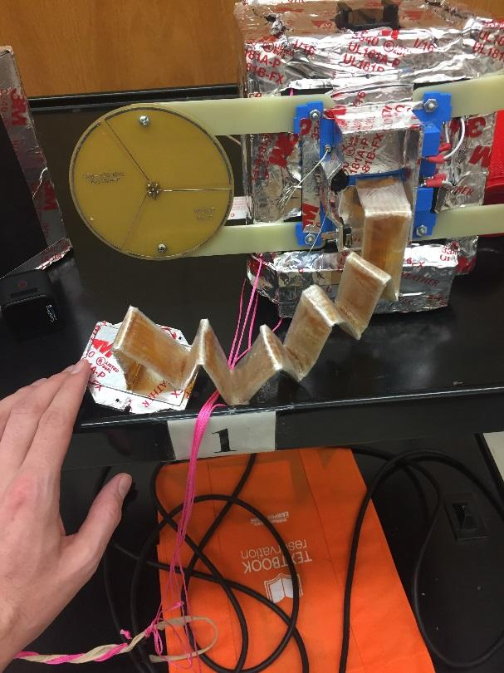 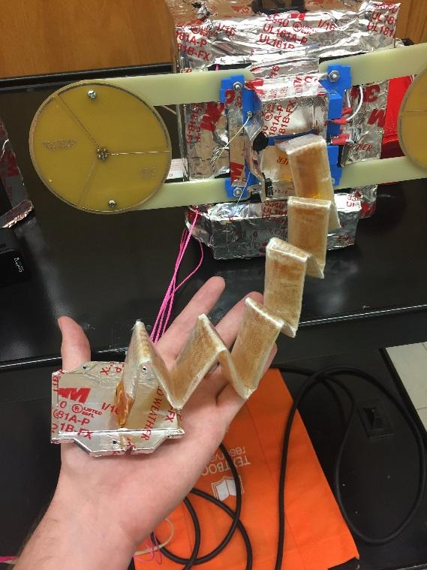

**Figure 1.** The boom after it had deployed.

**What went wrong?**

The Mechanical Team believes that the end plate of the boom, when it deployed, got stuck on the wires that held the box together. This explains the curvature of the boom, and why it was unable to deploy into a cylindrical shape. Another, non-separate possibility is that the boom partially cured inside of the box. When the box is tied and tested in low pressure, the boom bulges against the endplate and can create a small gap between the endplate and the box, which could allow U.V. light exposure for some parts of the boom. Given that the box is situated at the bottom of the payload during flight, the light exposure of the boom would be minimal aside from motion caused by turbulence.

The Mechanical Team will be conducting further testing by placing booms and their boxes first in a cold environment for several hours before deployment testing. In addition the booms in their boxes will be left outside in the sun for several hours before deployment testing in the vacuum chamber. These tests should help to determine other issues as well as ways to prevent future problems.

## 

## 

Appendix III.5

**High Altitude Balloon Launch**

**July 29, 2017**

**GAS Team – Mechanical**

**The Flight**

The GAS team launched two high altitude balloons on the morning of Saturday, July 29. This balloon launch went exceptionally well. The launch itself went quite smoothly with the first balloon launched at 8am and the second balloon launched an hour later at 9am. Our own payload was on the second balloon. There was no mishap during the flight of either balloons. Both balloons came down in the in the same field about a quarter mile apart.

**The Boom**

After the cold deployment testing, the mechanical team decided to try a few different methods to either keep the boom warm or to slow down the curing process to allow the resin time to heat up and allow a full inflation of the boom. The mechanical team made a boom and lined the outer layer with Kapton in order to slow down the curing process. At the time of the balloon launch, this balloon was four weeks old. However the boom deployed smoothly and inflated.

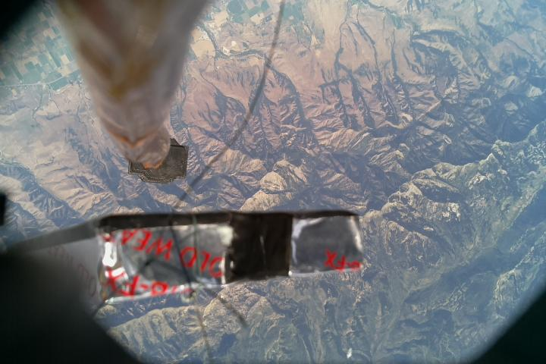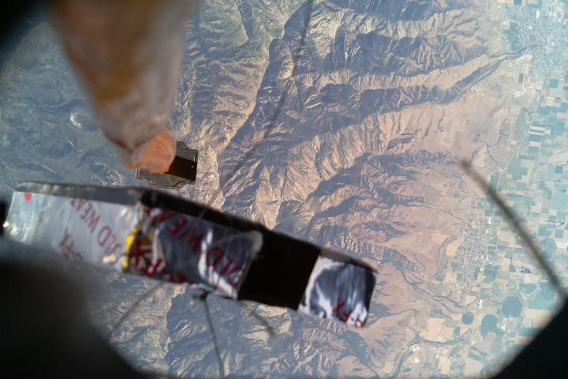

**Figure 1:** Pictures of the boom shortly after deployment. The edge of the boom is facing to the bottom of the picture with the boom inflating to the sides.

While the pictures that were retrieved show that the boom did indeed inflate, the boom did not cure during this flight. The Kapton lining the outer layer of the boom prevented any curing of the resin. The Kapton did help increase the lifespan of the boom. Moving forward the Mechanical team will be looking into finding a different film to line the outer boom with that will allow the UV curing resin to harden while also helping to prevent air from moving between the layers.

**The Structure**

As the software team decided to run a raspberry pi in addition to the Arduino to run the camera, the mechanical team has modified the payload structure. The payload structure has been expanded with another shelf added to hold the raspberry pi and the second battery.

Since the payload structure had been changed and expanded, the Mechanical team needed to create some new insulation to fit the new structure. It was decided to extend the insulation to cover the bottom of the payload around the boom box. With this a simple system was designed to allow a piece of the insulation to fall away when the boom was ready to be deployed. This piece was left to dangle from a string attached to the payload.

The old insulation was lined inside as well as outside with aluminum tape to make the insulation more durable and to prevent foam particle from getting on our electrical boards. Unlike the old insulation, the new insulation used electrical tape to line the inside of the insulation while keeping the aluminum tape on the outside. Replacing the aluminum tape on the inside of the insulation also drastically reduced the weight of the insulation. The old insulation weighed about .94 lbs. by itself. The new insulation, while it was bigger and there was more insulating material, only weighed .54 lbs.

Because of two reusable hand warmers placed inside the insulation just prior to launch and the fact that the insulation covered the bottom of the payload, including the boom box, the internal of the payload stayed much warmer. The internal temperature peaked at 45.69° C. and bottomed out at 3.5° C.

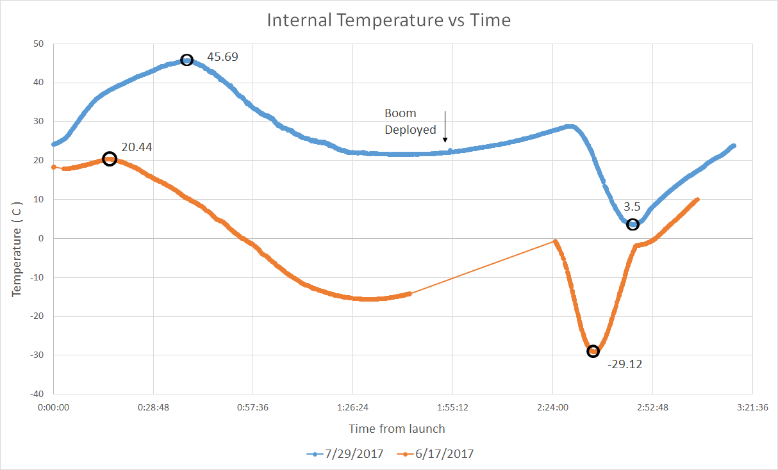

**Figure 2:** The temperature using the new insulation compared with the temperature using the old insulation versus time.

**Moving Forward**

This high altitude balloon launch can be considered a success. While the boom did not cure into a rigid structure, this flight showed evidence that the boom does inflate the way that we want it to. For the next balloon flight the boom will likely be made without a Kapton lining on the outer layer to ensure that the boom will cure. The boom will be kept warm by the insulation to allow the resin and the boom to move freely upon deployment. However, the Mechanical team will still be looking for a different, UV transparent film to line the outer layer with, as the extra layer is beneficial for storage life of the boom. This flight provided good results and a lot of information allowing for new goals to be worked towards.

**GAS Team – Electrical**

**Camera**

The only substantial change besides the structure of the payload was the addition of a Raspberry Pi, replacing the old uCam-II camera that had been previously used. A couple problems arose from using the uCam-II, notably that upon attempting to take a picture, no data was saved to the SD card and the camera became stuck in a nearly infinite loop. We were unable to retrieve any pictures from the last few launches and have yet to find the exact cause of the error. As such, we changed cameras and determined to introduce a Raspberry Pi with the intent that the camera taking process would be detached from the rest of the Arduino’s functionality, allowing us to see if the missing data was due to the camera impeding the SD card from saving the sensory inputs.

Our original purpose was to connect the Arduino and Raspberry Pi together, such that upon boom deployment and confirmation, a signal would be sent from the Arduino to the Pi. The Pi would be running a program that would, upon receiving the signal, begin taking pictures in an infinite loop with a thirty or so second delay between snapshots. However, due to time constraints, we were unable to connect the Arduino and Pi together appropriately.

**Flight**

For the flight, though the Arduino and Raspberry Pi inhabited the same payload, they ran completely separate with their own individual power supply. The camera was mounted into the bottom where the old uCam-II once resided, and the Pi was running a program upon startup, taking pictures every thirty seconds. As such, upon recovery, there was upward of 390 pictures on the Pi, most of them of the black interior of the box. Upon deployment, many pictures of the inflated boom and distant earth surface were also taken, helping to prove our aeroboom concept. Also, we found that the SD card had no breaks in saved data, further solidifying our hypothesis that the uCam-II, when attempting to take a picture, had been interfering with the SD card.

**Moving Forward**

For future flights, we intend to attach the Arduino and Raspberry Pi together, such that communication between the two can be maintained. We have hopes of capturing a five minute video of the boom deployment, alongside the looping snapshots.

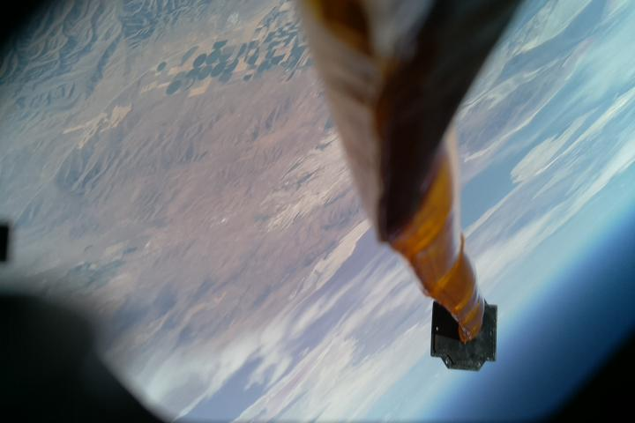

**Figure 3:** The boom shortly after the high altitude balloon popped. In its sudden descent, the payload was probably tipped to the side, the picture capturing some of the horizon in the bottom right corner.

Appendix III.6

**ERRNO Launch Report 10/14/17**

Authors:

Max Susman and Cara Frischkorn.



**Preparation/ Planning**

Roughly three weeks before the launch, Raul Ramirez approached Max Susman and Cara Frischkorn with the prospect of having them lead a balloon launch. The nature of this launch was to serve as practice for new members of GAS, as well as to prove the current iteration of GAS’s intent to properly document their work(so that it will benefit those who follow in their footsteps.) While the two newcomers were in charge of the flight the senior team members always kept a close watch and made sure to advise against any potentially detrimental error. Susman and Frischkorn were also instructed on the usage of HABHUB’s flight predictor, so as to determine the proper launch site. The senior team members had written the document “Instructions on How to Fly a High Altitude Balloon ,” which proved to be excellent for the purpose of teaching new team members the ins and outs of preparing and launching high altitude balloons. The night prior to the launch (10/13/17) the senior team members demonstrated to inexperienced members how to prepare payloads for launch. Susman and Frischkorn were taught how to use the “Ascent Rate Calculator.”

**Launch**

The launch team assembled in the GAS lab at 06:00 to prep for the launch (10/14/17) At this point it was designated who would travel to the launch site (Malta, Idaho) In each vehicle. Aside from loading the vehicles with the helium tanks, payloads, the balloon, and launch paraphernalia all the prep work had been completed the night before. At this point flight predictions were double checked, so as to account for changes in weather, lift values required for potential ascent rates were calculated, and the team loaded up in separate vehicles and made their way to the launch site. Travel time was roughly two hours for the Launch team to arrive at the launch site. At this point the Launch team began prepping the launch site, senior team members making correction where needed. During this process it was discovered that the boom had deployed early. The launch team did their best to reinstall the boom in ERRNO. While the balloon was being filled, an individual came forward with what they thought was the correct Lift value for the balloon. This second lift value was not verified by the team. The balloon was released at 10:05 MST.

**Flight**

During flight, communications were lost with ERRNO, fortunately the FAA was able to track the flight via the APRS network. Unexpectedly the Balloon’s ascent rate was much higher than calculated. This caused The balloon to reach its burst altitude much earlier than planned. Fortunately the payload landed at the south end of Cache valley, in the foothills of the the Wellsvilles.

**Retrieval**

While the launch team was enroute to return to the GAS lab; two of the launch teams vehicles went straight to the landing site in the foothills near Bothwell to search for it. At 12:55 the search team obtained permission from the owners of the land where the payload landed, to search for it. At about 15:30 Jared Smith, a Bridgerland Amature Radio Club (BARC) member arrived at the canyon to assist the retrieval crew with a radio tracker to pick up the payload signal. At around 1700, the payload was located and retrieved.

**Results/Reflection**

Upon inspection there were a number of issues with ERRNO post flight. The boom had not deployed in flight, this was due to the fact that when it had deployed early it’s switch read as open. This prevented ERRNO from ever trying to cut the wires when it achieved the right pressure. The team inspected the in flight loss of communications with ERRNO.It was revealed that the onboard radio’s wired connection to it’s power supply had been jostled loose due to in flight stress. Even prior to retrieval it was obvious that the balloons premature burst was due to it being overfilled. An investigation into this matter was conducted by multiple individuals. It was postulated that the issue was due to the sequence of values used in the HabHub flight predictor. However upon further investigation it was revealed that the incorrect value for Lift had been generated as a result of human error. The individual that had procured the second lift value had neglected to remove the parachute weight from the payloads weight while filling in values in the “Ascent Rate Calculator.” These errors have been acknowledged and documented, and changes both structural and procedural have been made so that they won’t occur again. The new members of GAS were able to launch a high altitude balloon, track it, and retrieve it which completed the mission of 10/14/17’s launch.

Appendix IV

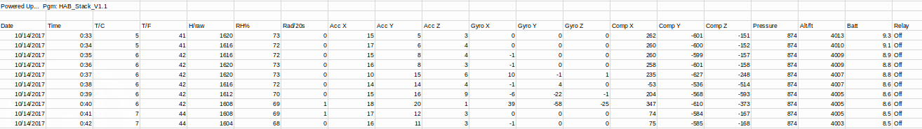

# 

# 15 Appendix V

The Table of APRS Symbols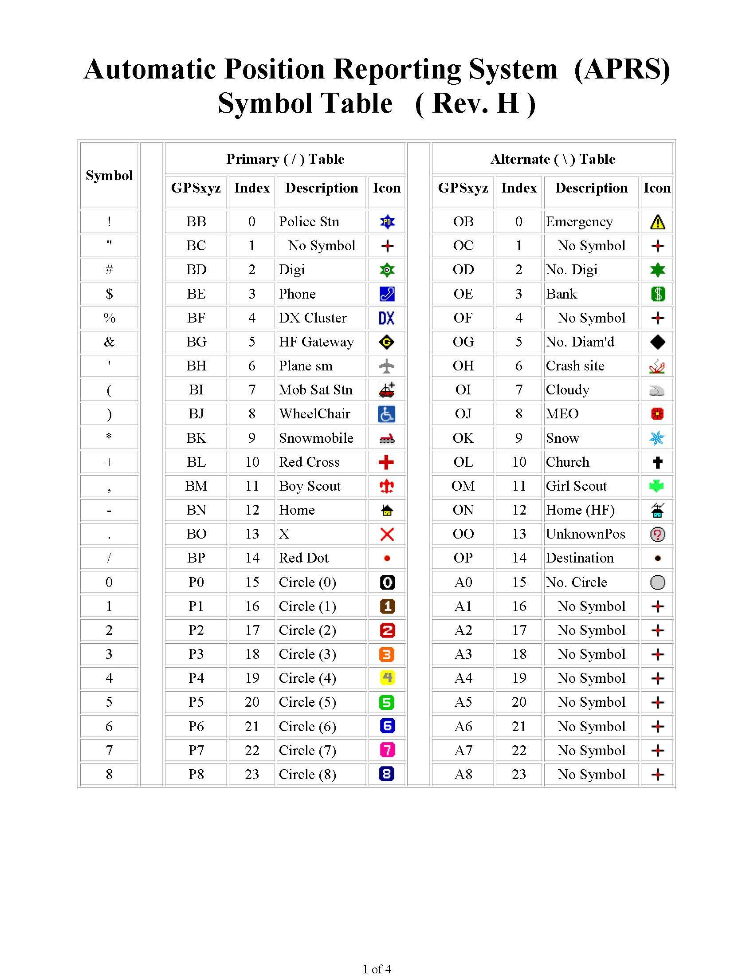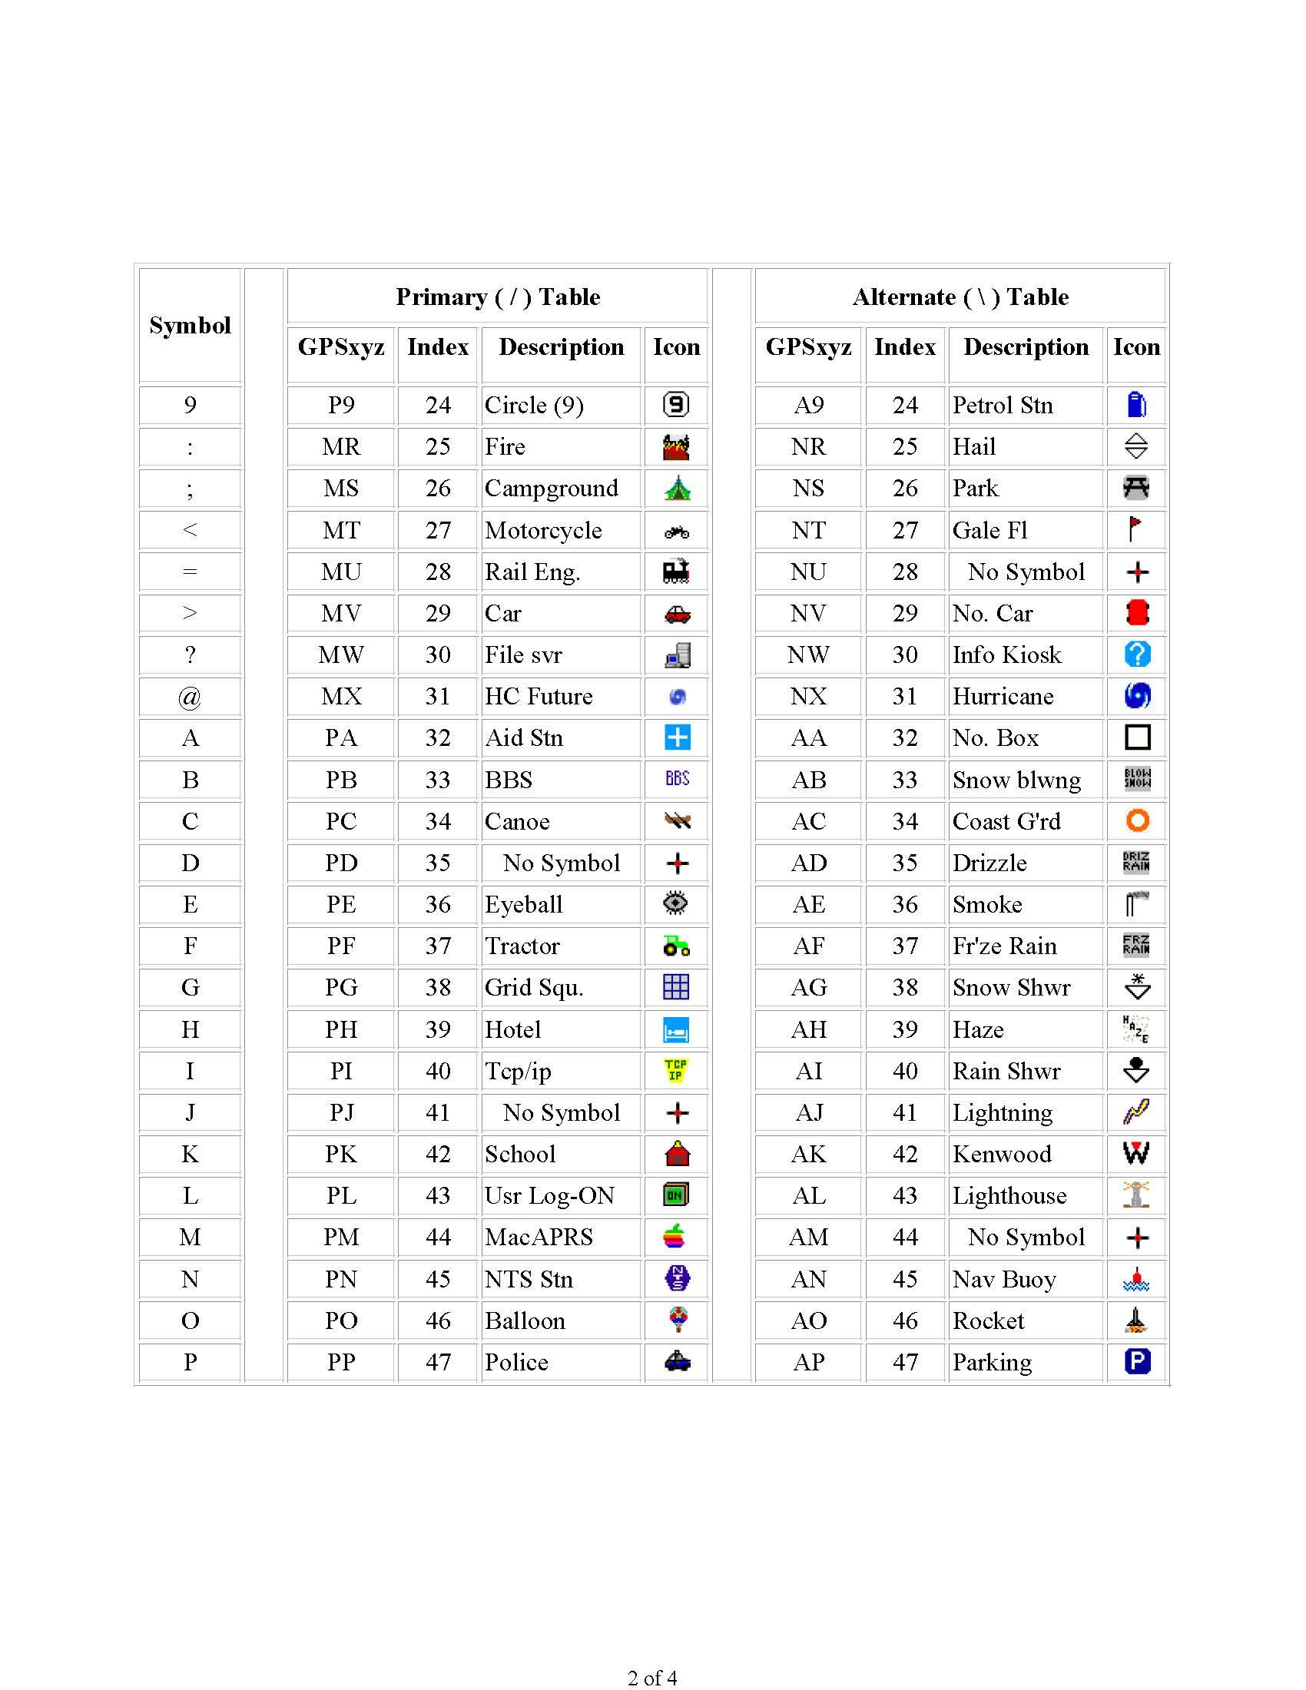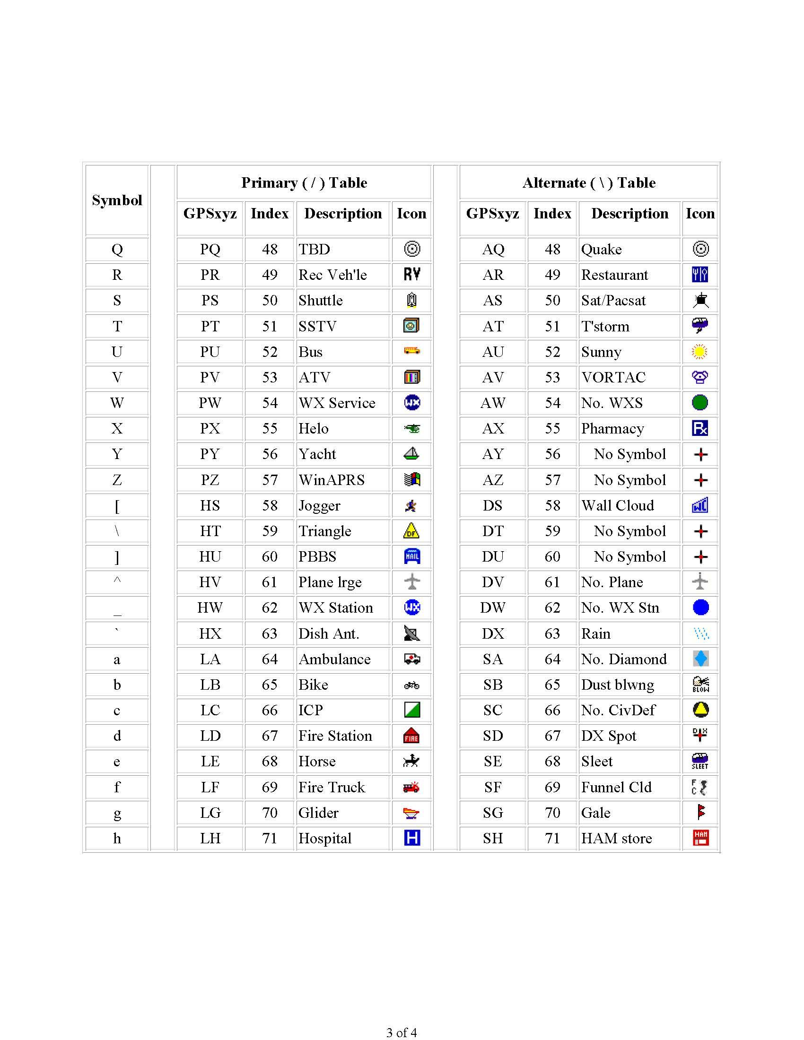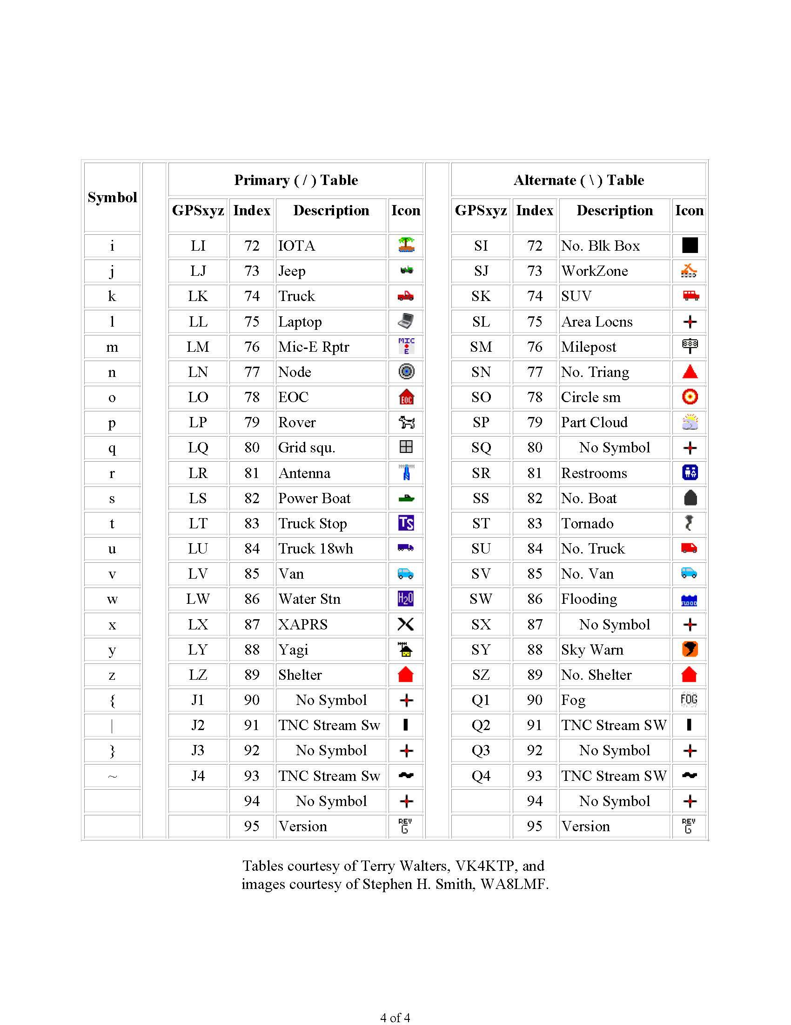

# 16 Appendix VI

* At least 300CF of low-grade helium
* Gas tank hose (Top image)
* Howyee 1600 gram latex balloon
* Parachute 5'
* Hula Hoop 25” diameter
* 50lb Fishing scale
* 11in. 75lb Tensile Strength Zip-ties
* Scissors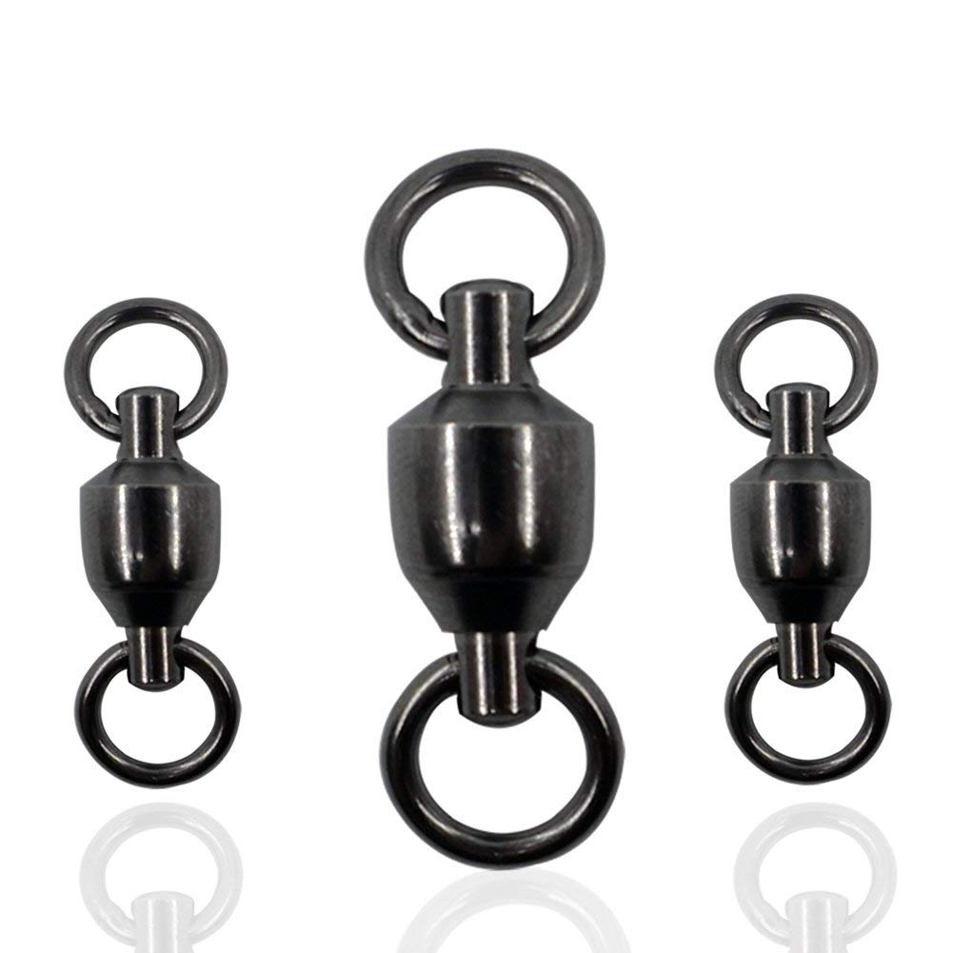
* Large Fishing Swivels (images to the right, either will do)
* 15’ x 15’ Tarps
* Nitrile or Latex gloves
* Tapes (important)
  + Electrical tape
  + Kapton tape
  + Cold-weather (aluminum) tape
  + Duct tape
  + Masking tape
* Bubble level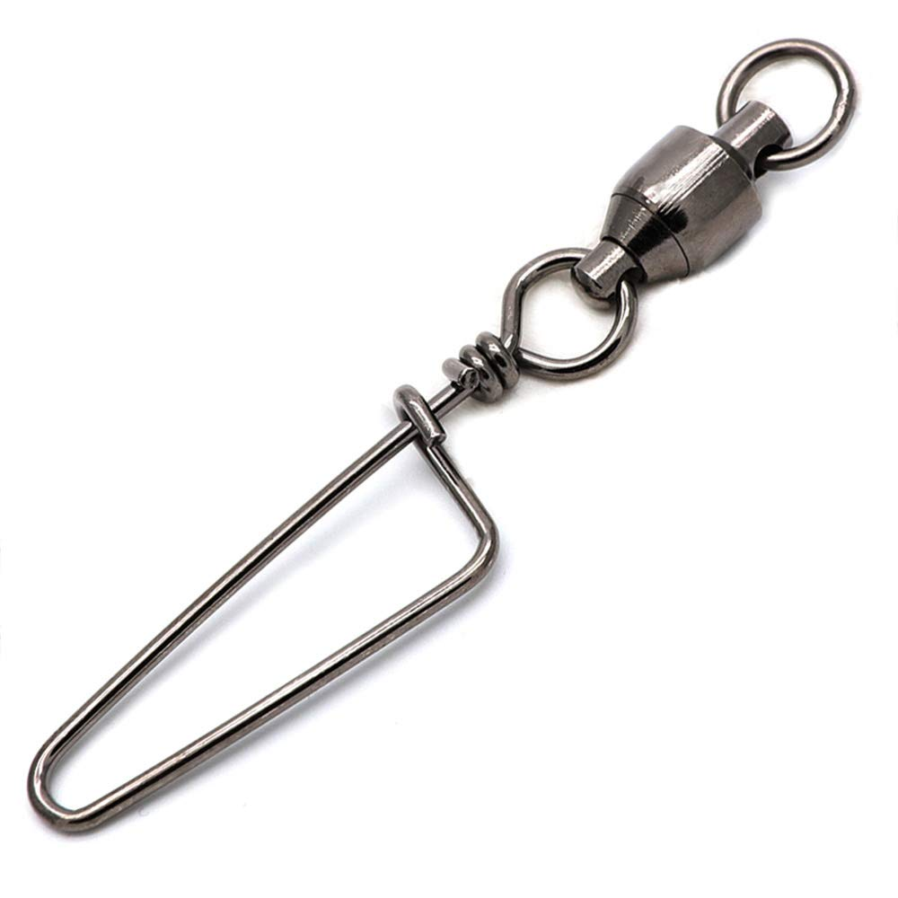
* Mason line (Bottom image)
* Radios
  + Byonics Micro-Trak 1000 - <http://byonics.com/mt-1000>
  + Micro-Fox 15 - <http://byonics.com/mf>
* Tow line (thin rope/paracord) 30 feet
* Key-Ring or Carabiner - approximate size of a key ring

# 

# 17 Change Log

* June 8th 2018 - Added instructions for configuring the APRS and Fox Beacons.
* February 6th 2019 - Added Appendix VI detailed list of materials